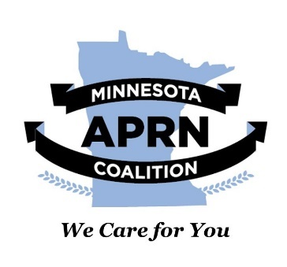

January 11, 2023

Chair Tina Liebling

477 State Office Building

St. Paul, MN 55155

Dear Chair Liebling:

I am writing on behalf of the Minnesota APRN Coalition in support of HF 91. As you may recall, Minnesota APRNs include four roles performing advanced practice nursing, including Certified Nurse Practitioners (CNPs), Certified Nurse-Midwives (CNMs), Certified Registered Nurse Anesthetists (CRNAs), and Clinical Nurse Specialists (CNSs).

The Minnesota Advanced Practice Registered Nurses (APRN) Coalition’s mission is to improve patient access to, and choice of safe, cost-effective healthcare providers by removing statutory, regulatory, and institutional barriers that prevent APRNs from practicing at the highest level of their education. As such, we strongly support repealing the physician-only provision that was found to violate the constitution in the case of Doe vs. Minnesota. Therefore, we heartily endorse **HF91: A bill for an act relating to health, repealing certain statutes regulating abortion…**

As providers of primary care services, Minnesota APRNs must be able to offer access to comprehensive reproductive healthcare services. The provision of these services is essential to women’s health and well-being and is in the best interest of women, their families, and their communities. HF91 helps to ensure this access and care.

We appreciate your leadership in this effort to ensure Minnesotans retain access to quality health care, Representative Liebling. We hope your other legislative colleagues will see the importance of this bill, and offer support as well.

Sincerely,



Brian K Goodroad, DNP, APRN, CNP, FAANP

President

Minnesota APRN Coalition

Email: [admin@mnaprnc.org](mailto:admin@mnaprnc.org)

Cell: (651) 263-0783