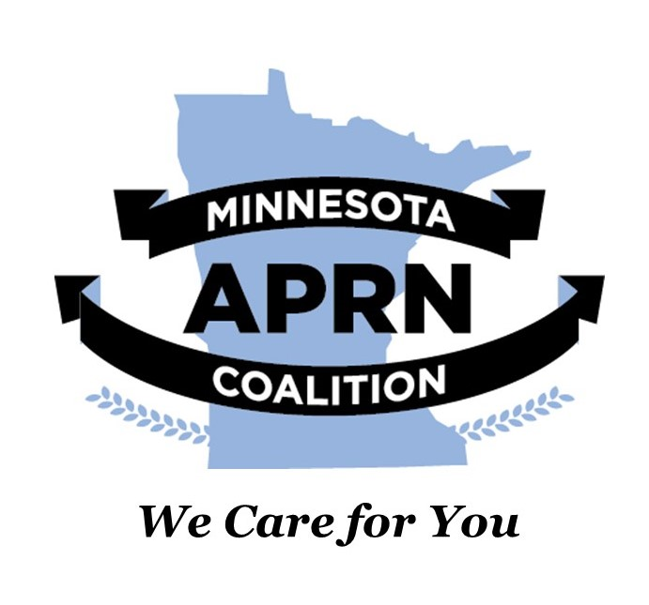
January 24, 2024

Chair Tina Liebling
477 State Office Building
St Paul, MN 55155

Representative Mike Freiberg
381 State Office Building
St Paul, MN 55155

Dear Chair Liebling and Representative Freiberg,

We are writing this letter to provide technical advice on the delete-all to HF1930, the End of Life Option for Terminally Ill Adults Bill.

The Minnesota APRN Coalition is an organization that represents over 10,000 Minnesota Advanced Practice Registered Nurses (APRNs), including Certified Nurse Midwives, Certified Nurse Practitioners, Certified Registered Nurse Anesthetists, and Clinical Nurse Specialists. Our organization works to ensure that Minnesotans have access to quality healthcare with fewer barriers to access that care, and fewer barriers to practice for APRNs.

We want to thank you for the inclusion of Advanced Practice Registered Nurses in the definition of “provider” on line 2.23 of the delete-all amendment. We request that psychiatric Certified Nurse Practitioner and psychiatric Clinical Nurse Specialist be added to the definition of “licensed mental health professional” under the Sec. 2 definitions (starting on line 2.5 of the DE). This addition is consistent with the Mental Health Uniform Service Standards Act: Provider Qualifications and Scope of Practice (MS 245I.04 Subd. 2(1)) definition of a mental health professional.

The Minnesota APRN Coalition shares the goal of ensuring that Minnesotans have access to all providers who are educated and licensed to provide the type of care described in this bill, and the ability to choose the type of provider based on their personal needs.

Thank you for your consideration of these recommendations, and for your work to ensure access to healthcare for all Minnesotans. Please don’t hesitate to contact us if you have any questions.
With regards,
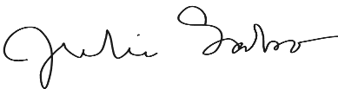
Julie Sabo, PhD, APRN, CNS, FCNS
President, Minnesota APRN Coalition

CC. Senator Kelly Morrison

