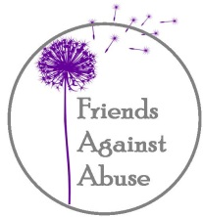

407 4TH STREET
INTERNATIONAL FALLS, MN 56649
PHONE: 218-285-7220
FAX: 218-285-7202
TOLL FREE: 888-344-3264

Date: 2/08/2021
To: Representative Peggy Scott
From: Katie Nordby, Parents Forever Facilitator
Re: Parents Forever

I have been teaching the Parents Forever course in Koochiching County, MN since 2016. This course benefits parents who are going through a divorce or separating, by preparing then for common co-parenting issues. Throughout the course, parents learn tips on such things as: self-care, child development and how they may cope with a divorce/separation, legal aspects of divorce, finances, child support and tools they can use to be more effective in co-parenting with their children’s other parent.

Since I have started teaching this course in Koochiching County, I have heard from participants that this course was greatly beneficial to them. What they have learned from this course will be applicable to their lives. Some participants have said that they wished they would have taken this course sooner due to how helpful the information was for them. Out of all the participants that I have taught, I have not had any complaints about the course.

Respectfully,
Katie Nordby, Parents Forever Facilitator

