February 28, 2023
Representative Zack Stephenson
Chair, House Committee on Commerce Finance and Policy
Room 10
State Office Building
Minnesota State Capitol
St. Paul, MN 55515

Re: Age Appropriate Design Code (HF 2257)

Dear Chair Stephenson and Members of the Committee,

The State Privacy & Security Coalition (SPSC), a coalition of over 30 companies and six trade associations in the retail, technology, telecom, payment card, and healthcare sectors, writes to respectfully oppose HF 2257. Children’s safety is extremely important, and our testimony today reflects significant concerns about the unintended consequences of this bill on vulnerable populations.

As drafted – and as enacted in California – this bill contains several elements that, when joined together, will almost certainly result in a loss of anonymity for teens on the internet as well as a restriction of content that those teens can access.

The first element is the definition of “child,” which is defined as “a consumer that is under the age of 18 years.” When this guidance was issued in the United Kingdom, it was done so with an expansive addendum that noted the differing developmental stages of children – hence the moniker “age-appropriate” design code. The fundamental premise of that guidance is that individuals have different needs at different developmental stages. But the legislation before the committee today, and that California enacted, treats a 4-year-old the same as a 16-year-old.

The second element that creates this issue is the definition of “likely to be accessed by children,” which brings into scope nearly every internet website and app available, because it must count any website that 17-year-olds may routinely use. Because of the way this bill is drafted, businesses will need to start verifying ages of individuals online. This will likely result in a substantial increase in the amount of personal information businesses will need to collect on individuals in order to be in compliance with the law. While this bill includes a catchall provision that may be intended to help mitigate the problem, the requirements of the bill will require businesses to, at the very least, institute a significantly increased level of “age-gating” for websites.

The last element of the legislation that is of primary concern is the requirement that businesses alter content that could be “materially detrimental” to a child. Again, this requires businesses to make editorial choices about removing content on its website.
As an example, consider a newspaper’s online site that carries reporting on the war in Ukraine. Under this law, it may very well need to set up two different sites that Minnesota consumers can access. One that carries a full level of detail in reporting, including graphic pictures and descriptions of war’s consequences, and another that provides a sanitized version. In order to properly direct consumers to the right website, it will need to obtain the age of every single visitor to the website. Clearly, this has significant ramifications for the consumer, the business, and the larger principles of free speech and free press.

As another example, consider a teen who is seeking information about issues of gender and sexual orientation. Because websites have to treat this teen in the same manner as a five-, six-, or seven-year-old, they will likely have to curtail providing information to them, because such information could be determined to be detrimental to such young children. Additionally, in order to determine what type of information the teen would be allowed to access, the website would likely have to obtain information about the teen’s identity, such as birth name and birthdate, address, etc. – to verify age and provide the right website content. This will result in a loss of online anonymity to a vulnerable individual attempting to obtain critical information.

SPSC believes that these consequences of the AADC are significant enough to pause and consider methods of mitigation, and believe strongly that this is an area where concerned stakeholders should come together to chart a better course. Online safety for children is of paramount concern, and SPSC feels strongly that the risks of moving forward with HF 2257 outweigh the potential benefits.

Respectfully submitted,

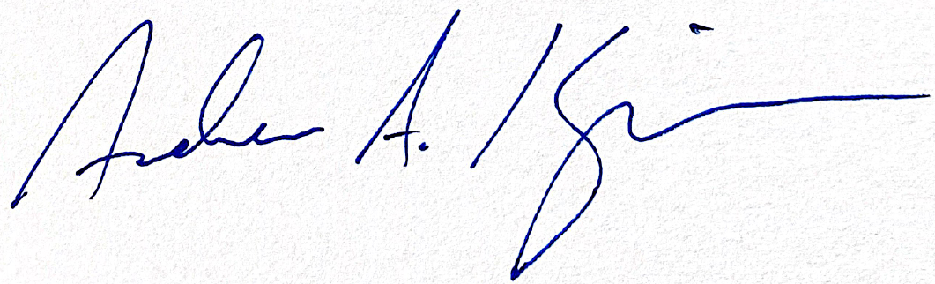
Andrew A. Kingman
Counsel, State Privacy & Security Coalition

