Dear Chair Noor,
I have been a Minnesota citizen for over twenty of my forty-one years and since 2005 I have worked in social services, representing people whose voices have not traditionally been heard. I write you today from my own personal perspective and I represent no organizations, but I cannot deny that my twenty years of experience in social services including working with diverse populations of color and different cultures, people experiencing homelessness, people living with HIV, people dealing with substances, and people dealing with mental health crises does not inform my view. My whole career I have worked with people who have been seen as less than human in some way. I have seen a lot of movement in some of these areas throughout my career and life. Some backwards and some negative but I do believe that we have moved in a positive direction in terms of seeing people as people even if we have a negative view of them. I was disappointed when I learned that we have not moved forward as a state in this way when it comes to people with disabilities. To judge the value of someone's work based on something like disability status is not even the echo of eugenics and the 3/5th compromise. It's the literal evolution of those concepts being applied to the last population of people that we can get away with it. In every instance of American history in which we have tried to push forward, we have run up against real fears of people who are afraid to lose what they have in order to gain what seems impossible. My mother grew up as a black woman in segregation in the south and the parents of some of her fellow students in the sixties were against segregation because they were afraid that it would increase negative outcomes for their children. Today we see parents that are afraid to lose the support and income that their children do have. However, that choice is false, and they have been misled. We can both provide support and hold ourselves to a higher standard in terms of ethics. Where would we be had we listened to our fears in the past? As scary as it is you cannot sail to new adventures while still standing on the shores of "It's always been this way". For these reasons "1 support the provisions in HF 2847 to increase wages for people with disabilities by phasing out subminimum wage in Minnesota". I hope that I can count on you to make the right choice in this matter and make history in a positive way.
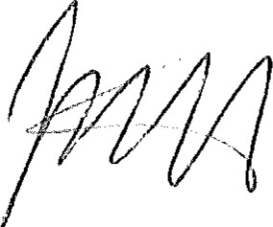
Jacorey SkottMyhre
Saint Paul, MN

