February 20, 2024

Chair Zack Stephenson
Vice Chair Charlie Kotyza-Witthuhn
Committee on Commerce Finance and Policy
75 Rev. Dr. Martin Luther King, Jr. Blvd.
Saint Paul, MN 55155

Re: HF 2309 – (Omnibus)

Dear Chair Stephenson and Vice Chair Kotyza-Witthuhn,

The State Privacy and Security Coalition (SPSC), a coalition of over 30 companies and six trade associations in the retail, telecom, tech, automotive, and payment card sectors, writes with recommendations to House Bill 2309. We appreciate that Minnesota is taking a comprehensive approach to privacy legislation and want to commend the sponsor, Representative Elkins, for a thoughtful and considerate process to moving the bill forward. We respectfully request consideration of recommendations that effectively balance consumer protections in Minnesota with implementation and compliance by the business community.

Broadly speaking, we believe that the best approach for state privacy legislation is that which works within the bounds of the original Washington Privacy Act framework, which has been adopted by thirteen states on a bipartisan basis, and now covers nearly 30% of the US population. Any further changes should strive to remain within this framework, both because we believe it provides the best approach for consumers and also because it is interoperable with the numerous other states that have adopted this comprehensive privacy framework.

We understand that there are amendments coming to the bill that may address some of our concerns, but wanted to flag the following as issues to focus on as the bill advances.

Ensuring Data Protection Assessment Interoperability
Data protection assessments (DPAs) are time-intensive endeavors that require businesses to expend a significant amount of resources across all business units to weigh the risks and benefits of particular processing activities. They are not, however, repositories for all data protection or compliance documentation. Currently, the bill’s DPA provisions include additional requirements that go well beyond the WPA framework, and would create interoperability difficulties, without significant corresponding consumer benefits to justify these outlier provisions.

Across the 13 states that have adopted this framework, DPA processes and scope are remarkably consistent. Requiring the inclusion of significantly distinct and unrelated material to the current requirements will have a materially detrimental impact on interoperability. We urge the sponsor to remove these additional requirements. However, should they remain, we have offered amendments to the sponsor that would move this provision to an addendum of the DPA and modifying Sec.9(a)(1)(2)(i)-(v) to more accurately reflect the particular standards set forth in the rest of the legislation.

By adopting this approach, HF 2309 can minimize the disruption with other existing state privacy law requirements while still including them in Minnesota’s privacy scheme.

Profiling
The Responsibilities of Controllers section contains a provision that sets forth specific requirements for decisions involving profiling. Profiling decisions are more likely individualized decisions rather than generalizations. It follows that the requirements of this provision are best addressed in the appeals section because this section describes how a consumer may request additional information in the event that a consumer rights request is denied.

Again, this is novel language that does not appear in any other state law, and we are offering language to move this to the appeals section in an effort to reach a fair compromise with the sponsor.

Clarifying Edits
We have some final suggestions for how to make this bill clearer, which will also have the effect of aligning it more closely with the other states implementing similar laws, and we have passed these along to the sponsor in the hopes of continuing to improve this bill.

Again, we wish to thank the sponsor and believe that Minnesota is closer than ever to enacting a comprehensive privacy law that strikes a reasonable balance between increasing consumer transparency and control while maintaining operational workability for businesses.

Respectfully submitted,

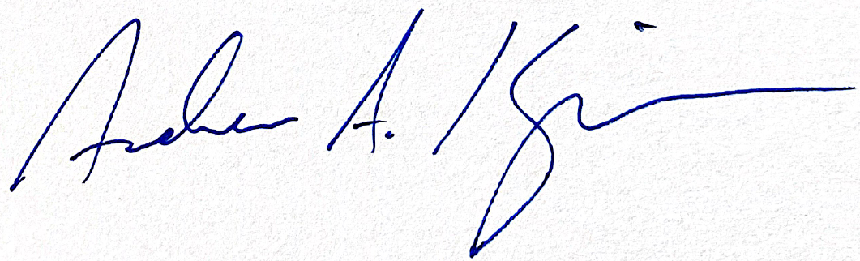
Andrew A. Kingman
Counsel, State Privacy & Security Coalition

