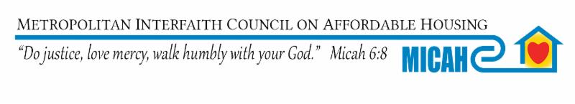
Dear Chair Gomez and Members of the Committee:

MICAH Supports
I. HF 3950 (Moran) - Ramsey County; families experiencing homelessness funding provided, and money appropriated.
II. HF 3377 (Keeler) - Homeless youth nonprofit grants authorized, and money appropriated.
III. HF 3568 (Her) - Housing support countable income modified.

HF 3950 It is critical to expand resources for all our counties to address the growing numbers of people experiencing homelessness in our communities. My hope is we do not have each county creating and lobbying their own bill; but can create flexible funds similar to FHPAP to ensure all counties have access to resources.

HF 3377 We must continue to expand resources for our youth experiencing homelessness and coordinate with other resources such as the bill Chair Gomez, passed last year in the tax committee.

HF 3568 People experiencing homelessness have expressed to MICAH paying 100% of their income is a barrier to utilizing the Housing Support Program. By paying only 30% of their income people experiencing homelessness will be able to take care of other personal needs and save money so they may move into their own unit in the future. MICAH supports this bill and would encourage you to expand this to include all sources of income.

MICAH’s mission is to ensure everyone, without exception, has a safe, decent accessible home that is affordable to them.
Over half of MICAH’s Board and staff have experienced homelessness, housing instability or discrimination and over 70% of our Board and staff are from diverse communities.
MICAH’s members are actively involved in our community to address the immediate needs of people at risk of and/or experiencing homelessness and creating and maintaining affordable housing opportunities. Our primary goals are to prevent homeless and to have homes that are affordable for everyone.
Over 550,000 Minnesota Households are paying over 30% of their income for housing. Which means they are making choices between paying rent, buying food, clothing, paying unexpected bill, etc. and are constantly at risk of homelessness with the loss of income, an accident, health crisis, or emergency .

God’s peace,
Sue Watlov Phillips, M.A.
Executive Director MICAH and President, National Coalition For The Homeless

MICAH 463 Maria Ave. St. Paul, MN 55106 651-646-0612 www.micah.org

