Medical Assistance Reform: HF 2438/SF 2284
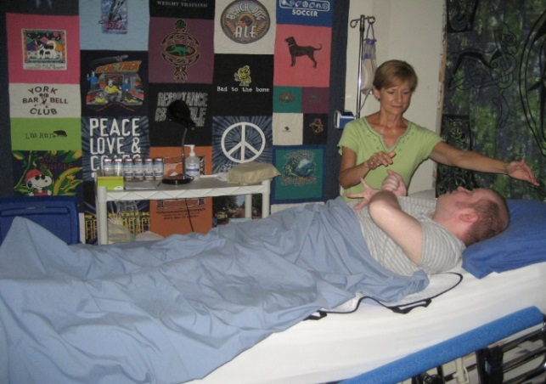
My name is Mary Fruetel, I live in Marine on St. Croix. I have worked as an independent contractor at Courage Kenny in Stillwater providing massage therapy to people with disabilities for 11 years. I love my job. The mother of a client (in photo) says that her son, who suffers from muscle tone and spasticity issues from his traumatic brain injury, goes from a state of anxiety and tightness to one of complete relaxation after a therapy session. It is gratifying to know that I have built a business around providing relief to people living with chronic pain and other side effects from their disabilities.
My client, Vince, started seeing me 4 years ago. His therapy sessions were funded through the Medical Assistance (MA) Brain Injury Waiver services. He was a logger and broke his neck and back several times and sustained a Traumatic Brain Injury from a car accident. My treatments helped his pain, mobility, range of motion and overall quality of life. He told me that my therapy is the only relief he has ever found from his chronic pain.
Last year Vince had to discontinue my services because his Social Security Disability Insurance, which is all he has to live on, had gone up to $982/month. This put him $1 over the qualifying limit for MA for people with disabilities. His only option to remain eligible for MA and waiver services was to pay what is known as a “spenddown” which expected Vince to spend his SSDI on medical bills (including my services) until he had $736/mo to live on. Vince couldn’t live on that amount so he discontinued MA and the BI waiver services. Vince would have been happy to pay a $1 spenddown to remain eligible but couldn’t afford to pay $246/month and still eat and pay his rent.
Losing Vince’s business cut into my income drastically, about $680/month. As a result my family can no longer afford dental insurance. My husband is also self-employed so we depend on each of our incomes. The low spenddown limit has not only hurt my business but Vince now has no relief from his chronic pain and other services that were helping him.
The low spenddown limit impacts many providers of disability services. When people can’t afford to pay their spenddown, service providers don’t get paid. They can only absorb so much debt before their business is in jeopardy and they must discontinue services. This is difficult for providers and our clients whose services start and stop or are discontinued, like Vince.
The current MA spenddown limit is putting thousands of people with disabilities’ health and independence at risk. Please fix this broken system by supporting MA Reform, HF 2438, SF 2284. It’s good for businesses dedicated to serving people with disabilities, it’s good for our state because supporting independence costs less than nursing home care and I know it’s better for the quality of life of people with disabilities.
For more information contact Erica Schmiel, MN Brain Injury Alliance at 612-877-7905 or ericas@braininjurymn.org

