Nursing Facility facts and figures
Background
The Minnesota Department of Human Services (DHS) and the Minnesota Department of Health (MDH) both have responsibilities for nursing facilities. DHS purchases nursing facility services through the Medical Assistance program and is also responsible for developing and interpreting policy concerning nursing facility services, quality of care and payment rates. MDH is responsible for licensing and inspecting nursing facilities, certifying them for participation in the federal Medicare and Medicaid programs, investigating complaints about them, and conducting resident assessments that are integral to care planning, quality measurement and rate setting. The departments co-sponsor the Nursing Home Report Card, at nhreportcard.dhs.mn.gov, which helps consumers compare quality of care in nursing facilities across the state.
What services are covered in nursing facilities?
Nursing facility services are bundled into a comprehensive package of room, board and nursing services. The package does not include costs for medication or such services as hospitalization, physician services, physical therapy, occupational therapy or speech therapy.
How is a person admitted to a nursing facility?
Anyone seeking admission to a Medicaid-certified nursing facility must be assessed to determine if they need nursing facility level of care. The pre-admission assessment can be arranged by contacting the county in which the person resides.
How much does it cost and who pays?
Approximately $2 billion is spent annually on nursing facility care in Minnesota. This includes state and federal dollars as well as private pay and funds from other sources. See page 2 for a breakdown by payer sources.

How many nursing facility beds?
Changing consumer preferences, along with incentives and restrictions imposed by the state, have led to about a 39 percent reduction in the number of beds in the state’s nursing homes since 1987. Minnesota has 368 licensed and Medicaid-certified (MA) nursing facilities as of Sept. 30, 2015.

How are nursing facility rates set?
Nursing facility rates for Medical Assistance and private pay do not differ within a facility. This is because Minnesota’s rate equalization law prohibits nursing facilities that participate in the MA program from charging private pay residents more than MA residents. Nursing facilities are allowed to charge private pay residents a higher rate for a single room and for special services not included in the daily rate
Value-Based Reimbursement (VBR), a new system for setting payment rates for nursing facilities, was established in 2015 legislation. These payment rates are made up of components for operating costs, external fixed costs and property costs.
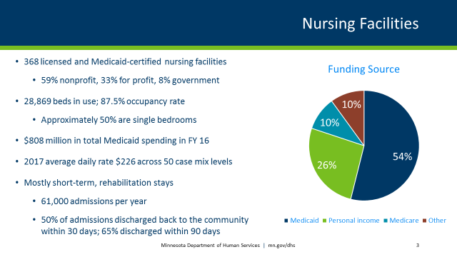

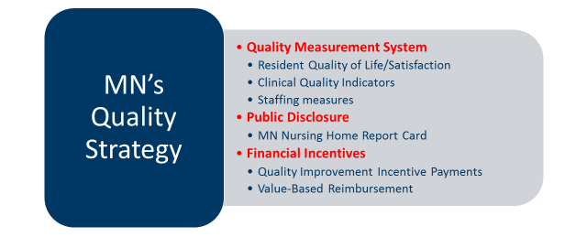

For accessible formats of this publication or assistance with additional equal access to human services, write to DHS.info@state.mn.us, call 651-431-2280, toll-free 800-747-5484, or use your preferred relay service.

