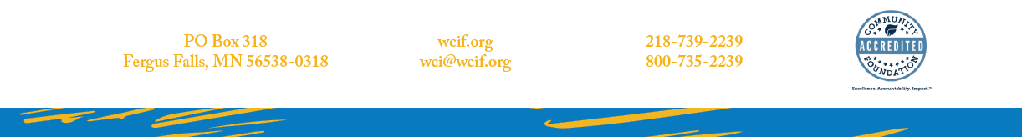

February 6, 2023

Chair Liebling and members of the committee:
My name is Nancy Jost, the Director of Early Childhood at West Central Initiative based in Fergus Falls. I am writing in support of HF 639, the Community Solutions Grant Program.
West Central Initiative supports HF 639, Community Solutions Grant Program because we believe it is a strategy that addresses inequality in a respectful and practical way. Community Solutions gives communities the ability to be innovative, to take advantage of their community strengths and to be culturally relevant. Communities know what isn’t working in their community, so it is respectful to allow communities to find the creative solutions that will work for them and that have come from them. It puts the power in the hands of rural communities and communities of color and American Indian communities to have them determine the solutions that best fit their needs.
HF 639, Community Solutions Grant Program represents more than money; it also recognizes that rural communities and communities of color and American Indian communities have knowledge about their own communities and should be active and valued participants in the creation of solutions for themselves. WCI strongly encourages you to support Community Solutions Grant Program. The collective health and prosperity of our state is ultimately tied to ensuring every child and their family have what they need to thrive. Minnesota has needs and Minnesota has the resources to meet the needs.

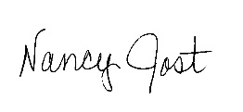
Sincerely,

Nancy Jost
Director of Early Childhood

