3880 Laverne Avenue North
Suite 114
Lake Elmo, MN 55042

Phone (651) 645-2452
Fax (651) 773-5914

March 6, 2017

Early Eye Drop Prescription Refill – Helping Preserve Patient Sight

Background
Each year, there are thousands of patients in Minnesota who are treated with topical eye medications. In the treatment of glaucoma, almost 75% are treated with more than one medication simultaneously for long periods of time, often years. It has long been recognized that non-adherence is a significant roadblock to successful treatment of patients even when appropriate medications are easily available. Inadequately treated glaucoma leads to vision impairment and blindness.

Although many patients are vigilant in taking their eye drops regularly and on schedule, even compliant patients may not be able to administer eye drops correctly and may waste significant volume every day. Unlike pills, eye drops are less reliable drug delivery systems. We have found that, even in experienced glaucoma patients who self-administer their eye drops, between 53 and 61percent regularly administer more than one drop at a time, many without even realizing it. These numbers are increased in those with poor vision from glaucoma, cataract, or retinal diseases. Eighty percent to 88 percent of these patients with visual comorbidities are unable to adequately instill a single eye drop at a time.

Presently, some patients often run out of their prescription eye drops well before the expiration of the intended period of use denoted on the prescription label. This is particularly problematic for patients with unsteady hands. However, even those using the utmost care in storing and using the eye drops find it nearly impossible to ration the medication to last the period of intended use. When a patient runs out of their prescription prior to the expiration of the intended period of use and returns to their pharmacist seeking a refill of the prescription, coverage is denied by the insurance company and the patient is turned away empty handed. Physical disabilities can also interfere with the administration of eye drops. It is particularly difficult for older patients to master and perform this task proficiently. Eye drop administration requires both the technical ability to easily squeeze out a single drop and the hand-eye coordination to find the eye and squeeze the drop onto the eye. Regrettably in individuals where glaucoma is common, diseases such as arthritis, tremor, Parkinson's and other musculoskeletal problems make it difficult to accurately squeeze the bottle to administer just a single drop. It is not uncommon for some patients to require double the allowed volume.

Furthermore, many of these medications are not yet available in generic form and are very costly, thereby prohibiting patients from paying for the necessary prescription out of pocket which disproportionately burdens our elderly and infirm. Unfortunately, many patients are unable to utilize the entirety of the medication because of shaky hands or a defect in the products' dispensing mechanism.

To ensure that patients who have prescription drug coverage continue to receive this important treatment, it is necessary to require coverage for the limited refilling of prescription eye drops without regard to coverage restrictions for early refill of renewals. Enactment of such policies will provide much needed protections for those who rely on prescription eye drops for preservation of sight.

www.MNeyeMD.org KWMAO@aol.com

Early Eye Drop Prescription Refill
page 2

What We’re Doing?
To date, legislators in eighteen state legislatures (as of October, 2015), working with the health care community to preserve patients sight have enacted legislation allowing patients with commercial drug plans to refill their eye drop medications prior to the refill date on the prescription label. These states include:

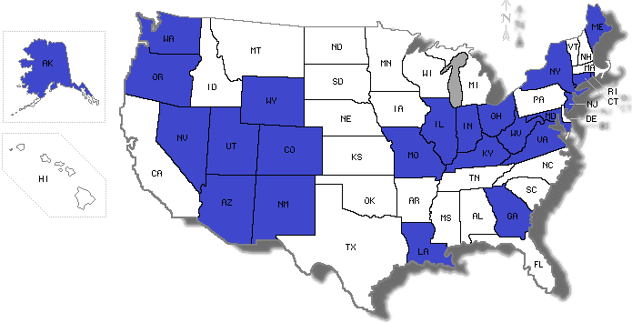 Early Refill Policies Enacted

www.MNeyeMD.org KWMAO@aol.com

