House Commerce, Finance and Policy Committee
Minnesota House of Representatives
St. Paul, MN 55155

Dear Chair Stephenson and House Commerce Finance and Policy Committee Members:
On behalf of the National Marine Manufacturers Association, I would like to thank you for the opportunity to express our strong opposition to House File 1337, Digital Fair Repair
The National Marine Manufacturers Association (NMMA) is the nation’s leading trade association representing boat, marine engine and accessory manufacturers. Collectively, NMMA members manufacture an estimated 80 percent of marine products used in North America. NMMA is the voice of the recreational boating industry, working to strengthen and grow boating and protect the interests of its member companies.
Recreational boating is a major pastime in the state of Minnesota and a significant economic driver. The marine industry provides more than 11,000 jobs between nearly 700 businesses and contributes over $3 billion to Minnesota’s economy. Minnesota is the home of waterskiing, the birthplace of the now ubiquitous pontoon boat, and home to many of the nation’s most popular marine manufacturing companies.
Proponents of the so-called “Right to Repair” legislation want access to proprietary software and specialized tools. They demand access to mechanical, electrical, safety, and emissions features that are incorporated into marine engine and marine electronic products. We firmly oppose these demands. If passed, “Right to Repair” would pose serious threats to the marine industry, and the consumers that enjoy our products.
Providing this level of access to untrained individuals would negatively affect the products’ compliance with federal safety, security, and emission standards. Marine engines can become a dangerous liability if modified. Modifications can cause engine malfunction in open water or on Minnesota’s rivers, putting users, their families, and bystanders at risk of bodily harm. Even attempting basic tasks, an untrained technician can unwittingly cause performance issues, and irreversible damage, and make the engine noncompliant with federal emissions standards. Boaters depend on their equipment to operate reliably, and to navigate them safey through unpredictable and dangerous situations.
The marine industry has invested heavily on cutting-edge innovations that use complex technology to enhance reliability, reduce emissions and increase efficiency. Equipment manufacturers and dealerships have a vested interest in providing the user with a safe, and enjoyable experience. This is why they have invested millions of dollars in educating and training technicians and obtaining certifications that qualify them to properly service these products. Manufacturers put their confidence in certified dealers and technicians to maintain highly specialized engines through their lifetime. With “Right to Repair” legislation, dealers, manufacturers, and consumers lose confidence in this system because it negatively impacts equipment longevity, emissions, and safety for boaters.
For these reasons, NMMA opposes House File 1337 and respectfully asks you to protect the boating industry in Minnesota by voting against its approval in committee. Please contact me at ddickerson@nmma.com if you have any questions.

Sincerely,
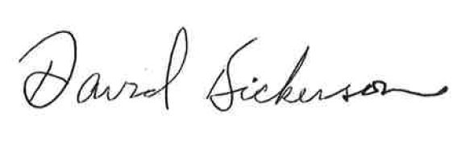
David Dickerson

