This proposal will save Minnesota an estimated $1M per year as costs will be offset by the reduction in state-funded services as they are replaced by federally-funded supportive services.

2017 Minnesota Supplemental Aid (MSA) - Housing Assistance Reform Proposals

Expand MSA-Housing Assistance to support people moving out of a GRH program. [HF866/SF853]
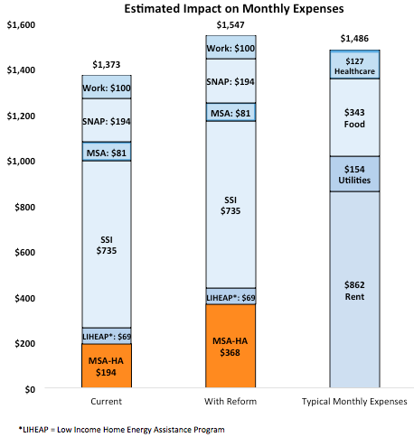
- Minnesotans using GRH who want to move into their own home will be eligible to receive MSA-Housing Assistance.
- The amount of MSA-Housing Assistance will increase to $367.50 per/month.**
- 1 in 3 Minnesotans with disabilities can sustainably afford to live in their own home. Increased housing support is critical to creating a more independent future.
People served and cost:
- An estimated 1,467 people will use the reformed MSA-Housing Assistance to move into or remain in their own home by 2021.
- After 2021, approximately 370 new recipients each month will use MSA-Housing Assistance to live independently.
- Expanding MSA-Housing Assistance will cost approximately $3 million/year, beginning in FY 2020 (with the offset from federally-funded services).

Establish federally-funded housing support services. [HF865/SF852]
- DHS (Department of Human Services) will apply for federal Medicaid (MA) funding for housing services that are currently state-funded; these services will be available to other qualifying Minnesotans, including those receiving MSA-Housing Assistance.
- Over 51,000 individuals with disabilities are living in unstable or segregated settings. Housing services will help some find and maintain their own homes, increasing individual choice and sustainable housing.
People served and cost:
- An estimated 5,088 people will be assisted by federally-funded housing services by 2021.
  - Creating the new housing services will cost approximately $8 million in SFY 2020-2021.
  - Reducing state-funded services that will be duplicative of the new federally-funded services will save the state approximately $13.8 million in the same time period.

Eligibility for Minnesota Supplemental Aid – Housing Assistance and Group Residential Housing

- Minnesota Supplemental Aid (MSA) - Housing Assistance is an income supplement for housing costs available to people with disabilities moving out of certain settings and paying over 40% of their income to housing costs in their own home.
  - 811 people received MSA-Housing Assistance in July 2016.
- Current eligibility requirements for MSA-Housing Assistance:
  - Eligible for Minnesota Supplemental Aid [Age 18 or older, receive Supplemental Security Income (SSI), or eligible to receive it except income is too high].
  - Relocating from an institution or receiving a home and community-based services waiver and living in their own home.
  - Monthly housing costs exceed 40% of gross income.

- Group Residential Housing is a state-funded program that provides housing for adults with disabilities who are low-income or are over 65. Services may also be provided to maintain housing.
- In July 2016, 20,784 people were enrolled in GRH. In FY 2016, 5,841 persons received GRH services, 2,568 of them in their own home.
  - The average GRH payment per person is $634.58/month.

*Sources for Estimated Expenses in Graph:
- Utilities (in budget column): US Dept. of Health and Human Services. LIHEAP Home Energy Notebook for FY 2011. https://www.acf.hhs.gov/sites/default/files/ocs/fy2011_hen_final.pdf
- Utilities (in income): LSS data
- Rent: US Dept. of Housing and Urban Development. 2016. Final FY 2017 Fair Market Rent Documentation System. https://www.huduser.gov/portal/datasets/fmr.html
- Healthcare, Food: Minnesota Dept. of Employment and Economic Development. Cost of Living in Minnesota. https://mn.gov/deed/data/data-tools/col/ (154 for utilities payments)
**One-half of the SSI payment/ currently $194/month authorized by the Federal Food Stamp program.
***Source: https://edocs.dhs.state.mn.us/lfserver/Public/DHS-6143E-ENG; Governor’s 2018-2019 Biennium Budget

