 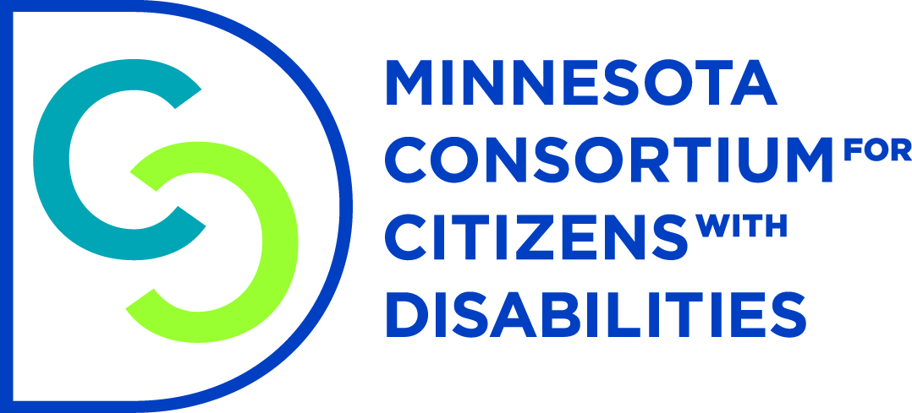

**Advancing Independence of People with Disabilities: Fix the Spenddown**

My name is Rik Seiler and I live in St. Paul. I sustained a traumatic brain injury in 2014 when a car slid into me on an icy patch of Hwy 169 in Shakopee. I had just rescued a 19 year old driver whose car had flipped on that same patch of ice when I was hit. After a 2 month induced coma I had to learn to talk, swallow and eat all over again. A series of infections further complicated my recovery and left me with permanent physical disabilities in addition to my brain injury.

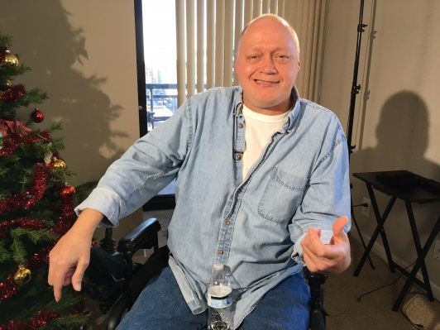

Today, I have limited mobility of my arms and legs, suffer vertigo, short-term memory loss and have a hard time staying organized. It is humbling to admit I now need help paying my bills when I used to be able to balance my checkbook in my head.

I am thrilled that I have regained my independence with the help of Medical Assistance CADI waiver with PCA services, medical transport, meals and an Independent Living Skills worker. I live on about $1,000/month from Social Security Disability Insurance which I paid into working construction for 25 years. **But, because this is over the $990 poverty level I am expected to pay all my medical bills until I have just $792/month to live on.** It feels like I am being penalized for working hard my whole life and paying into Social Security.

I am only able to afford my rent through the generosity of others. One day soon that will end and I am worried that I won’t be able to find housing I can afford and pay my spenddown**. It makes no sense that a program meant to help me live independently puts my very independence at risk by leaving me with so little income to live on.**

**Please fix the spenddown so people with disabilities like me can keep more of our social security income** to pay rent and other living expenses. I went from being a rescuer at the scene of an accident to someone who now needs a helping hand so I can take care of myself and live independently.

**Please Fund HF 225**