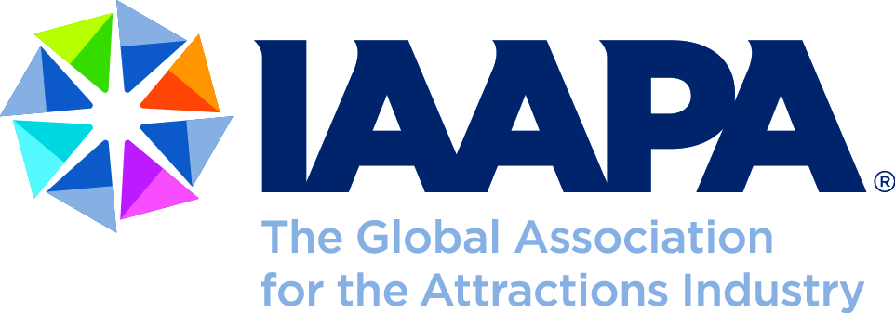

**Objective: Change the Amusement Ride Operator Age Requirement from 18 to 16 Years of Age in Minnesota**

Founded in 1918, IAAPA represents more than 6,000 attraction, supplier and individual members from more than 100 countries. Members include professionals from amusement parks, theme parks, attractions, water parks, resorts, family entertainment centers, zoos, aquariums, science centers, museums, manufacturers and suppliers.

IAAPA is a diverse and dynamic community of global attractions professionals. As the largest international trade association for permanently located attractions, IAAPA unifies the attractions community, connects people to learn and grow together and strives to promote the highest professional standards for excellence and safety around the world.

On behalf of IAAPA’s members in Minnesota, IAAPA seeks to change the current amusement ride operator age requirement of 18 years of age to 16 years of age, the federal standard.

The majority of U.S. states allow for ride operators to be 16 years of age and IAAPA is aware of no data that suggests that the safety of these operators or the guests who experience their attractions is adversely affected as compared to an older operator.

IAAPA’s position is that all rides need to have equally capable ride operators and that those operators can be 16 years old. If they are old enough to be trusted with operation of a car on a public road or agricultural equipment, they should be trusted with operation of a ride that has a far more robust safety system than is present on any motor vehicle or farming equipment. Indeed, unlike a motor vehicle driven by a 16-year-old driver, the operation of the vast majority of amusement rides cannot be significantly altered by the ride operator. Ride speed, dispatch function, and restraint function are generally automated as part of the ride safety system precisely so that each rider has a uniformly safe experience each ride cycle. Operators, of course, have the ability to stop a ride whenever necessary, but a 16-year-old ride operator has far less opportunity to alter or control the ride function than a driver of a car

Prohibiting 16- and 17-year-olds from operating rides significantly reduces the available pool of workers available to attractions. IAAPA’s members’ businesses are largely seasonal and therefore depend heavily upon workers with the willingness and availability to work only a few months each year during the late-spring, summer, and early-fall months. These are entry-level positions, generally offering no benefits typically associated with year-round, full time work such as health insurance or retirement plans and paying entry-level wages.

The current minimum age for ride operators creates a burden on employers who are challenged with finding sufficient numbers of qualified adults willing to only work a few weeks or months at a time for entry-level wages and benefits. Given their academic calendars, however, 16- and 17-year-old high school students represent an ideal segment of the population to fill these positions. They are most frequently available during the attractions industry’s summer season and are amenable to entry-level work. The attractions industry in Minnesota has hundreds of openings for ride operators each year. Expanding these opportunities to 16 and 17-year-old individuals would expand employment opportunities and alleviate the burden on attraction owners of filling these positions.

The attractions industry trains its ride operators well and requires them to adhere to exacting ride operating industry standards. It is this training and management that makes the attractions industry one of the safest in the country, not the age of the ride operators. We, therefore, request that the minimum age of ride operators in Minnesota be lowered from 18 years old to 16 years old.

**IAAPA Government Relations Office – 2111 Eisenhower Avenue, Suite 304 – Alexandria, VA 22314 – United States**

**Tel: (703)/299-5758 – Fax: (703)/299-5758 – E-mail: GR@IAAPA.org – www.IAAPA.org**