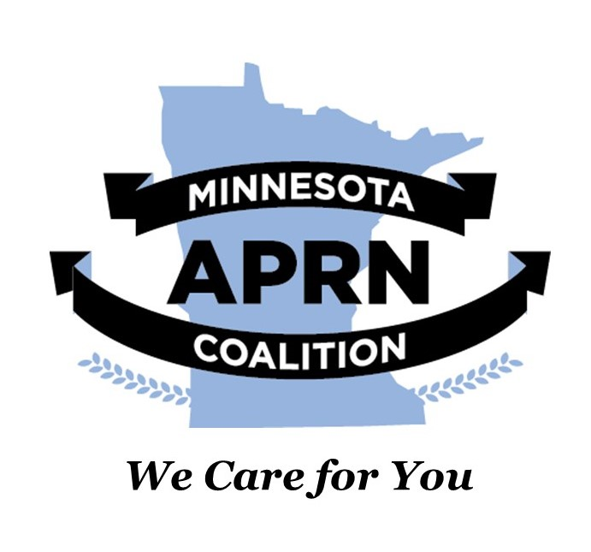

March 1, 2022

The Minnesota Advanced Practice Registered Nurses (APRN) Coalition and the Minnesota Nurse Practitioners (MNNP) organization heartily endorse **HF 3696: Health data collection and use provisions modified,** on the modification of health data collection and use provisions, and endorse a study and report on the systems used to pay health care providers.

Advanced practice nurses are committed to improving population health by:

* Rethinking healthcare infrastructure
* Expanding payments for primary care services
* Strengthening the primary care workforce

Nurse practitioners (NP) account for a large percentage of the workforce that delivers primary care. According to the American Association of Nurse Practitioners (AANP), 88.9% of NPs are certified in an area of primary care, and 70.2% of all NPs deliver primary care. The vast majority of NPs (69.7%) provide care to patients across the lifespan (AANP, 2021). According to the Minnesota Board of Nursing (2022), there are 10,746 licensed advanced practice nurses in the state. Of these, 71% (~7,682) are NPs and roughly 48% work in ambulatory settings. Certified Nurse Midwives also provide women’s primary healthcare with the American College of Nurse Midwives reporting that over 52% of midwives report primary care provision in their current practice (ACNM, 2012).

Providing whole-person care is a key tenet of primary care. This has long been a core value of professional nursing and advanced practice registered nursing. Our emphasis on health promotion and wellbeing and the provision of patient-centered care is reflected in our commitment to primary care. We, therefore, support HF 3693 and ask the legislature to support it as well.

Sincerely,

S:\it\Local Settings\Temporary Internet Files\Content.IE5\ENR7H8UB\CAP4KCY4.gif 

Sara McCumber, DNP, APRN, CNP, CNS Brian K. Goodroad, DNP, APRN, CNP, FAANP

President President

Minnesota Nurse Practitioners Minnesota APRN Coalition