February 9, 2023

House Health Finance and Policy Committee

100 Rev. Dr. Martin Luther King Jr. Blvd.

Saint Paul, MN 55155

Dear Chair Liebling and Members of the Committee:

The Minnesota Council of Health Plans, the trade association for Minnesota’s nonprofit health plans (Blue Cross and Blue Shield of Minnesota, HealthPartners, Medica, Sanford Health Plan of Minnesota, and UCare) works every day to support access to high-quality affordable health care. Our nonprofit members structure their products to balance the increasingly expensive cost of accessing care. Minnesota currently offers some of the lowest premiums in the country and maintains a high rate of coverage.[1]

It is important to note that the Minnesota Legislature regulates the individual market, the small and large group markets, SEGIP, Medical Assistance (Medicaid), and MinnesotaCare which comprise approximately 43% of the marketplace. The remaining market, including employer sponsored self-insured coverage, Medicare, and TRICARE are regulated by federal law and will not be impacted by HF 390.

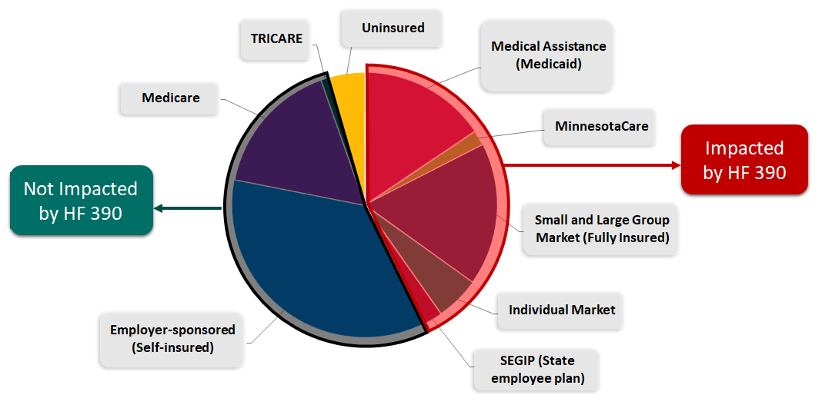

Health plan products include premiums, copays and other out-of-pocket costs that reflect the underlying costs to pay providers to deliver care. HF 390 would prohibit a health plan from designing a product which associates cost sharing for procedures following an initial mammogram. These are not defined and could include mammograms, pathology, biopsies or other secondary procedures. The bill does not require providers to lower the actual cost of these procedures. Without an accompanying lowering of the cost of those services, health plan products will need to shift these costs into premiums or cost sharing for other services to stay compliant with federal and state regulations.

Health plan design is highly regulated and some have actuarial values and cost sharing ratios set by federal and state laws. For example, a Silver level plan on the Individual Market is required to have a 70%/30%, premium to cost sharing ratio. If the procedures targeted by HF 390 no longer goes towards that 30%, cost sharing will need to be increased or applied to other health care services.

|  |  |  |
| --- | --- | --- |
| **Plan Category** | **Premiums** | **Cost Sharing** |
| Bronze | 60% | 40% |
| Silver | 70% | 30% |
| Gold | 80% | 20% |
| Platinum | 90% | 10% |

We look forward to working closely with you on this proposal to support Minnesotans with broad access to high quality care.

Sincerely,

Lucas Nesse

President and CEO

1. Kasier Family Foundation, Health Insurance Coverage of the Total Population <https://www.kff.org/2fdbf6d/>; Kasier Family Foundation, Average Marketplace Premiums <https://www.kff.org/db70157/>