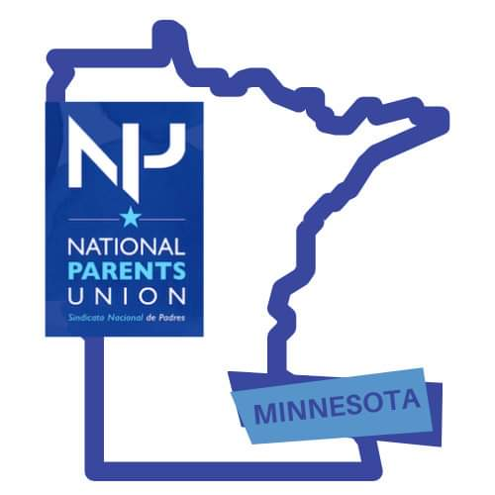
February 4, 2023

Dear members of the Health and Human Services Conference Committee,

National Parents Union, as members of the Voices and Choices for Children Steering Committee and Coalition strongly asks you to include the Community Solutions for Healthy Child Development Grant Program in the final version of the Omnibus Health and Human Services bill. This historic program focuses on improving measures of well-being for children of color and American Indian children in Minnesota prenatal to age 8 through a community and equity-centered approach across the state. Our coalition focuses on shaping more equitable practices and policies that will support better outcomes for children of color and American Indian children prenatal to 8 years old across the state. More than ever, we want to ensure every Black, Indigenous and child of color and their families in Minnesota are valued in systems and in society in a way that allows for them to have equitable access to resources that celebrate and affirm their cultural background, race, ability, and experience so that they have opportunity to thrive and live their fullest lives.
The grant program, housed in MDH’s Center for Health Equity, is guided by a Community Solutions Advisory (CSA) Council comprised of 12 community members who bring professional expertise and lived experience in racial equity, early childhood development and advocacy. The council has been involved from the beginning of the grant program from RFP creation, reading and scoring applications, and ongoing support and advocacy for more streamlined implementation and processes. The amazing grantees have also shown the diversity of ideas that center community needs.

For example, there are three different grantees working on language immersion and they approach it in ways that really speak to and involve children, families, and community. We can only imagine the many other ideas in the state of Minnesota to approach language immersion and other topics around social determinants of health. It is time to increase the state’s investment in community solutions and listen to the voices of community members who for too long have said that solutions for significant challenges facing children and families should come from communities closest to those challenges and closest to leverage local assets to make meaningful change.We strongly encourage you to give this innovative program the permanent adequate funding needed to fully deliver on its promise. Minnesota has the need and Minnesota has the resources.
We need to leverage more community led solutions beyond the pilot group of grantees as an upstream way to support children and

Thank You

Khulia Pringle
Minnesota State Director
National Parents Union

