Twenty-five years ago, PRO.C.E.E.D. was founded as Progressive Center for Education and Economic Development. Initially, it worked to provide low-income housing for Eastside and other St. Paul residents. PRO.C.E.E.D. also founded the Progressive Early Childhood Education Center more than a decade ago to provide early education for urban youth and the largest Black college tour in MN to expose urban youth to post-secondary options. Currently, PRO.C.E.E.D.’s outreach programming has expanded to address the needs of the Eastside and now focuses on 5 areas: 1) Employment, 2) Education, 3) Youth Enrichment, 4) Health, and 5) Civic/Community Events.

1. Employment:
For 7 years, PRO.C.E.E.D. has held the Progressive Job, Career and Resource Fair. Over fifty (50) employers attend this annual event, along with nearly 700 potential employees. Potential employees are offered résumé writing classes as well as instruction on staying employed long term. The organizers have also been successful in connecting felons with felony friendly employers (e.g., trade unions—iron workers union, carpenter’s union, etc.). Many of these individuals have been a part of a pre-apprentice program through Summit-OIC, with whom PRO.C.E.E.D. has had a formal relationship for close to a decade—providing daily transportation from St. Paul to Summit-OIC’s pre-apprentice programming. The new youth complex will allow Progressive to add two new features to its employment initiative—a workforce center and a mobile office.

2. Education:
PRO.C.E.E.D. has 5 educational programs to guide urban youth in their efforts to make good choices in the future. First, the Progressive Early Childhood Education Center was built on the premise that early intervention is the key to addressing the educational disparities between kids of color and their white counterparts. The graduates are kindergarten ready, and some are reading at the first and second grade levels entering into kindergarten. Secondly, PRO.C.E.E.D. has established a long-term relationship with Skylearn Educational Software Company. Using MN State standards, the diagnostic software assesses the true grade level of a child in math and reading, and then provides a clipboard of lessons to bring the student up to grade level. Students who are on the program for the prescribed 40 hours and within the appropriate timeframe experience significant gains. Thirdly, PRO.C.E.E.D. offers a tutoring lab for Eastside youth that has been staffed with U of M students, Page scholars and Progressive members. Fourthly, PRO.C.E.E.D. holds an annual college fair and a college tour for students and their parents. The college fair is carried out in conjunction with St. Paul Public Schools and the college tour has successfully taken youth around the country to Historically Black Colleges and Universities for the past 15 years. Literally 1000s of Twin City youth have benefitted from this programming as they have been exposed to post-secondary options and given the tools to succeed. In fact, many of these youth go on to attend many of the colleges they have visited. Lastly, PRO.C.E.E.D. has entered into close partnership with the Minnesota STEM Partnership, who exposes urban children to computer programming, robotics, construction of drones and so on, all with an eye toward their importance to Artificial Intelligence to our modern economy. As a result of this partnership, in 2018, PRO.C.E.E.D.’s team took 5th place out of 31 teams, held at Capitol Hill Elementary School. The students were featured on the Fox Morning Show.

3. Youth Enrichment:
PRO.C.E.E.D. has an array of youth enrichment programs for community youth in the summer and throughout the school year. Programming like robotic, the tutorial lab, Girl Scouts, the stepping troop and so on, operate throughout the summer months and the school year. During the summer, however, PRO.C.E.E.D. runs a series of summer camps and partnerships with other organizations.

4. Health:
Over 15 years ago, P.R.O.C.E.E.D. implemented a health program to address the notable health disparities that exist within the African American community. This problem is particularly acute in the area where P.R.O.C.E.E.D. is housed. It is called a “health care desert” by healthcare providers and others since there is no health clinic within 5 miles. P.R.O.C.E.E.D. has partnered with M Health Fairview to provide community COVID-19 vaccination clinics and other services onsite at Progressive Baptist. With support and guidance from M Health Fairview, P.R.O.C.E.E.D is planning to place a functional clinic in its youth complex. This clinic, along with the P.R.O.C.E.E.D.’s wrap around services, will go a long way to help community members find primary care and get the healthcare that they need. Secondly, in conjunction with Whole Foods and Trader Joes, the Fishes & Loaves Food Shelf (TEFAP certified) brings healthy and organic foods to children and adults in the urban core.

5. Civic/Community Events:
PRO.C.E.E.D. has hosted some of the cities most important civic, cultural and community events. The new complex will enable PRO.C.E.E.D. to expand its tradition of community and multi-cultural conversations. Some of the events already hosted onsite are as follows—the Chief of Police Forum, St. Paul Superintendent Forum, Quinceañeras, Community Healing event with death of Philando Castile, Hmong Political Pac, Voting Site, etc.

The youth complex accomplishes several things. First, it will provide a place for Eastside youth to engage S.T.E.M. camps and activities, building go-carts, engaging in Lego robotic competitions, gaming programming, and building and flying drones. It will also provide spaces for community youth to get tutored young adults from area colleges as well as community members. The gymnasium will house team sports (i.e., basketball, volleyball, soccer, etc.), which is of critical importance, given closure eastside recreation centers and current budget restraints. The complex will have 5 classrooms, a computer lab/workforce center, a walking track, a workout center, and a permanent place for the food shelf. Lastly, it will house a health clinic to address the tragic health disparities (primary care, infant mortality, a youth mental health crisis, etc.).

This new complex will cost approximately $7 million to build. Due to generosity of donor and stakeholders—including $60,000 from the City of St. Paul—Progressive has raised over $300,000 towards this effort.

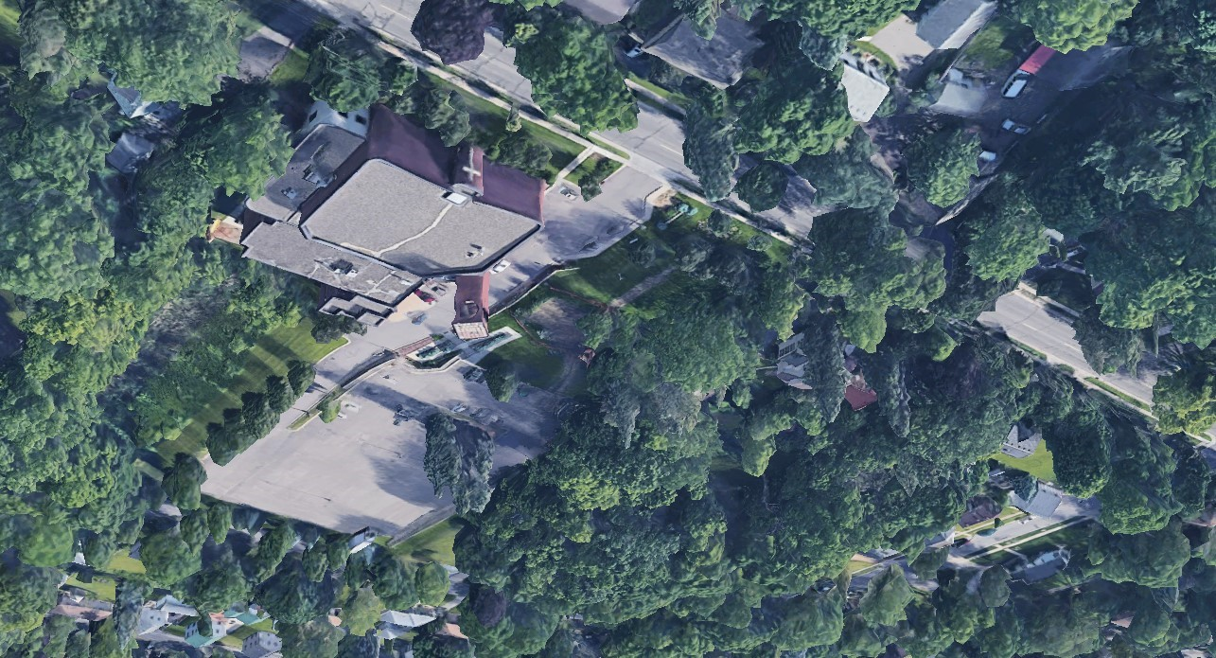
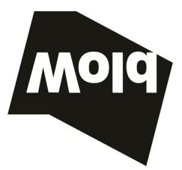
\\wae-srv-mndata\ED_PRIVATE SCHOOLS\PRI-Progressive
Baptist\Concept Drawing.rvt
/19/2022 7:56:49 PM
1
Progressive Baptist
Facility Planning
DRAFT January 19, 2022
Comm No: 9999
2
M HEALTH
CLINIC
GYM WITH
WALKING
TRACK
FOOD
SHELF
BLDG
SUPPORT
LOBBY

PBC PROGRAMING

One recreation center did reopen on a limited basis. See how this step has helped to reduce crime in that area. https://www.twincities.com/2019/04/02/st-pauls-highwood-hills-rec-center-reopens-11-years-after-closing-due-to-budget-cuts/
There is no health clinic within 5 miles of the church, which is unprecedented.

