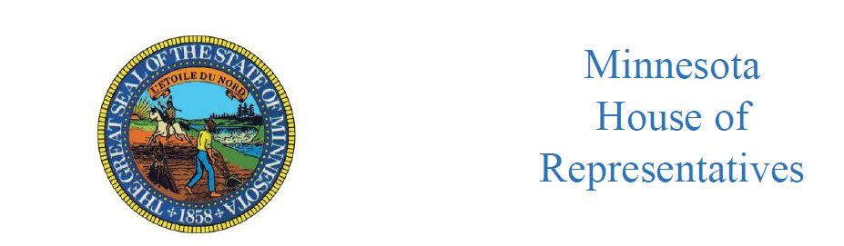
Mike Sundin
State Representative
District 11A
Agriculture Finance and Policy Committee
Representative Mike Sundin, Chair

June 14, 2021
8:30-10:00 PM
Remote Hearing

AGENDA

This remote hearing is taking place pursuant to Rule 10.01.
I. Call to Order

II. Roll Call

III. Informational hearing on House/Senate Chairs Ag/Broadband Finance Agreement
- Walkthrough by Ken Savary, House Fiscal Analysis

IV. Adjourn

