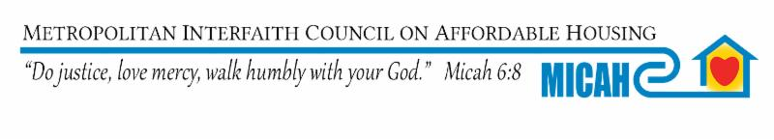
Dear Chair Pinto and Members of the Children & Families Finance and Policy Committee.
MICAH supports HF 1858.

MICAH has been advocating and working to end homelessness for 35 years. Our members prevent and end homelessness as we create welcoming communities to ensure everyone, without exception, has a safe, decent, accessible home (rental or homeownership) that is affordable at their income and meets their needs.

We greatly appreciate Representative Keeler, Chair Pinto along with other members of the committee for being supportive of the Safe Harbor and youth survivors of sex trafficking.

We are writing this letter in support of HF 1858 which would provide additional critical resources for some of the most vulnerable people in our state-youth who are being sex trafficked.

Thank you for your leadership and bringing this bill forward.
Together, we can Bring Minnesota Home NOW!

God’s peace,
Sue Watlov Phillips, M.A.
Executive Director, MICAH

MICAH 463 Maria Ave. St. Paul, MN 55106 651-646-0612 www.micah.org

