FAIR REPAIR HF1337/SF1598

**Minnesota Supports the**

**Fair Repair Act!**

**Problem:**

Manufacturers use software locks and other gimmicks to make certain repairs only possible through authorized dealers. This is hostile to “Main Street” business, increases E-waste and takes away individual choice.

**Solution:**

The Fair Repair Act would require manufacturers to make repair manuals, tools and parts available for purchase by consumers and independent repair shops. The bill covers electronic devices such as cell phones, laptops, household appliances, farming equipment, etc.

**Results:**

* Gives Minnesota individuals freedom of choice – especially in Greater Minnesota – of where to bring electronics for repair.
* Supports and grows tech jobs across spectrum of Minnesota industries.
* Guarantees free market access.
* Reduces growing amount of E-waste for local governments to handle.

  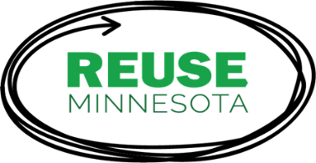

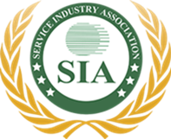 

 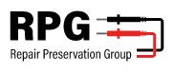  

**Arguments Against HF1337/SF1598 ARE NOT Correct:**

* HF1337/SF1598 is based on 2012 Massachusetts auto industry fair repair law.
* HF1337/SF1598 does not violate U.S. copyright law. US Copyright Office has ruled that manufacturers cannot use Digital Millennium Copyright Act to prevent owners from taking apart and repairing their own devices.
* HF1337/SF1598 does not create cyber security risks to individuals and/or larger entities. Trade secrets are protected.
* HF1337/SF1598 does not alter Minnesota’s liability laws.
* HF1337/SF1598 does not pose extraordinary danger to individuals fixing cell phones.