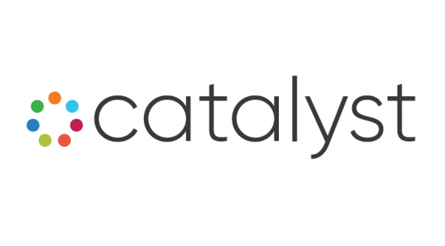

Catalyst is a consortium of five Minnesota-based organizations that support minority entrepreneurs and their businesses through providing technical assistance, consulting, and funding resources.

Our mission is simple - to help Minority Business Enterprises Succeed.
---

African Economic Development Solutions (AEDS) is a nonprofit organization that serves African immigrants in Minnesota. The mission of AEDS is building wealth within African immigrant communities to improve the economic status and quality of life of African immigrants in Minnesota.

Gene Gelgelu, President + CEO, AEDS
www.aeds-mn.org

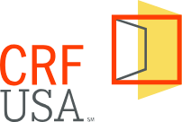
The Community Reinvestment Fund- USA is a national level organization headquartered in Minnesota with strong relationships built between banks, other Community Development Financial Institutions (CDFIs), small businesses, nonprofits, and philanthropic institutions across the nation. As a mission-driven organization, CRF prioritizes delivering capital to those that need it most – the nonprofits and small businesses that are located in, or provide services to, low- and moderate-income communities. CRF has funded over 1000 loans in all fifty states, totaling more than $3.5 Billion. We do this in partnership with a network of more than 200 local development organizations across the country. As a result, CRF understands that several diverse product offerings and resource support mechanisms must be utilized for the immediate survival and long-term recovery of small businesses and nonprofits

Frank Altman, Founder + CEO, CRF
www.crf.usa

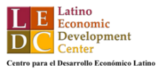
The Latino Economic Development Center (LEDC) was founded by Latinx entrepreneurs and community members who recognized the need for culturally and linguistically competent economic development services - the type of services that could help recent immigrants bridge gaps in knowledge and understanding and help them develop assets that would enable them to achieve self-sufficiency.

Henry Jimenez, Executive Director + President, LEDC
www.ledcmn.org

The mission of Metropolitan Economic Development Association (Meda) is to help minority entrepreneurs succeed. Our vision is thriving communities through equal economic participation. Meda's three main accelerator services provide the tools and resources crucial for business scaling, including: access to capital, access to trusted business advising, and access to contracts.

Alfredo Martel, President + CEO, MEDA
www.meda.net

The Northside Economic Opportunities Network (NEON) is an economic development organization located in north Minneapolis. Our mission is to build wealth for low- to moderate income entrepreneurs in North Minneapolis and surrounding communities.

Warren McLean, President, NEON
www.neon-mn.org
---
Minnesota Inclusive Growth Fund

The Minnesota Inclusive Growth Fund is designed to equip community small business lenders (primarily minority, veteran an women owned facing) with the support required to meet the unique rebuild and recovery needs of their communities.

- Liquidity - Enables participating CDFIs to focus on new lending in their communities by providing them with liquidity and mitigating on-balance sheet risk.

- Low Cost/Flexible Capital - Provides CDFIs with the low-cost and flexible capital required to offer deeply affordable and flexible loans to small businesses (5% interest rate).

- Operational Support - Provides CDFIs with the financial resources through the origination fee and servicing fee to ensure they have operational capacity to execute on a high volume of loans.

- Sustainable and Scalable Partneships - Builds a scalable source of financing that leverages and combines existing infrastructure, networks, and relationships to activate new recovery lending.

