Representative Morrie Lanning
Minnesota House of Representatives
Room # 379, State Office Building
100 Rev. Dr. Martin Luther King Jr. Blvd.
St. Paul, MN 55155

March 17, 2011

Dear Representative:
The Association of Minnesota Counties (AMC) recognizes the economic and societal benefits of public/private collaborations and supports policies that encourage partnerships between government and non-government entities that address the needs of our communities. H.F. 1063 is consistent with that position and counties are supportive of allowing counties the option to have the county audit performed by a certified public accountant firm that meets the requirements of Minnesota Statutes 326A.05.
Counties have generally been very pleased with the quality and value of the work conducted by the Office of the State Auditor (OSA). Auditor Otto has been extremely proactive in reaching out to local governments during her time in office which has helped educate local government officials on compliance issues as well assist them in finding ways they can take action locally to drive down the costs of audits conducted by the OSA. Our position on this issue is longstanding and predates the current state auditor and AMC’s support for this legislation should in no way be interpreted as a condemnation of the OSA or the work of its employees.
AMC believes it is critically important that this legislation remain permissive and not mandate the use of a certified public accountant firm to conduct the audit. Counties should have the flexibility to find the most cost-effective way to conduct the county audit whether that is through the OSA or the private sector. Some counties were directed to use private certified public accounting firms in response to budget reductions to OSA in 2003 and since that time some of those counties have found private audits to be more cost-effective.

Sincerely,
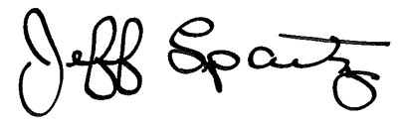
Jeff Spartz , AMC Executive Director
651-789-4325
jspartz@mncounties.org

