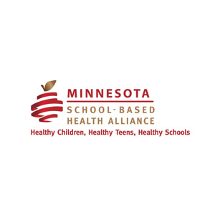

March 25, 2022
Re: HF 4398 and School Based Health Centers

Dear Chair Liebling and members of the House Health Finance and Policy Committee,

We are seeking your vote for HF 4398, and wish to express our gratitude for inclusion of language in support of School Based Health Center programming. School-based clinics have been strongholds of accessible, equitable and comprehensive preventive care for students in Minnesota for 50 years. If passed, this legislation would be the first state policy and dedicated funding to support school-based health centers in that time. As the only part of the health care safety net dedicated entirely to children, your vote for HF 4398 with inclusion of SBHCs at this pivotal time will be historic.

The gold-standard model for school-based clinics had its genesis here in St Paul, Minnesota, and is now codified in federal statute. Today, over 2,200 school-based clinics operate across the United States. Until 2022, our local School Based Health Alliance was a voluntarily coalition of the leaders who operate school-based clinics in Minnesota. There are now 27 in existence and at least 10 in development in our state. The Alliance represents and supports each of the health care providers and districts partnering in school-based health care.

The Alliance is a long-term community partner of the Minnesota Department of Health (MDH). MDH has provided a convener to support this work since 2015 when the Alliance became an official affiliate of the national School Based Health Alliance. In January, MDH extended a CDC COVID Workforce grant to the Alliance, now a nonprofit, to assist schools with pandemic recovery. During distance learning, the mental health therapy, medical care, nutrition services, health education, and parent support delivered in Minnesota’s school-based clinics proved SBCs are a durable part of the health care safety net. HF 4398, with inclusion of language specific to School Based Health Centers, supports continued growth of this critical part of Minnesota’s safety net and pivotal partnership with MDH.

Evidence shows partnership between a local Alliance and a state program office like MDH, and dedicated state funding for new and existing school-based health initiatives, correlates with expansion of care for kids, decreases Medicaid costs and increases school success. Growth has been slow in Minnesota compared to most other states. This is a critical time to change that, particularly in rural areas where one school-based clinic can offset care shortages for an entire community. This bill allows school-based clinics to be here for kids as they recover from the pandemic, a time when their needs are critically underserved and increasingly acute.

The ROI on school-based care is irrefutable. Care within SBHCs is not a replacement for the allied health professionals in schools such as Licensed School Nurses, School Counselors, and Social Workers. Simply said, their co-existence creates ease for families and optimizes learning. Expanding this to more children is a key lever for reducing disparities in education and health outcomes for children in Minnesota.

Thank you,
Shawna Hedlund
Executive Director
MN School Based Health Alliance

