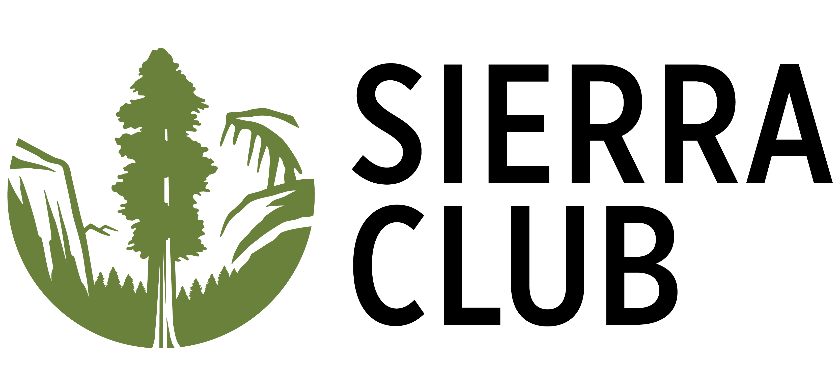

March 8, 2023

Re: HF1419 - support

Dear Representative,

Sierra Club strongly supports Minnesota continued funding of the Department of Health’s Skin Lightening Products Public Awareness and Education Grant program, as outlined in HF2236. Minnesota urgently needs to provide ongoing and community-based support to Black and other people of color communities who are the target of racist and colorist pressures to lighten their skin.

The grant program would support public awareness and education to reduce use of highly toxic skin lightening products. Minnesota has been one of the states on the forefront of this important issue in its efforts to end the use of mercury and hydroquinone-based skin products, and halt retail sales of illegal products. We support Minnesota’s focus on education, and addressing the root causes of skin lightener use. Yet, ongoing efforts are necessary to avert these harmful exposures within our communities.

Skin-lightening creams harm Black women, other women of color including those from the Global South. These products are used repeatedly, and often over large portions of the body, leading to skin damage and other health risks. Mercury-based products pose additional risks if used during pregnancy. US laws set limits on mercury and hydroquinone concentrations, but illegal products are too easily available. In addition to small stores targeting recent immigrants, some products are also available for purchase online.

The fact is that these highly damaging products are only available because they are marketed to Black and Brown people and used to uphold racist beauty norms that favor people with lighter skin. As a result, Minnesota must invest in efforts to develop culturally and linguistically-appropriate educational efforts for communities where there is on-going social and community pressure for people to lighten their skin.

Thank you for your attention to this serious issue,

Sonya Lunder, MPH
Senior Toxics Policy Advisor
Sierra Club
sonya.lunder@sierraclub.org

