Profile of HIV in Minnesota

In 2015, 294 Minnesotans were newly diagnosed with HIV

8,215 Minnesotans are living with an HIV diagnosis

Minnesota HIV Treatment Cascade

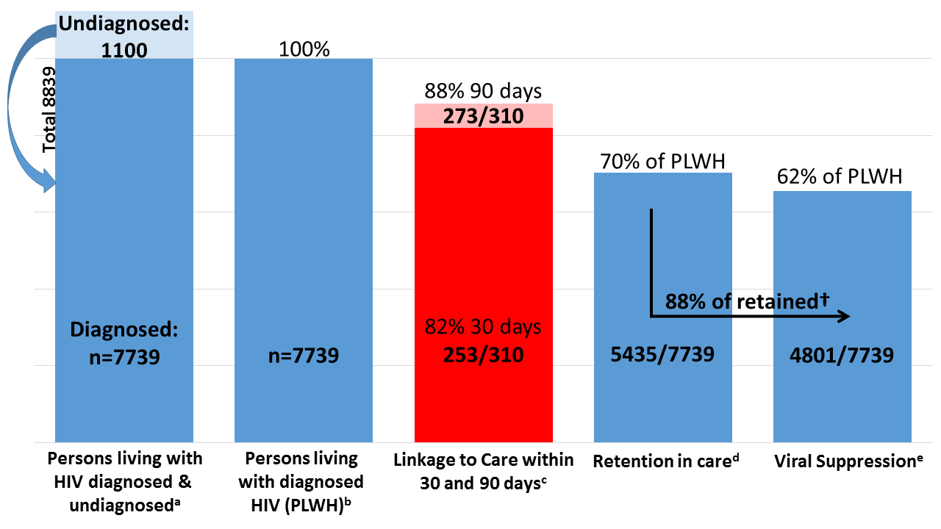
The HIV Treatment Cascade demonstrates steps in care from diagnosis to viral suppression and where people are lost to care. Ultimately, roughly half of HIV positive Minnesotans achieve viral suppression.
HIV by the Numbers
•By Location: 38% of people live in Minneapolis, 33% in Suburbs
13% in St. Paul and 16% in Greater MN
•76% of people living with HIV are men and 24% are women
•African Americans are 10x more likely than whites to become infected with HIV
•African-born residents are 16x more likely to become infected with HIV
•5% of gay and bisexual men in Minnesota are HIV positive
Comprehensive Plan to End AIDS | 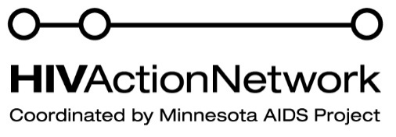

MN Comprehensive Plan to End AIDS
SF847 (Dibble)/ HF2047 (Franke)

The MN Comprehensive Plan to End AIDS requires the Department of Health, in coordination with the Department of Human Services and community stakeholders, to develop a strategic, statewide plan to address the state’s HIV epidemic by significantly reducing the number of new infections and ensuring that all individuals living with HIV access and maintain necessary medical care.

Why is this needed?
- Minnesota continues to see roughly 300 new HIV infections every year, and has for more than15 years.
- 300 new infections a year is unacceptable.
  - We have the knowledge and tools today to significantly reduce new infections. We need a coordinated government and community response to make this happen.
- Every new HIV infection costs Minnesota roughly $400,000 in lifetime medical costs.
  - Every year, 300 new infections adds $120,000,000 in expected state medical costs.

What does the bill do?
- Requires Commissioner of Health to submit a report to the legislature by February 1st 2018
- The report must identify strategies to reduce new HIV infections by 75%
- The report must identify strategies to increase the percentage of individuals living with HIV who know their serostatus to 90%, increase the percentage of people living with HIV who are receiving HIV treatment to 90% and increase the percentage of people living with HIV who are virally suppressed to 90%
- The report must provide recommendations for optimal allocation and alignment of resources
- The report must provide recommendations to ensure a coordinated statewide response
