April 11, 2018
Dear Health and Human Services Finance Committee Members,
Minnesota Partners to End Hunger opposes HF 118. This bill creates a $3,500 asset limit for seniors and people with disabilities and a $2,250 asset limit for everyone else, with one car excluded.
Minnesota is currently one of 35 states that has eliminated SNAP asset limits. We don’t want to move backwards and make it more difficult for people to apply for benefits and for counties to administer. Asset limits are the most complicated and administratively burdensome part of the application and renewal process. County workers must spend time verifying that assets are below the maximum and applying sanctions on households who exceed the limit. People are often terminated for a lack of paperwork verification.
This bill would affect thousands of seniors and working poor in our state. We are not in favor of limiting someone’s access to SNAP when a temporary setback—like an illness or job loss—means they must zero out their banking account to be able to put food on the table.
Asset limits discourage good financial habits, and don’t allow families to have access to savings to help buffer against unexpected expenses – like a home repair or a health care bill. We want to encourage households to build assets. Asset limits send the message that people should spend and not save for their future.
Minnesota Partners to End Hunger urges you to not support HF 118 because we are not in favor of taking food off the table for many seniors and working poor in our state.
Sincerely,
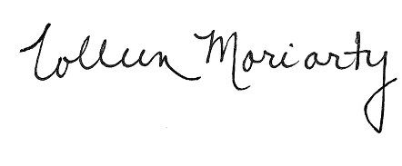
Colleen Moriarty
Chair, Minnesota Partners to End Hunger

