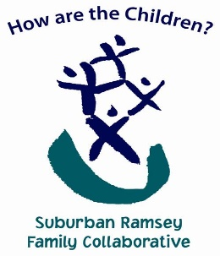
March 20, 2023

I am writing to express support for bill HF 2930 Article 2, Section 68 ADOLESCENT MENTAL HEALTH PROMOTION because young people need opportunities to develop skills to thrive and experience positive mental health, including opportunities to engage with supportive adults and peers and skills to manage daily stress and make responsible decisions.

Since 2009, Minnesota’s adolescent population has reported increased rates of mental health concerns, including increased rates of stress, anxiety, depression, hopelessness, and suicide. Reports of psychological distress doubled during the pandemic and inequities intensified among Minnesota’s Black, Indigenous, and populations of color, LGBTQ+, and rural populations.
Our young people need access not only to more mental culturally relevant health resources but resources for building out resources in their own communities. This parallels the alarming increase in suicidal ideation, substance abuse, and mental health-related ED visits we’re seeing in our work with the schools and the Ramsey County Children’s Mental Health Collaborative (RCCMHC). Less than half of those with symptoms of a mental illness will get the help they need as there are greater disparities in under-represented populations. In addition, there are new barriers and obstacles serving youth and families in the schools. These include, fear of illness (e.g. COVID 19, flu, RSV, etc.), families seeing school as optional after the pandemic, the political divide that has created a sense of tribalism, ongoing school-based traumatic events such as school shootings/stabbings, and a distrust for history and fact.

Because complex needs require a complex, multi-system response, the Suburban Ramsey Family Collaborative (SRFC) collaborates very closely with the Ramsey County Children’s Mental Health Collaborative and all public school districts in Ramsey County. This work involves planning and supporting Joint Health and Wellness and Basic Needs Resource Fairs such as Quarterly Financial Health and Wealth Creation Resource Fairs, Monthly EC Jam Sessions for families with children in early childhood, Basic Needs and Wellness Resource Fairs, and Expanded Countywide Community Resource Navigator Monthly Meetings. We also Co-Facilitate Bi-Monthly Crisis Response/De-Escalation Countywide Peer Learning Team where we’re working across multiple systems to address mental health and chemical health access barriers, and lastly we co-Facilitate the NEW! School Linked Mental Health (SLMH) Collaborative Pilot Project and SLMH Task Group and provide Rapid Response Support for practitioners working on complex issues to support families with complex, multi-system needs. Helping our providers work together on complex cases creates solution- and confidence building for both providers and families. We have been able to resolve issues together where there were challenges that seemed insurmountable alone. Our buddy system gives everyone hope in the hardest of times.

During the pandemic, RCCMHC and SRFC have worked very closely together as the needs of the community and providers were so great. We combined budgets and services where possible to ensure that families had continuity of care during these very difficult times and practitioners and partners had rapid, reliable and responsive support. In November of 2022, RCCMH and SRFC launched a new Collaborative SLMH model using a system platform through JotForm that was collaborative and included whole family approaches that providers would want to support and schools would find responsive. This portal creation was based on all the things Parents, Schools and Providers were asking for; whole family approaches, rapid access, streamlined referrals, coordinated services and care teaming, provider funding that honors the real costs of holding appointments for families, and comprehensive support required to ensure that families are successful in accessing services both in stabilization therapy and pathways thereafter. This Collaborative SLMH complements the School Based Mental Health services of the DHS grant and very often intersect when looking for ‘best fit’ resources for families.

The volume and acuity of needs we are seeing both in the School Based and Collaborative School Linked models have exponentially increased with families over the pandemic. The combined needs in HOUSING, MENTAL HEALTH AND EMPLOYMENT that we’re seeing with every family we’re working with behooves us to work together across systems, increasing and embedding staff where possible, integrate our expanded services at every level to meet the needs of our times.

For these reasons, we urge you to support HF 2930.
Thank you,
Sincerely,
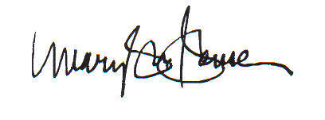

Mary Sue Hansen, Suburban Ramsey Family Collaborative Director, Pronouns: She/Her
The Suburban Ramsey Family Collaborative (SRFC) Providing an umbrella of resources and support to Suburban Ramsey children, youth and families. We are Stronger and Better Together! www.HowAreTheChildren.org

