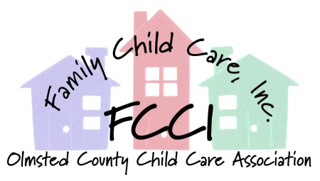

February 8, 2017

Dear Madam Chair and members of the Subcommittee;

We are writing to encourage you to support HF xxxx (Franson) Exemption from positive supports strategy rules.

Licensed providers are also responsible for the supervision and safety of all children in the program. The positive supports strategy rule hinders providers from protecting the safety of all children in the program with developmentally appropriate behavior guidance. Most children can be guided through their big emotions with calm conversation, redirection, distraction, or engaging the child in another activity. However, big emotions can rapidly escalate and turn into hitting, kicking, pinching or biting another child. The positive supports strategy does not allow for quick intervention by the provider to guide or move the child away from the escalated scene to another space to calm down and work with the provider.

We must be able to ensure that providers may continue to use developmentally-appropriate practices to ensure all children's safety.

Thank you for your consideration,

Sincerely,

Ariane Bromberg
FCCI Advocacy Chair

Jessica Tukua
FCCI President

Established in 1973, FCCI is an organization of licensed family child care providers in Olmsted county committed to developing and promoting high quality child care in our community through education,
resources, and support.

