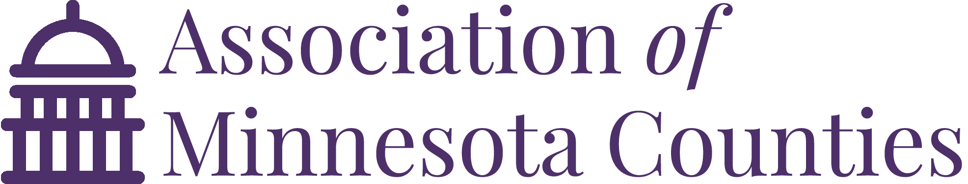

May 8, 2019

Senator Roger Chamberlain
Senator Ann Rest
Senator Gary Dahms
Senator David Senjem
Senator Jeff Howe
Representative Paul Marquart
Representative Greg Davids
Representative Diane Loeffler
Representative Aisha Gomez
Representative Dave Lislegard

Dear Members of the Conference Committee (HF 2125),

The Association of Minnesota Counties (AMC) is grateful for both chamber’s work towards passing a comprehensive tax bill, currently identified as HF 2125. As members are well aware, counties rely on property taxes as their main source of revenue in providing valuable and often mandated services to constituents.
To this extent, AMC is extremely grateful for the House and Governor’s inclusion of an association priority— additional funding for County Program Aid. Funding this proposal would provide vital property tax and mandate relief that would have positive impacts on county budgets and property taxpayers. We also appreciate the Senate’s recognition of the role counties provide regarding Indian Child Welfare Act cases and the disproportionate impact these cases can on county budgets. As the conference committee continues, we hope that conferees from both chambers will recognize the critical roles counties play on behalf of the state and the importance of including property tax relief as part of any/all larger goals of taxpayer relief.
Please also find attached a condensed list of the foremost provisions the Association of Minnesota Counties is supportive or concerned with. AMC appreciates your willingness to consider these positions going forward. Should you have any questions, please do not hesitate to contact Matt Hilgart at mhilgart@mncounties.org / 651-789-4343.

Sincerely,
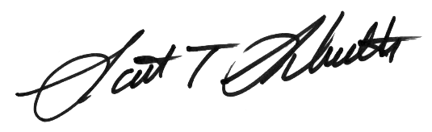

Scott Schulte, Anoka County Commissioner Matt Hilgart, Government Relations Manager
President, Association of Minnesota Counties Association of Minnesota Counties

CC: Commissioner Cynthia Bauerly, Department of Revenue
House Speaker Melissa Hortman
Senate Majority Leader Paul Gazelka
SUPPORT | CONCERNS
County Program Aid Increase (HOUSE, Article 6, Sec. 15) CPA is a critical resource to help alleviate the cost of state mandates and keep property taxes reasonable. Just two years ago, every single one of Minnesota’s 87 counties passed a board resolution indicating the importance of county program aid as a tool for property tax and mandate relief. In 2000, CPA accounted for (on average) 25% of a county’s levy; today, that number is less than 10%. During this same time, counties have been asked to take on increased burdens in child protection, probation, mental health, and more. While counties have prided themselves “doing more with less,” communities are clearly coming to a head where sheer mandate costs and lack of state reimbursements are requiring levy increases. We appreciate the House and Governor’s recognition of these burdens and ask conferees to support investing in this vital property tax relief mechanism during final negotiations. | Solid Waste Management Tax (SWMT) increases (House, Art. 4, Secs. 12-17) AMC has concerns regarding proposals to increase SWMT tax rates. Counties believe SWMT revenue should be use for solid waste reduction and recycling purposes. This proposal would further dilute the purpose of these tax proceeds while also creating new tax burdens for residents, businesses, and governments.
Indian Child Welfare Act/ICWA Funding (SENATE, Article 5, Sec. 5) ICWA funding is a critical resource to alleviate costs of counties complying with court ordered child placements. Compared to other states, Minnesota counties shoulder a disproportionate share of child protection and placement costs. The Senate Tax committee heard from several counties about the impacts this particular unfunded mandate is having on their overall financial sustainability. In summary, they are dire. AMC askes members to support the Senate language and increase the appropriation accordingly to recognize the mandate’s true cost. | Property tax shifts (HOUSE, Art. 5, Sec. 10) As legislators are keenly aware, Minnesota’s property tax classification system is second to none in terms of complexity. AMC opposes the creation of a new exemption for “charitable farming.” Furthermore, AMC and MAAO hope to work with legislators to bring efficiency and simplification to our complex system.
PERA Pension Aid sunset removal (HOUSE, Art. 6, Sec. 1) In 1997, the state created a PERA general plan pension aid program for local governments as a result of mandated increases in employer contributions. This aid was intended to offset the levy impacts of these contributions and has since served as an important property tax relief mechanism that goes out to counties, cities, townships, SWCDs, watershed districts, municipal hospitals, utilities, libraries, and more. AMC joins several other local government organizations in asking the legislature to honor and respect its previous commitment by extending the aid to the fund’s actual amortization date: July 2048.
$15K deduction for State and Local Taxes/SALT (SENATE, Art. 1, Sec. 12) Prior to passage of the TCJA, nearly one million Minnesota households took advantage of the State and Local Tax deduction. Local governments are concerned that the $10K cap of this deduction will not only increase individual taxpayer burdens but also create a form of double taxation that will adversely impact local governments from raising future revenues to maintain core services. We appreciate the Senate’s proposal to expand this cap—compared to the federal government—to $15K.

SUPPORT | CONCERNS
Fractional homestead changes (HOUSE, Art. 5, Sec. 20, Sec. 19/SENATE, Art. 4, Sec. 20) AMC supports House and Senate efforts to provide further clarity to determining fractional homestead. While we support both bill’s underlying language in premise, we continue to work with stakeholders and the DOR to make certain any final language is clear, administrable, and does not contain any unintended consequences. We ask both bodies to support the outcome of that work.
Assessor/CVSO data sharing provisions (HOUSE, Art. 5, Secs. 3, 21/SENATE, Art. 4, Secs. 4, 12) AMC was proud to work with authors in both chambers to create language that will allow a quicker and more efficient application and certification process for the Disabled Veterans Market Value Exclusion. We ask for your support of this bipartisan, commonsense provision.
Housing affordability (HOUSE, Art. 5, Sec. 52/SENATE, Art. 2, Sec. 30) AMC supports the House’s proposal to study 4d before considering dramatic decreases to the overall class rate for 4d, which may cause sizable shifts in tax base. AMC recently added a platform position supporting a tax credit contribution fund to assist in the development of new and affordable housing stock.
Disabled Veterans Market Value Exclusion expansion (HOUSE, Article 5, Sec. 25 and SENATE, Article 4, Secs. 19-21) As members are aware the costs of the current Disabled Veterans Market Value Exclusion benefit is borne not out of the state general fund, but from local community tax bases, some of which are home to high numbers of disabled veterans. While AMC is completely supportive of the benefits, our association has routinely updated members of the growing magnitude of the local property tax shift (more than $2.6b shift in 2018)—which is paid by local residents, businesses, and fellow veterans—and has suggested moving from an exclusion model to a credit model so as to not disproportionately impact the very communities that are home to large numbers of disabled veterans. While included House and Senate language will likely add to a property tax shift, we are extremely grateful for the bipartisan acknowledgment by authors and chairs about the importance of not further restricting local community tax bases. Because of this bipartisan acknowledgment and good faith commitment to not adding further tax shifts to local residents via this benefit structure, AMC stands in support of this language.
Buffer Credit/Exemption. AMC supports providing compensation to landowners required to comply with the riparian buffer requirement. Auditors, assessors, and AMC staff have been working closely with authors from both the House and Senate to create a proposal that provides landowners of 2a/2b acres that have been put land into riparian buffers a property tax exemption. AMC remains committed to working with committee members, the Governor, and DOR if there is interest in this proposal.

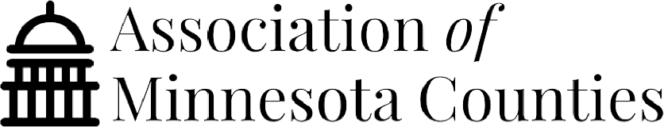
Strengthening
County Program Aid
Updating the County Program Aid
Formula to Support Today’s Counties
Minnesota has a tradition of state-mandated, county-administered programming that requires counties to deliver essential services in public safety, human services, transportation, and other vital program areas on the state’s behalf. To help pay for these services, the state distributes funding to counties via County Program Aid (CPA) with the additional goal of offsetting mandate costs and decreasing property taxes. While recent legislative changes successfully addressed formula flaws that created regional volatility, funding is still not near historic highs when program dollars accounted for more than 20 percent of counties’ average levy. As counties continue to grapple with new mandates, cost shifts, and increased service costs, CPA stands as the most important general purpose aid in managing these costs and providing property tax payers relief.

County Program Aid is still significantly underfunded compared to its historic values, forcing counties to make up the difference through levy increases.

CPA is Property Tax Relief
“Rock County receives $517,040 in CPA, this money results in a direct “buy down” of our levy by 8%. This money is used as general property tax relief for our taxpayers and helps defray the cost of mandated services.”
- Rock County
“We rely on CPA as an important revenue source to fund our operations. It makes a big difference for us --helping provide state-mandated services, and keeping local property taxes down.”
-Dakota County
“Counties are expected to offer efficient, fair and consistent services to tax payers. Over the last 10 years, Marshall County’s aid fluctuated from $1.2 million to $133,000. Without consistency in CPA, it’s not possible to provide consistency for taxpayers.”
- Marshall County
In an age when counties are forced to do more with less, while still providing quality services and maintaining low property tax burdens, CPA remains an important tool in providing counties with the resources to fund transportation, human services, public safety, and many other programs of statewide importance.

