Text for Life

Areas for Statewide Expansion

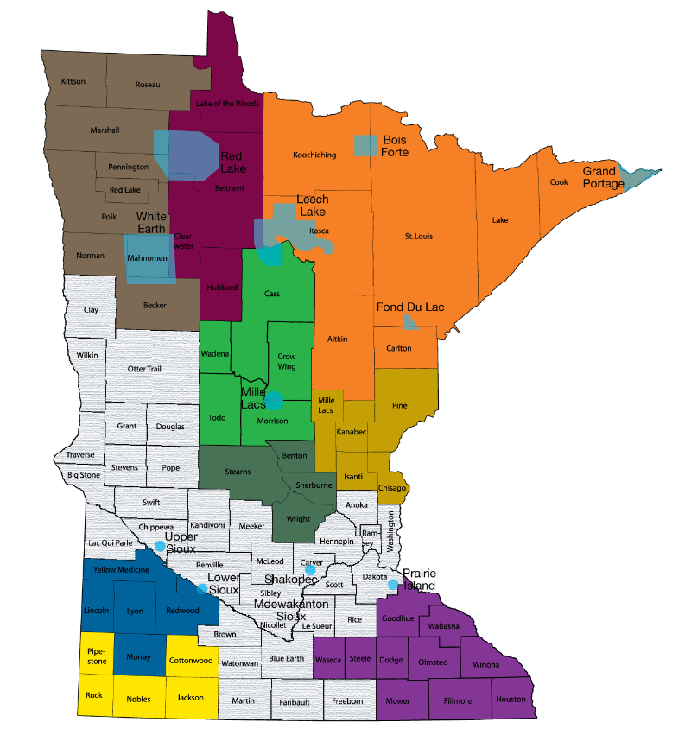

Note:
- Colored shading shows areas where TXT4Life Coordinators are funded and available.
- Grey areas indicate areas that available for expansion.
Individual colors denote specific coverage areas by individual TXT4Life Regional Coordinators

Testimonials

TXT4Life also has a strong presence with students across 54 counties in the state. During a recent school presentation by a TXT4Life Regional Coordinator, a young boy connected deeply with the presentation in emotional ways. When counselors at the school talked with him, they discovered that he had been having suicidal thoughts, and the TXT4Life presentation had encouraged him to reach out for help. “You saved a young boy’s life today,” the school counselor said. “What you do matters.”
"I spoke with a man who appeared to be in his mid to late fifties who used the Txt4Life line while driving to his intended suicide location. The counselor talked him out of it, and had a deputy waiting to do a welfare check on him at his home when he got back there. He spoke very highly of the counselor and the Txt4Life program overall."

