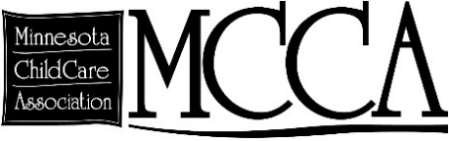March 13, 2019

Dear Chair Pinto and Committee Members,

My name is Clare Sanford, and I am Government Relations Chair for the Minnesota Child Care Association. Our membership organization represents roughly 250 licensed child care centers across the state. I also work with New Horizon Academy, Minnesota’s largest child care provider. I write in support of HF 2264, a bill to increase investments in the Retaining Early Educators Through Attaining Incentives Now (R.E.E.T.A.I.N.) program. Adding state funds to this program is part of our 2019 legislative agenda.

The child care workforce is the one that allows the rest of the workforce to prosper, and without it we cannot build a stable future for children, families, and our shared economy. You are well aware of the child care crisis facing our state and its implications for our current and future economies. You are also aware of the critical period of brain development that occurs prenatal to through age five, and that any investments we make in addressing the child care crisis must also address the need to attract and retain highly-qualified professionals to deliver this education and care.

R.E.E.T.A.I.N. has existed in Minnesota for some time, currently operating on only federal funds. Because of limited resources educators qualifying for grants cannot get them in successive years, and the intent to be a retention strategy and wage supplement cannot be most effectively realized. The National Governor’s Association and the Minnesota Birth-8 Workforce Group both recommend this approach and investment. For the many child care professionals making at or near poverty wages, the addition of this grant can be the deciding factor for whether to stay in child care or take their education to another, higher-paying field.

Parents cannot pay more and providers cannot make less. Please support HF 2264 to create state investment in R.E.E.T.A.I.N. It is one of the many avenues needed to increase compensation and encourage education and training in the critical child care field.

Sincerely,



Clare Sanford

Chair, Government Relations, Minnesota Child Care Association

763-383-6221

[csanford@nhacademy.net](mailto:csanford@nhacademy.net)