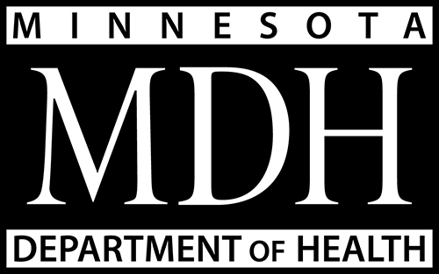
Health Partnership Division
P.O. Box 64975
St. Paul, MN 55164-0975
651-201-3880
www.health.state.mn.us/divs/cfh/ophp

Loan Forgiveness for Public Health Nurses

Background
Public health nurses (PHN) make up the largest portion of the public health workforce and play a central role in the delivery of essential public health services to communities. Public health nursing is a specialty practice with a primary prevention focus and systems-level perspective on improving population health. A public health nurse must have a baccalaureate or higher degree with a major in nursing and course work that included theory and clinical practice in public health nursing (MN Statute 148 Subd. 18, Board of Nursing Rule Chapter 6316).
At a minimum, the public health nurse must be prepared to:
- Identify populations at high risk of illness, disability, premature death, or poor recovery;
- Identify strategies for controlling diseases
- Intervene and evaluate the effects of interventions on the health status of the general population and high-risk populations;
- Use community services, institutional resources, and other health care providers.
Local Public Health Workforce
- The total local public health workforce was 2,637 in 2013
- The local public health workforce has decreased 12% since 2003 and a 17% since 1993
- The local public health workforce has decreased by over 500 FTEs since 1993 and nearly 400 FTEs since 2003
Public Health Nursing Workforce
- In 2013, public health nurses made up 29% of the public health workforce (765 of 2,637 FTEs)
- There has been a 14% decrease in the number of public health nurses in the last 10 years (127 FTEs)
- 31% of local public health nurses work in public health departments in the 7-county metro area
- 45% of all local public health full-time employees work in the 7-county metro area
Rural local health departments rely heavily on a public health nursing workforce. A range of 27% to 47% of the local public health employees in greater Minnesota are public health nurses. By comparison, 20% of the seven-county metro region local public health employees are public health nurses.
Need for More Public Health Nurses
More information is needed to definitively define the need for public health nurses in Minnesota. However, some Minnesota and national data is indicative of the challenges facing local health departments.
- In 2011, 24% of local public health departments indicated difficulty in filling public health nursing positions.
- 24% indicated they could not compete for pay and benefits
Minnesota’s local health departments have indicated that recruiting, hiring and retaining public health nurses is difficult, especially in the rural areas. Reasons include the following:
- Pay is not competitive with hospitals and clinics in the community
- Pay is poor in rural Minnesota compared to the metropolitan area
- Even in greater Minnesota, pay is variable across county lines
- Students do not go into public health because of lack of good public health clinical sites in school
- To address pay competition, nurses are often hired at the top of the pay scale leaving no room for pay advancement
Recruitment and hiring of registered nurses into public health positions is challenging, according to a 2012 national public health nursing workforce study.
- Approximately 60% of responding state and local health department respondents disagreed or strongly disagreed that their department’s salary scale for RNs is competitive.
- 23% of responding local health departments agreed or strongly agreed that their department has difficulty hiring RNs.

Loan Repayment Programs
Limited loan repayment programs are available for nurses, but these programs are not specific to the specialty of public health nursing and are limited to a commitment to work in clinical care settings.

Health Partnership Division
P.O. Box 64975
St. Paul, MN 55164-0975
651-201-3880
www.health.state.mn.us/divs/cfh/ophp

