Using the Framework
Part 2 (Legislator Review/Evaluation Tool): This part is meant to support legislators in the process of reviewing and evaluating the proposed legislative changes. It includes a series of open-ended questions designed to provoke critical review of key information. It is meant to be completed by the legislator(s) reviewing the proposal and serve as a quick reference.

Section 2 – Proposal Details
To be completed by the proposal sponsor. Please respond to applicable questions. A response is not required for questions which do not pertain to the profession/occupation (may indicate “not applicable” or leave the response area blank). Where applicable, please provide supporting evidence (including source of information and citations, where appropriate). Please note, this section has been designed to provide more detailed information about the proposal. Some overlap with the summary provided in Section 1 is expected.

A. Public Safety and Well-Being
1) Describe, using evidence to the extent possible, how the proposed scope and regulation may improve or may harm the health, safety, and welfare of the public?
Pharmacists are overseen by the Minnesota Board of Pharmacy. They undergo rigorous training and must complete yearly educational requirements, which are enforced by the Board of Pharmacy. The Board of Pharmacy also has a disciplinary and complaint process for Licensed Minnesota Pharmacists.
The proposed scope change not only ensures public safety, but will also improve access to smoking cessation medications, contraceptive products, travel medicines and the lifesaving medication, naloxone. The Centers for Medicaid and Medicare Services has released a statement encouraging the expanded role of pharmacists to provide more timely and convenient access to these medication classes to improve public safety.
Naloxone:
- Because opioid abuse and overdose has reached epidemic proportions in the U.S., expansion of naloxone access programs are necessary to reduce health care cost and improve health outcomes. The following data indicates an alarming trend in the United States, which requires innovative healthcare approaches in order to curb the opioid abuse epidemic.
- According to the 2014 National Survey on Drug Use and Health, 15 million people, aged 12 or older, used prescription drugs non-medically in the past year.
- Since 2000 the rate of deaths due to drug overdoses has increased 137% including a 200% increase in the rate of opioid related overdose deaths.
- In 2014, a total of 47,055 drug overdose deaths occurred in the United States, which represents a 1-year increase of 6.5%, from 13.8 per 100,000 persons in 2013 to 14.7 per 100,000 persons in 2014.
- There was a 153% increase in the number of emergency department visits for problems regarding opioid abuse between 2004 and 2013.
- Prescription opioid abuse costs were about 55.7 billion in 2007.
- As of 2016, Walgreens has expanded its efforts to combat opioid abuse to 33 states where the drug can be dispensed without a prescription and CVS has expanded its access in 37 states.
- The Kelley-Ross Pharmacy Group launched a naloxone program in its Seattle pharmacy in 2013. According to Ryan Oftebro, PharmD, CEO of Kelley-Ross, to date, the group has dispensed 100 naloxone kits and confirmed more than a dozen rescues.
- In 2013 New Mexico became the first state to allow pharmacists to prescribe Naloxone Rescue Kits (NRKs) to patients at risk of opioid overdose without a physician issued prescription.The New Mexico Pharmacist Association (NMPhA) prepared a Naloxone Pharmacist Prescriptive Authority Protocol stating that pharmacists must complete a certification training program through the Accreditation Council for Pharmacy Education (ACPE) in order to prescribe these NRKs. To monitor this program pharmacists are requested to send a confidential summary of patient/prescription data for each prescribed NRK to the Prevention of Opioid Overdose by New Mexico Pharmacists Data Registry (POINt-Rx).
- Since 2013, 196 pharmacists have received NMPhA certification to prescribe NRKs.
- According to data on 133 NRK reports compiled by POINT-Rx, the most common reason for NRK prescription was patient, family or friend request (56.4%). The next most common reason was a high dose of opioids (28.6%) and history of opioid abuse (15.0%). This data suggests that patients or family of at risk patients, might feel more comfortable requesting NRKs from pharmacists, thus increasing the direct access to NRKs for at risk patients.
- About 43% of the NRKs were dispensed based on the pharmacist’s judgment of overdose potential. This supports the idea that pharmacists play an important role in reducing overdose deaths and educating the community on opioid abuse and naloxone use.
- Prior research has shown that patients in rural counties have higher mortality rates due to opioid overdose. Access to pharmacy based opioid overdose prevention programs is especially important in rural and underserved populations where pharmacists are the most accessible health professionals.
- The fact that many states have required Medicaid to cover NRKs and the opportunity for pharmacists to educate the patient on signs and symptoms of overdose and how to use NRKs, could lead to lower healthcare costs, decreased patient opioid abuse and improved patient experience and mortality rates.

Smoking Cessation and Travel Medications:
- According to the Minnesota Department of Health, smoking causes 5,900 deaths and over $2.5 billion in medically costs every year in Minnesota.
- More Minnesotans die from tobacco than alcohol, homicides, car accidents, AIDS, illegal drugs, and suicide combined.
- Smokers are 1.7 - 2.2 times more likely to successfully quit smoking for at least 5 months when receiving assistance from a clinician.
- There are 27 international travel clinics identified by the Minnesota Department of Health that service the entirety of Greater Minnesota; there are 34 international travel clinics within the Twin Cities Metropolitan Area.

2) Is there any research evidence that the proposed change(s) might have a risk to the public? Please cite.

Naloxone: While some might cite the “relapse theory”, suggesting increased access to NRKs encourages people to overdose, in response to increased access to NRKs there is no evidence this phenomenon occurs.
Smoking Cessation and Travel Medications: There were no perceived risks associated with expanding the pharmacist’s scope of practice to include smoking cessation and travel medication.

3) Will a regulatory entity/board have authority to discipline practitioners?
The Minnesota Board of Pharmacy currently has regulatory and disciplinary governance over practicing pharmacists in Minnesota. The Minnesota statute and relevant sub-sections granting this authority is as follows:

151.06 POWERS AND DUTIES.

Subdivision 1.Generally; rules.
(a) Powers and duties. The Board of Pharmacy shall have the power and it shall be its duty:
(1) to regulate the practice of pharmacy;
(2) to regulate the manufacture, wholesale, and retail sale of drugs within this state;
(5) to examine and license as pharmacists all applicants whom it shall deem qualified to be such;
(7) to take disciplinary action against any registration or license required under this chapter upon any of the grounds listed in section 151.071, and in accordance with the provisions of section 151.071;

Subd. 1a.Cease and desist orders.
(a) Whenever it appears to the board that a person has engaged in an act or practice constituting a violation of a law, rule, or other order related to the duties and responsibilities entrusted to the board, the board may issue and cause to be served upon the person an order requiring the person to cease and desist from violations.
(b) The cease and desist order must state the reasons for the issuance of the order and must give reasonable notice of the rights of the person to request a hearing before an administrative law judge. A hearing must be held not later than ten days after the request for the hearing is received by the board. After the completion of the hearing, the administrative law judge shall issue a report within ten days. Within 15 days after receiving the report of the administrative law judge, the board shall issue a further order vacating or making permanent the cease and desist order. The time periods provided in this provision may be waived by agreement of the executive director of the board and the person against whom the cease and desist order was issued. If the person to whom a cease and desist order is issued fails to appear at the hearing after being duly notified, the person is in default, and the proceeding may be determined against that person upon consideration of the cease and desist order, the allegations of which may be considered to be true. Unless otherwise provided, all hearings must be conducted according to chapter 14. The board may adopt rules of procedure concerning all proceedings conducted under this subdivision.
(c) If no hearing is requested within 30 days of service of the order, the cease and desist order will become permanent.
(d) A cease and desist order issued under this subdivision remains in effect until it is modified or vacated by the board. The administrative proceeding provided by this subdivision, and subsequent appellate judicial review of that administrative proceeding, constitutes the exclusive remedy for determining whether the board properly issued the cease and desist order and whether the cease and desist order should be vacated or made permanent.

Subd. 1b.Enforcement of violations of cease and desist orders.
(a) Whenever the board under subdivision 1a seeks to enforce compliance with a cease and desist order that has been made permanent, the allegations of the cease and desist order are considered conclusively established for purposes of proceeding under subdivision 1a for permanent or temporary relief to enforce the cease and desist order. Whenever the board under subdivision 1a seeks to enforce compliance with a cease and desist order when a hearing or hearing request on the cease and desist order is pending, or the time has not yet expired to request a hearing on whether a cease and desist order should be vacated or made permanent, the allegations in the cease and desist order are considered conclusively established for the purposes of proceeding under subdivision 1a for temporary relief to enforce the cease and desist order.
(b) Notwithstanding this subdivision or subdivision 1a, the person against whom the cease and desist order is issued and who has requested a hearing under subdivision 1a may, within 15 days after service of the cease and desist order, bring an action in Ramsey County District Court for issuance of an injunction to suspend enforcement of the cease and desist order pending a final decision of the board under subdivision 1a to vacate or make permanent the cease and desist order. The court shall determine whether to issue such an injunction based on traditional principles of temporary relief.

4) Describe any proposed disciplinary measures to safeguard against unethical/unfit professionals. How can consumers access this information?
Disciplinary measures are set forth and enforced by the Minnesota Board of Pharmacy. The extent of the Minnesota Board of Pharmacy’s ability to discipline is defined in the following Minnesota Statute:

151.071 DISCIPLINARY ACTION.

Subdivision 1.Forms of disciplinary action.
When the board finds that a licensee, registrant, or applicant has engaged in conduct prohibited under subdivision 2, it may do one or more of the following:
(1) deny the issuance of a license or registration;
(2) refuse to renew a license or registration;
(3) revoke the license or registration;
(4) suspend the license or registration;
(5) impose limitations, conditions, or both on the license or registration, including but not limited to: the limitation of practice to designated settings; the limitation of the scope of practice within designated settings; the imposition of retraining or rehabilitation requirements; the requirement of practice under supervision; the requirement of participation in a diversion program such as that established pursuant to section 214.31 or the conditioning of continued practice on demonstration of knowledge or skills by appropriate examination or other review of skill and competence;
(6) impose a civil penalty not exceeding $10,000 for each separate violation, the amount of the civil penalty to be fixed so as to deprive a licensee or registrant of any economic advantage gained by reason of the violation, to discourage similar violations by the licensee or registrant or any other licensee or registrant, or to reimburse the board for the cost of the investigation and proceeding, including but not limited to, fees paid for services provided by the Office of Administrative Hearings, legal and investigative services provided by the Office of the Attorney General, court reporters, witnesses, reproduction of records, board members' per diem compensation, board staff time, and travel costs and expenses incurred by board staff and board members; and
(7) reprimand the licensee or registrant
Grounds for disciplinary action relevant to the proposed expanded scope of practice and to the well being of public health as defined in Minnesota Statute:

Subd. 2.Grounds for disciplinary action.

The following conduct is prohibited and is grounds for disciplinary action:
(1) failure to demonstrate the qualifications or satisfy the requirements for a license or registration contained in this chapter or the rules of the board. The burden of proof is on the applicant to demonstrate such qualifications or satisfaction of such requirements;
(9) engaging in any unethical conduct; conduct likely to deceive, defraud, or harm the public, or demonstrating a willful or careless disregard for the health, welfare, or safety of a patient; or pharmacy practice that is professionally incompetent, in that it may create unnecessary danger to any patient's life, health, or safety, in any of which cases, proof of actual injury need not be established;
(12) for a pharmacist or pharmacy intern, engaging in unprofessional conduct as specified in the board's rules. In the case of a pharmacy technician, engaging in conduct specified in board rules that would be unprofessional if it were engaged in by a pharmacist or pharmacist intern or performing duties specifically reserved for pharmacists under this chapter or the rules of the board;
(14) for a pharmacist, the inability to practice pharmacy with reasonable skill and safety to patients by reason of illness, drunkenness, use of drugs, narcotics, chemicals, or any other type of material or as a result of any mental or physical condition, including deterioration through the aging process or loss of motor skills. In the case of registered pharmacy technicians, pharmacist interns, or controlled substance researchers, the inability to carry out duties allowed under this chapter or the rules of the board with reasonable skill and safety to patients by reason of illness, drunkenness, use of drugs, narcotics, chemicals, or any other type of material or as a result of any mental or physical condition, including deterioration through the aging process or loss of motor skills;
4) Describe any proposed disciplinary measures to safeguard against unethical/unfit professionals. How can consumers access this information?

6800.9200 INITIATING PROCEEDINGS.
Proceedings to revoke or suspend licenses may be initiated in one of two ways, except insofar as any order of suspension or revocation may be issued pursuant to a statute not requiring hearing:
- on a verified complaint by an individual or an agency required by law to enforce the law in question, filed with the Board of Pharmacy; or
- by the board on its own motion, when its investigation discloses probable grounds for disciplinary action; the board president or director may act for the board in initiating proceedings under this part.

6800.9300 PROCEDURE UPON FILING COMPLAINT.
All complaints received pursuant to the provisions of part 6800.9200 shall be dealt with in accordance with the requirements of Minnesota Statutes, section 214.10.

214.10 COMPLAINT, INVESTIGATION, AND HEARING.

Subdivision 1.Receipt of complaint; notice.
The executive director or executive secretary of a board, a board member or any other person who performs services for the board who receives a complaint or other communication, whether oral or written, which complaint or communication alleges or implies a violation of a statute or rule which the board is empowered to enforce, shall promptly forward the substance of the communication on a form prepared by the attorney general to the designee of the attorney general responsible for providing legal services to the board. Before proceeding further with the communication, the designee of the attorney general may require the complaining party to state the complaint in writing on a form prepared by the attorney general. Complaints which relate to matters within the jurisdiction of another governmental agency shall be forwarded to that agency by the executive director or executive secretary. An officer of that agency shall advise the executive director or executive secretary of the disposition of that complaint. A complaint received by another agency which relates to a statute or rule which a licensing board is empowered to enforce shall be forwarded to the executive director or executive secretary of the board to be processed in accordance with this section. No complaint alleging a matter within the jurisdiction of the board shall be dismissed by a board unless at least two board members have reviewed the matter. If a board makes a determination to investigate a complaint, it shall notify a licensee who is the subject of an investigation that an investigation has been initiated at a time when such notice will not compromise the investigation.

The preceding information is freely available to the public on the Minnesota Board of Pharmacy website. http://mn.gov/boards/pharmacy/complaints/. Printable complaint forms and requests for a mailed copy of information related to the complaint on a pharmacist are also available.

B. Access, Cost, Quality, Care Transformation Implications
1) Describe how the proposed change(s) will affect the availability, accessibility, cost, delivery, and quality of health care.
According to the National Alliance of State Pharmacy Associations (NASPA), “there is growing recognition across the U.S. that pharmacists are a perfect resource to enhance access to public health services due to their expertise in medications and wellness and their exceptional accessibility”. Additionally, it should be taken into consideration that ninety-three percent of Americans live within five miles of a community pharmacy, many of which are open 12 to 16 hours a day, seven days a week.
Pharmacist-driven protocols for birth control, smoking cessation medications, and travel medications will undoubtedly increase the public’s access to these important resources. States such as Oregon, California, Idaho, and New Mexico have already implemented these changes. Allowing pharmacists to furnish these medications by following a protocol has been an ideal approach in these states. Rather than merely making medications such as hormonal contraceptives available over-the-counter, the pharmacist keeps professional oversight intact while also improving medication access. The cost and quality is anticipated to be comparable to the same type of treatments provided at a physician's office.
Amidst growing concern about lack of access to primary care providers, pharmacists are an untapped resource. With an expanded ability to furnish the aforementioned medication classes, pharmacists can help address unmet health needs in the population.
2) Describe the unmet healthcare needs of the population (including health disparities) that can be served under this proposal and how the proposal will contribute to meeting these needs.
Increased access to smoking cessation medications has the potential to reduce smoking rates. Reducing adult smoking rates by 1% could result in at least 30,000 fewer heart attacks, 16,000 fewer strokes, and $1.5 billion saving over five years, according to the CDC.
Underserved populations have many barriers to receiving adequate health care needs such as transportation and cost. The proposed legislation reduces barriers for the public. Rural and economically disadvantaged urban areas have less than half the rate of primary care physicians than wealthier urban areas, meaning that patients often have to travel long distances or wait for months to see their doctor. For those who do not have adequate insurance coverage for an office visit, cannot take time off work for an appointment, or have trouble finding a doctor with an opening to see them, the proposed legislation can increase accessibility to important medications.
3) Please describe whether the proposed scope includes provisions to encourage or require practitioners to serve underserved populations.
Currently there is no language in the suggested proposal to encourage or require practitioners to target underserved populations. However due to the local nature of pharmacy business and pharmacists working in clinics and hospitals throughout the State, underserved areas will experience an increase in access to care by the proposed scope of practice changes. As the pharmacies located within these areas will be able to offer more services.
4) Describe how this proposal is intended to contribute to an evolving health care delivery and payment system (e.g. inter-professional and collaborative practice, innovations in technology, ensuring cultural agility and competence in the profession, value based payment etc.)

EXPANDING PATIENT ACCESSES TO CARE:
Amidst growing concern about lack of access to primary care providers, pharmacists are an untapped resource. Underserved populations have many barriers to receiving adequate health care needs such as transportation and cost. Rural and economically disadvantaged urban areas have less than half the rate of primary care physicians than wealthier urban areas, meaning that patients often have to travel long distances or wait for months to see their doctor. Ninety‐three percent of Americans live within five miles of a community pharmacy, many of which are open 12 to 16 hours a day, seven days a week. According to the World Health Organization:

“Community pharmacists are the health professionals most accessible to the public.”
OPIOID ANTAGONISTS
Opioids have killed more than 2,700 Minnesotans in the last 15 years. More than 80% of these deaths involved prescription drugs, and nearly 60% have occurred in the past 5 years. There were 355 deaths in 2015 and a 31% increase in 2016. Hennepin County saw a record 144 opioid‐related deaths in 2016. A study by the National Bureau of Economic Research found that legislation that expanded the access of naloxone to the public was “associated with a 9 to 11 percent reduction in opioid‐related deaths....” This study also states that there was “little evidence that these laws increase the recreational use of prescription painkillers.” Increased access to naloxone can save lives.

TOBACCO CESSATION TREATMENT
According to the Minnesota Department of Health, smoking causes 5,900 deaths and over
$2.5 billion in medical costs every year in Minnesota. A study found that community pharmacist intervention led to a 12.7% increase in smoking cessation rates through interventions related to nicotine replacement.

TRAVEL MEDICATIONS
International tourists are estimated to reach 1.6 billion by 2020, with an increasing proportion visiting the developing world. Providing Minnesota pharmacists with the ability to prescribe medications according to the CDC for travel abroad would enhance access to recommended medications and be a practical convenience for thousands of Minnesotans. It would also will help Minnesotans stay healthy while traveling and returning home. Travel medications include: vaccines, medications for traveler’s diarrhea and malaria prevention.
Giving more responsibilities to pharmacists also frees up doctors and other health care providers to perform services and see more patients. As part of the collaborative healthcare team, pharmacists can directly provide services or support and referrals to other members of the health care team when necessary. Allowing pharmacists to practice at the top of their license will serve to strengthen interprofessional collaboration and ultimately improve patient outcomes.

C. Regulation
1) If the services or individuals are currently unregulated, what is the proposed form of credentialing/regulation (licensure, certification, registration, etc.)? State the rationale for the proposed form/level of regulation.i If there is a lesser degree of regulation available, state why it was not selected.
See section C, whole-point number 2.

2) Describe if a regulatory entity/board currently exists or will be proposed. Does/will it have statutory authority to develop rules related to a changed/expanded scope or emerging profession, determine standards for education and training programs, assessment of practitioners’ competence levels? If not, why not?
See existing statutes and rules below.
Pharmacists in Minnesota are under the regulation of the Minnesota Board of Pharmacy:

151.02 STATE BOARD OF PHARMACY.
The Minnesota State Board of Pharmacy shall consist of three public members as defined by section 214.02 and six pharmacists actively engaged in the practice of pharmacy in this state. Each of said pharmacists shall have had at least five consecutive years of practical experience as a pharmacist immediately preceding appointment.

151.03 MEMBERSHIP.
Members of the board shall be appointed by the governor. The governor shall make appointments to the board that reflect the geography of the state. The board members who are pharmacists must, as a whole, reflect the broad mix of practice types of pharmacists practicing in Minnesota. Membership terms, compensation of members, removal of members, the filling of membership vacancies, and fiscal year and reporting requirements shall be as provided in sections 214.07 to 214.09. The provision of staff, administrative services and office space; the review and processing of complaints; the setting of board fees; and other provisions relating to board operations shall be as provided in chapter 214. Any pharmacist on the board who, during incumbency, ceases to be actively engaged in the practice of pharmacy in this state shall be automatically disqualified from membership.

151.06 POWERS AND DUTIES.

Subdivision 1.Generally; rules (a) Powers and duties. The Board of Pharmacy shall have the power and it shall be its duty:
(1) to regulate the practice of pharmacy;
(2) to regulate the manufacture, wholesale, and retail sale of drugs within this state;
(3) to regulate the identity, labeling, purity, and quality of all drugs and medicines dispensed in this state, using the United States Pharmacopeia and the National Formulary, or any revisions thereof, or standards adopted under the federal act as the standard;
(4) to enter and inspect by its authorized representative any and all places where drugs, medicines, medical gases, or veterinary drugs or devices are sold, vended, given away, compounded, dispensed, manufactured, wholesaled, or held; it may secure samples or specimens of any drugs, medicines, medical gases, or veterinary drugs or devices after paying or offering to pay for such sample; it shall be entitled to inspect and make copies of any and all records of shipment, purchase, manufacture, quality control, and sale of these items provided, however, that such inspection shall not extend to financial data, sales data, or pricing data;
(5) to examine and license as pharmacists all applicants whom it shall deem qualified to be such;
(6) to license wholesale drug distributors;
(7) to take disciplinary action against any registration or license required under this chapter upon any of the grounds listed in section 151.071, and in accordance with the provisions of section 151.071;
(8) to employ necessary assistants and adopt rules for the conduct of its business;
(9) to register as pharmacy technicians all applicants who the board determines are qualified to carry out the duties of a pharmacy technician;
(10) to perform such other duties and exercise such other powers as the provisions of the act may require; and
(11) to enter and inspect any business to which it issues a license or registration.
The Minnesota Board of Pharmacy reserves the authority to determine qualifications for licensure as a pharmacist in the state of Minnesota as well as the authority to determine standards for education and training programs, assessment of practitioners’ competence levels:

151.10 QUALIFICATIONS OF APPLICANTS.

Subdivision 1.Graduates of schools in good standing.
To be entitled to examination by the board as a pharmacist the applicant shall be of good moral character, at least 18 years of age, and shall be a graduate of the College of Pharmacy of the University of Minnesota or of a college or school of pharmacy in good standing of which the board shall be the judge and shall have completed internship requirements as prescribed by the board.

Subd. 2.Graduates of schools outside the United States.
An applicant who is a graduate of a school or college of pharmacy located outside the United States, when that school or college of pharmacy has not been recognized by the board as a school in good standing, may be entitled to examination for licensure by the board if the applicant is of good moral character, at least 18 years of age, has completed the internship requirements prescribed by the board, has provided verification of the applicant's academic record and graduation, and has successfully passed examinations approved by the board to establish proficiency in English and equivalency of education with graduates of schools or colleges of pharmacy which the board has determined to be in good standing.

The following rule establishes thresholds for minimum continuing education required by licensed pharmacists in the state of Minnesota to maintain active licensure. These rules are enforced by the Minnesota Board of Pharmacy.

6800.1500 CONTINUING EDUCATION.

Subp. 2. Minimum hours required for pharmacists; reporting.
Beginning March 4, 1975, no annual license renewal shall be issued to a pharmacist under Minnesota Statutes, section 151.13, until the pharmacist has submitted to the board satisfactory evidence that the pharmacist has completed at least 30 hours of approved continuing education during the previous two-year period. Thereafter, a pharmacist shall submit the evidence every two years. Pharmacists exempted from the payment of all renewal fees and from the filing of any application for renewal under Minnesota Statutes, section 326.56, subdivision 2, shall also be exempted from the requirements of this subpart for a concurrent period of time. Beginning with the 1981-1983 reporting period, participation in continuing education shall be reported by September 30 of each even-numbered year. The board may grant a pharmacist, on application, an extension of time not to exceed one year to comply with the requirements of this subpart. The extension shall not relieve the pharmacist from complying with the continuing education requirements for any other two-year period. Each pharmacist is responsible for maintaining a complete record of the pharmacist's continuing education participation during each continuing education reporting cycle.
3) Is there model legislation for the profession available at the national level? If so, from what organization? Which states have adopted it? Briefly describe any relevant implementation information.
As of March 2016, 22 states have at least one statewide protocol for pharmacists and four states have three or more statewide protocols for pharmacists.
4) Does the proposal overlap with the current scope of practice for other professions/practitioners? If so, describe the areas of overlap. (This question is not intended to imply that overlap between professions is negative.)
This bill does not prohibit or change any other professions/practitioners’ scope of practice; it only regulates licensed pharmacists. However, the proposal herein overlaps with the current scope of practice for the following professions and practitioners:
- Physicians
- Nurse Practitioners
- Physician Assistants

Physician (MD, DO, MBBS)
Nurse Practitioner,
Clinical Nurse Specialist,
Physician’s Assistant,
Nurse Midwife (151.01 subd 16a, subd 23).

Traditional Midwife - only Vit K, postpartum antihemorrhagic meds, local anesthetics, oxygen, and prophylactic eye agent to newborn (147D.09),

Optometrist - topical ocular meds, no oral antivirals >10 days, no oral carbonic anhydrase inhibitors > 7 days, and no oral steroids, no IV or IM meds (except Epi). (148.576)

151.37 LEGEND DRUGS, WHO MAY PRESCRIBE, POSSESS.

Subdivision 1.Prohibition.
Except as otherwise provided in this chapter, it shall be unlawful for any person to have in possession, or to sell, give away, barter, exchange, or distribute a legend drug.

Subd. 2.Prescribing and filing.
(a) A licensed practitioner in the course of professional practice only, may prescribe, administer, and dispense a legend drug, and may cause the same to be administered by a nurse, a physician assistant, or medical student or resident under the practitioner's direction and supervision, and may cause a person who is an appropriately certified, registered, or licensed health care professional to prescribe, dispense, and administer the same within the expressed legal scope of the person's practice as defined in Minnesota Statutes.

D. Education and Professional Supervision
1) Describe the training, education, or experience that will be required for this professional based on this proposal, including plans for grandfathering in prior qualifications and/or experience where appropriate.
All newly registered pharmacists are required to attend a four-year, graduate-level program and obtain a doctorate of pharmacy. This is equivalent to the amount of didactic school based learning a physician needs and more than other health professionals such as physician assistants, who only complete 2-3 years of graduate coursework. The education requires pharmacist to take similar course to other health professionals with an emphasis on medicinal chemistry, pharmacokinetics, pharmaceutical directed therapy, pharmacology, and medication safety, truly making pharmacist the drug expert on the health care team. A registered pharmacist must also pass a rigorous national license exam, called The North American Pharmacist Licensure Examination (NAPLEX), as well a state level law exams (Multistate Pharmacy Jurisprudence Examination) for each state the pharmacist wishes to practice in. Additional education opportunities are available to pharmacist in the form of residencies, fellowships, or extra coursework. More and more pharmacists are pursuing these additional training opportunities with 35% of graduates from the University of Minnesota (the only college of pharmacy in Minnesota) in 2016 going into these positions.
Pharmacy School Curriculum:
There are currently over 130 accredited pharmacy schools in the United States. In order to become accredited the school must meet the high standards set by the Accreditation Council for Pharmacy Education (ACPE). The education that a pharmacist receives requires both didactic and experience based learning. Throughout the first 3 years of the doctorate of pharmacy a student will spend the majority of their time in a didactic education environment, learning the theory and scientific knowledge behind human anatomy, pharmacology, and the US health system among other topics. A little bit during this time and largely during their 4th year of the pharmacy curriculum students participate in hands on learning through experiential practices. This is when a pharmacy student works alongside an approved pharmacist, so that they have real life training prior to graduation. Currently the Minnesota Board of pharmacy requires that student accomplish 4000 hours of experiential practice. However most students will obtain more as they have the opportunity to become an intern after their first year of pharmacy school. This allows students, under the direct supervision of a pharmacist, to legally practice much like a pharmacist. Activities allowable by law for interns include counseling patients, performing medication reconciliation, and obtaining prescriptions via telephone from providers. This designation as an intern is unique to pharmacy when compared to other healthcare practitioners and allows for advanced learning through countless hours of hands on experience prior to becoming licensed. The ACPE helps regulate experiential practices and assures that pharmacy schools provide a suitable level of education in the following areas. (Sample from the University of Minnesota College of Pharmacy):
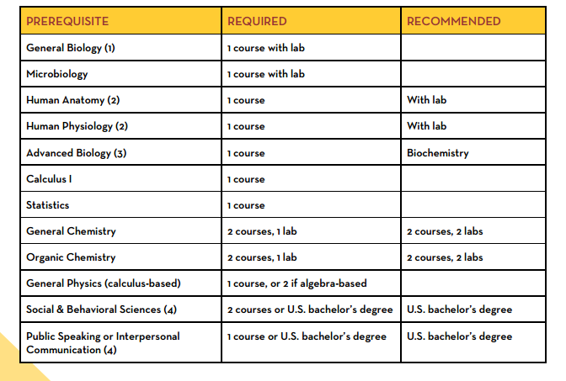

Followed by the following graduate level course work:
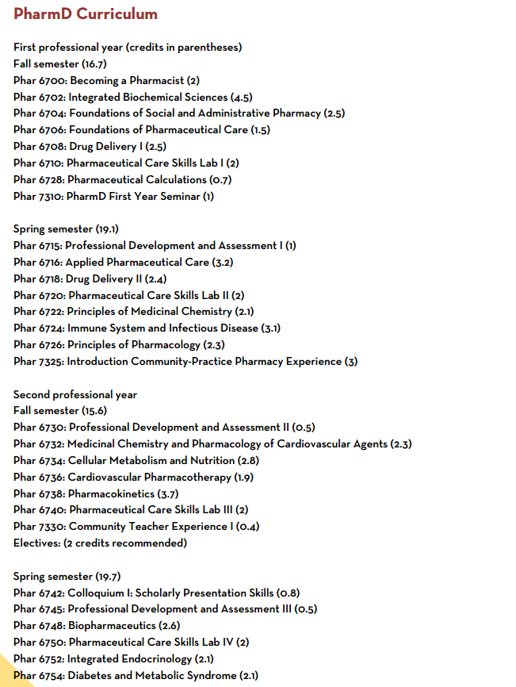
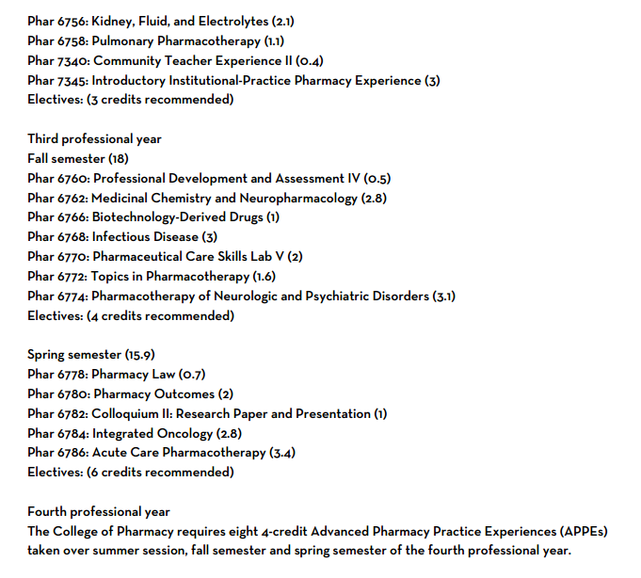
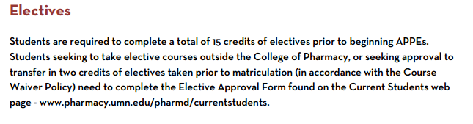

The Accreditation Council for Pharmacy Education (ACPE) is recognized by the US Department of Education (USDE) for the accreditation and pre-accreditation, within the United States, of professional degree programs in pharmacy leading to the degree of Doctor of Pharmacy. ACPE is also recognized by the Council for Higher Education Accreditation (CHEA), which is a private, nonprofit that coordinates accreditation activity in the United States. CHEA represents more than 3,000 colleges/universities and 60 national, regional and specialized accreditors. CHEA affirms that accrediting organizations are consistent with high academic quality, improvement and accountability standards.
Graduation from an accredited college of pharmacy or college that is a candidate for accreditation guarantees eligible to sit for The North American Pharmacist Licensure Examination (NAPLEX). ACPE has membership with the Association of Specialized and Professional Accreditors (ASPA). This organization accepts as members those accreditors recognized by the Secretary of Education or that meet ASPA’s own criteria. Among the almost 50 agencies that belong to ASPA are the recognized accreditors for allopathic (M.D.), osteopathic (D.O.), chiropractic (D.C.), acupuncture (L.Ac.), and dental programs.
Board Examinations:
In order to be registered as a licensed pharmacist in the United States and the state of Minnesota all people must sit and pass the North American Pharmacist Licensure Examination. This examination is a 250 question exam that assess competency in the following areas as determined by the National Associations of Boards of Pharmacy.
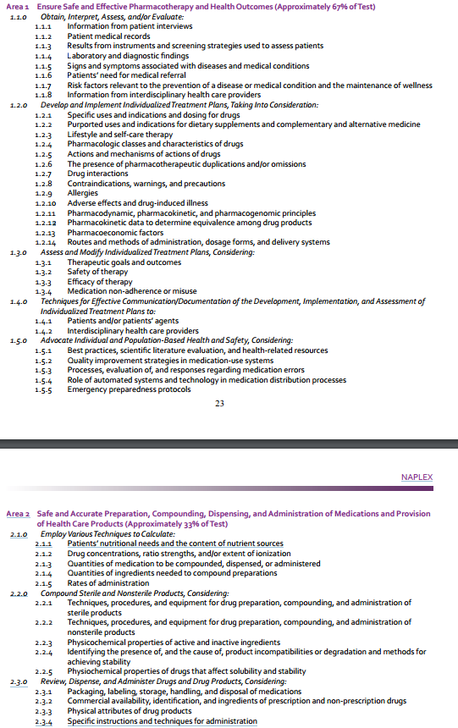
In order to legally practice in a given state a pharmacist must pass that states represented MPJE, this is a test that covers both state and national laws around the use of medications and roles of a pharmacist. The following are the competences for state level MPJE exams.
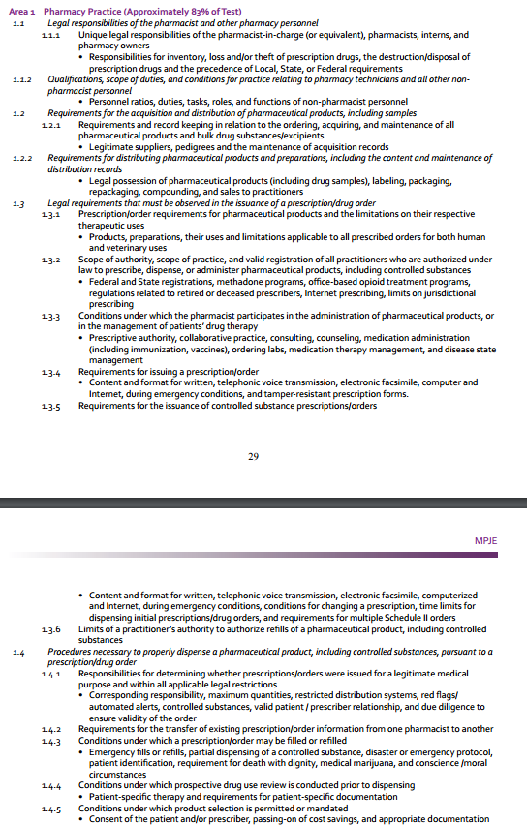
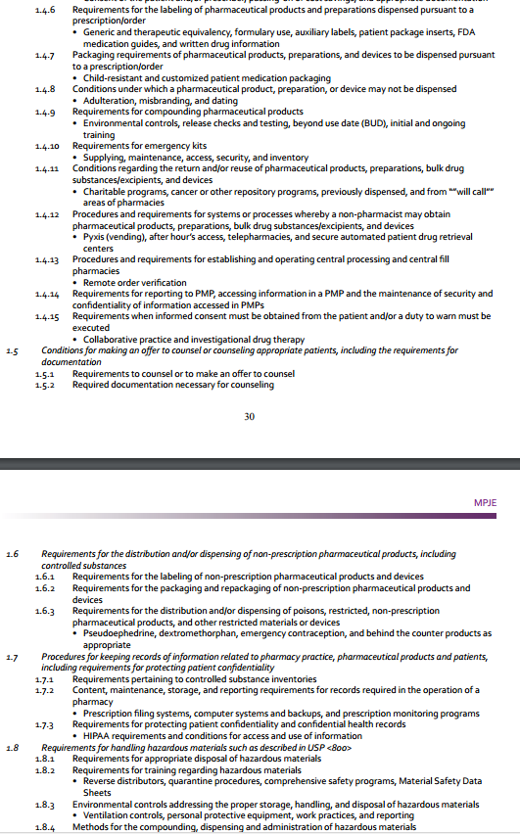
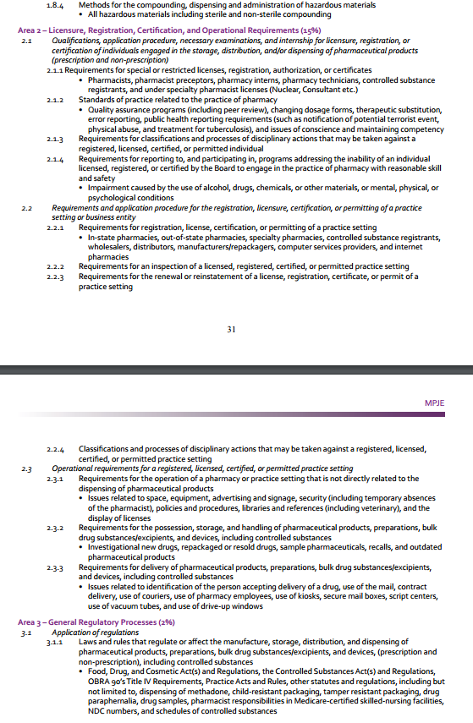

2) Is the education program available, or what is the plan to make it available? Is accreditation or other approval available or proposed for the education program? If yes, by whom?
This document proposes methods followed by other states to create education and accreditation programs for pharmacist prescribing rights. Currently, partnerships are being leveraged through state and national pharmacy organizations to gain access to or develop a training program for pharmacist for each of the proposed medication classes. Connecticut recently released a pharmacist naloxone certificate that is obtained through viewing and passing online courses. These programs were developed and employed through collaboration of various organizations at a local, national levels, and with Colleges of pharmacy. Programs like these use a certificate of completion to demonstrate that a pharmacist meets the standards to prescribe a particular medication. Oversight of education would be done by the Minnesota Board of Pharmacy, in a similar fashion as their oversight and accreditation of continued education programs. We propose a similar method to be used in Minnesota.
3) Do provisions exist or are they being proposed to ensure that practitioners maintain competency in the provision of services? If so, please describe.
Registered pharmacist are required to maintain continuing education (CE) credits relevant to health care and the practice of pharmacy in order to be eligible to renew their license annually. The number of CE required by the Minnesota Pharmacist is 30 hours on a biannual basis. It is proposed that pharmacists maintain this requirement as well as go through and pass an approved training program for each of the prescribed medication classes prior to having the ability to offer the proposed services.
4) Is there a recommended level/type of supervision for this practitioner—independent practice, practice needing formal agreements or delegated authority, supervised practice? If this practitioner will be supervised, state by whom, the level, extent, nature, terms of supervision.
The recommended level for this practitioner is for all guidance and any formal protocol come from the Minnesota Board of Pharmacy in conjunction with the Minnesota Board of Medical Practice and the Minnesota Board of Nursing.

E. Finance Issues – Reimbursement, Fiscal Impact to state,etc.
1) Describe how and by whom will the new or expanded services be compensated (e.g., Medical Assistance, health plans, etc.)? What costs and what savings would accrue and to whom (patients, insurers, payers, employers)?
In Minnesota certain pharmaceutical services, such as medication therapy management, are already covered by both private and government insurers. A similar use model is suggested for pharmacist prescribing services mentioned in this document, as they can result in a cost savings over physician directed therapy. Currently for patients to obtain access to naloxone, travel medications and smoking cessation medications they must visit a physician which requires similar coverage by insurance. If pharmacist are allowed to prescribe these medications it would shift the cost from expensive doctor's visits to cheaper visits with a pharmacist. A similar cost savings has been identified when shifting services from physicians to other mid-level providers. A report by Hooker et al estimated that Alabama could save $729 million by shifting general services away from physicians to mid-level practitioners. MN Community Measurement, a non-profit company, reports that an initial 30 minute visit with a doctor cost on average $200. While the allowable billing amount for pharmacist visits set by the Minnesota Department of Health ranges from $34 to $148, depending on the complexity of the patient. If the cost of providing the prescribing services mentioned in this document follow similar guidelines as those set currently by the MDH. Then a cost savings of at least $112 per visit should be realized.
Pharmacist provided pharmaceutical services have demonstrated, on multiple occasions, the savings they can provide:
- A study performed by Fairview found a 12:1 dollar return on investment with money spent on pharmacist directed medication management services. They also demonstrated an increase in smoking cessation rates in diabetic patients when managed by a pharmacist.
- Barnes-Jewish Hospital noted a savings of $394,000 due to pharmacist interventions made through medication therapy management
- The Ohio Medicaid Health Maintenance Organization found that patients who had access to and used pharmacist medication therapy management services had a lower yearly cost on an average of $5,500 then patients who did not.
- In Pennsylvania, pharmacist intervention was shown to greatly increase medication adherence and reduce cost by as much as $200 - $350 per patient
- When looking across 1016 hospital in the United States there was a lower total cost of care for patients when pharmacist participated in drug protocol management.
- Pharmacist reduced cost, health care utilization, and improved medication adherence for commercial populations when able to provide interventions in the community pharmacy setting
- A comparison of 44 studies found that outpatient pharmacist provided services reduced hospitalization rates and hospitalization cost by $350-$400 dollars on average per patient.

Another way the proposed changes in pharmacist scope of practice will provide cost savings to Minnesota is by improvement in access of care and reductions in expensive outcomes.
Naloxone:
- Improving access to care for opioid abuse and overdose patients through pharmacist provided services has the potential to save a large sum of money. It is estimated that the yearly cost of opioid abuse in Minnesota is $375,689,480, that equals $69 per Minnesota resident from 2010-2011.

Smoking Cessation:
In a recent report released in the New England Journal of Medicine it was found that more than 25% of adults used Tobacco from 2013-2014. A report by the surgeon general estimated that annual healthcare cost of smoking is around $170 billion.

It can be seen that the medication classes mentioned in this document result in a huge burden on state and national healthcare costs. As shown above, access to pharmacist provided services can improve outcomes, reduce cost, and prevent adverse effects of drugs.
2) Describe whether reimbursement is available for these services in other states?
Other states that have expanded the scope of pharmacy practice to include prescribing the listed medications reimburse for the services as defined below.
To note in all states with these services if the prescription is valid, it can be billed for through insurance using already established infrastructure. As a result patients will see no change in the amount the pay with pharmacist prescribed medications compared to physician prescribed medications.
- California requires Medicaid programs to cover services provided by pharmacists related to the prescribing of medications
- Oregon has both private and governmental coverage for birth control prescribed by a pharmacist.
- New Mexico Medicaid managed care plans cover pharmacist prescribed naloxone.
- Medicare part D provides coverage for pharmaceutical services provided by a pharmacist in the form of Medication Therapy Management for complex patients who have multiple disease states and take an assortment of medication
- Many Private Minnesota insurances also provide payment for pharmacist provided services, such as Health Partners, Blue cross Blue shield, UCare, The Minnesota State Employee Group Plan.
3) What are the projected regulatory costs to the state government, and how does the proposal include revenue to offset those costs?
There are no projected regulatory cost as a result of this change in scope of practice. The Minnesota Board of Pharmacy already oversees all pharmacy related services and is the suggested regulatory body for this proposal.
4) Do you anticipate a state fiscal impact of the proposed bill?
☐ No ☐ Yes
If, yes, describe briefly and complete table below to the extent possible:
Fund (specify) | FY2017 | FY2018 | FY2019 | FY2020
Expenditure

F. Workforce Impacts
1) Describe what is known about the projected supply/how many individuals are expected to practice under the proposed scope? If possible, also note geographic availability of proposed providers/services. Cite any sources used.

As of 2016, the U.S. Bureau of Labor and Statistics (BLS) reports there are 5,450 pharmacists currently employed and serving patients in the State of Minnesota (https://www.bls.gov/oes/current/oes291051.htm).
The Minnesota Board Of Pharmacy reports 8620 actively licensed pharmacists (http://www.lcc.leg.mn/lhcwc/meetings/161004/Minnesota%20Health%20Care%20Workforce%20Presentation%2010-4-16.pdf) within the state of Minnesota. Within the 7-county metro area of Twin Cities, there is 3,700 active pharmacists.

Pharmacist can work in a variety of different settings. Based on the Minnesota board of pharmacy statistics, below are the listed:
- Retail: 3,151
- Hospital: 1,412
- Long Term Care: 240
- Clinical Pharmacy: 391
- Parenteral-Enteral/Home Health Care:72
- Nuclear:13
- Manufacturer/Wholesaler: 42
- Pharmacy Benefits Manager:169
- Teaching/Government:115
- Relief: 412
- Other, Pharmacy Related:34
- Other, Non-pharmacy related:2044
- Unemployed:68

Figure 1 displays the number of pharmacists employed in 12 different areas created by the BLS.
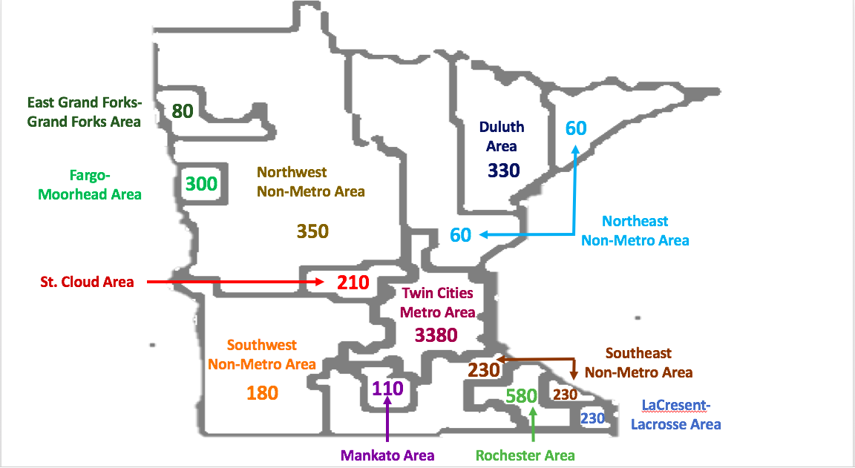

An expanded scope of practice for pharmacists in Minnesota would increase the number of options and accessibility to important healthcare services for the state’s residents. In fact, available data shows that 93% of all Americans live within five miles of a pharmacy (National Association of Chain Drug Stores (NACDS). 2011–2012 chain pharmacy industry profile. Alexandria, VA. 2011), which is an especially important consideration in Health Professional Shortage Areas for Primary Care (HPSA-PC). HPSA-PC’s designations represent shortages in primary care providers (i.e., physicians, physician assistants, and nurse practitioners) for geographic locations (e.g., counties), populations (e.g., low income), or facilities (e.g., rural health clinic) as determined by the Health Resources & Services Administration (HRSA). HRSA assigns scores based on demographic, health, and other criteria ranging from 0-25 with higher scores indicating greater need. Figure 2 overlays 12 areas determined by the BLS on top of each Minnesota county’s Health Professional Shortage Area - Primary Care (HPSA-PC) score category, with a higher score indicating greater need.

Figure 2. Minnesota county’s Health Professional Shortage Area - Primary Care (HPSA-PC) score category, with a higher score indicating greater need.
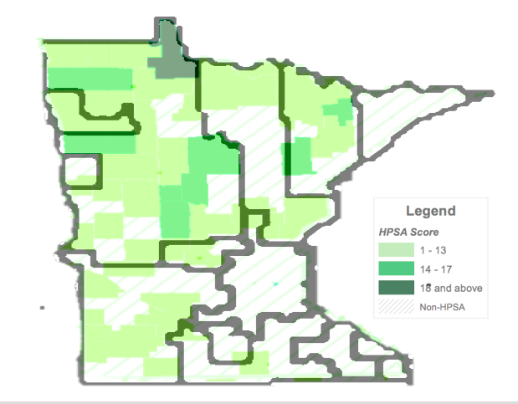

A comparison of Figure 1 and Figure 2 shows that pharmacists are well positioned geographically to make a significant impact. They could make a significant impact in some of the areas of highest need like rural regions in the western and northeastern parts of the state and economically disadvantaged urban areas. This is especially important considering that meeting the health needs of rural Minnesota in the next decade will require more than 800 physicians that what is currently projected to be available (http://www.startribune.com/with-rural-minn-doctors-in-short-supply-lawmakers-weigh-more-incentives/293104531/).

Even if nurse practitioners and physician assistants are fully utilized, they cannot fully meet this demand. Furthermore, an increased scope of practice for pharamcists can be expected to ease the heavy workload of primary care providers and allows them to provide for and serve more patients (https://www.nga.org/files/live/sites/NGA/files/pdf/2015/1501TheExpandingRoleOfPharmacists.pdf). The impact of pharmacist driven will improve this deficit in the near term and the long term as job growth for pharmacists is estimated to grow 7.7% in Minnesota by 2022 (Projections Central).

2) Describe, with evidence where possible, how the new/modified proposal will impact the overall supply of the proposed services with the current/projected demand for these services.

Naloxone
The Minnesota Department of Health reports that more than 2,273 Minnesotans have died from opioid overdoses since 2000. Table 1 displays the dramatic rise of this epidemic that continues to grow every year and has touched every corner of the state including urban counties like Hennepin (56 deaths in 2015), suburban counties like Dakota (17 deaths in 2015), more rural counties like St. Louis county (15 deaths in 2015) (http://www.health.state.mn.us/divs/healthimprovement/content/documents/2015OpioidDeathReport.pdf).
St. Louis county had determinantal effects especially hard in 2015, having the highest overall death rate per capita. Significant steps have already been taken to address this issue like the Prescription Monitoring Program, better data collection, and availability to opioid-overdose rescue drugs like naloxone, but more can be done. For instance, although the effective, safe, and non-addictive drug naloxone can be bought without a prescription at larger chain pharmacies around the state, it is still inaccessible for many rural and low-income patients or their families who often do not have access to pharmacies run by large organizations that provide this drug. Failing to allow pharmacists to independently dispense this medication creates an unnecessary hurdle to a life-saving drug that can help people suffering with addiction and need a second chance (https://www.mprnews.org/story/2015/10/08/naloxone-over-the-counter-minnesota). States like New Mexico (The Network for Public Health Law. Using law to support pharmacy naloxone distribution. Website. 2016. networkforphl.org/_asset/qdkn97/Pharmacy-Naloxone-Distributions.pdf.) and California, which have a high number of relatively isolated rural communities, (http://www.mpha.org/?page=journal_15_summer_07) have granted pharmacists prescriptive authority for these medications and have seen promising results (http://www.pharmacytimes.com/contributor/marilyn-bulloch-pharmd-bcps/2016/10/as-naloxone-accessibility-increases-pharmacists-role-expands). In New Mexico, a cross-sectional analysis found that naloxone kits were more frequently dispensed by pharmacists to a patient or from family or friends of a person suspected of abusing opioids (Bachyrycz A, et al. Opioid overdose prevention through pharmacy-based naloxone prescription program: innovations in healthcare delivery. Subs Abus. 2016;10:0). The study also found there was no evidence that this increased avalability of naloxone encouraged or increased the abuse of opioids (http://www.mpha.org/?page=journal_15_summer_07).

Table 1. Opioid Overdose Deaths in Minnesota
 | 2  0  0  0 | 2  0  0  1 | 2  0  0  2 | 2  0  0  3 | 2  0  0  4 | 2  0  0  5 | 2  0  0  6 | 2  0  0  7 | 2  0  0  8 | 2  0  0  9 | 2  0  1  0 | 2  0  1  1 | 2  0  1  2 | 2  0  1  3 | 2  0  1  4 | 2  0  1  5
Opioid Overdose Deaths | 23 | 57 | 62 | 74 | 102 | 111 | 130 | 154 | 168 | 211 | 179 | 173 | 197 | 204 | 212 | 216
(http://www.health.state.mn.us/divs/healthimprovement/content/documents/2015OpioidDeathReport.pdf)
Smoking Cessation
According to the Minnesota Department of Health, smoking causes 5,900 deaths and over $2.5 billion in medically costs every year in Minnesota. A study found that community pharmacist intervention lead to a 12.7% increase in smoking cessation rates through interventions related to nicotine replacement.

More Minnesotans die from tobacco than alcohol, homicides, car accidents, AIDS, illegal drugs, and suicide
combined. [1] A report by the surgeon general estimated that the national healthcare cost of smoking is around $170 billion annually. [2] Smokers are 1.7‐2.2 times more likely to quit smoking successfully for at least 5 months when receiving assistance from a local healthcare professional. [3] Pharmacists, as the most accessible health care professionals, can play an integral role in helping individuals quit smoking. A study found that community pharmacist intervention led to a 12.7% increase in smoking cessation rates through
intervention.

Travel medications
An APhA study found that pharmacists increased administered vaccines in the population by 41.4% . Pharmacists can use the exact same skills, and the same success, to help protect immigrants and other traveling individuals receive the appropriate vaccinations. Overall, this improves the public health of all citizens living in Minnesota. Every year of the last five years, approximately 101,000 migrants have entered the state of Minnesota. Nineteen percent (24,000) of those 101,000 migrants annually hail predominantly from areas endemic with vaccine-preventable travel-related illness, such as India, Eastern and Western Africa, Mexico, and China. In these areas, the highest rates of vaccine-preventable travel-related illness include cholera, hepatitis A and B, Japanese encephalitis, malaria, typhoid and yellow fever, rabies, and polio. As these immigrants travel back and forth from their migrating countries of origin, it is imperative to protect them and the population of Minnesota from the contraction and spread of vaccine-preventable disease. Pharmacists are poised to ease this public health burden because

G. Proposal Supporters/Opponents
(Sponsor should understand and attempt to address the concerns of the opposition before submitting the document)
1) What organizations and groups have developed or reviewed the proposal?
The Pharmacy Advocacy Task Force has been the lead group in development of this proposal. It is a combined effort from many Minnesota pharmacy organizations. At the time this document was drafted the following organizations helped review/develop the proposal:
- Minnesota Pharmacists Association (MPHA)
- Minnesota Society of Health System Pharmacists (MSHP)
- Minnesota Board of Pharmacy
- The American Pharmacist Association (APHA)
- American Society of Health System Pharmacists (ASHP)
The following organizations have reviewed the proposal:
- Minnesota Medical Association
- The Minnesota Nurses Association
- The Minnesota Nurse Practioners
- ClearWay Minnesota

2) Note any associations, organizations, boards, or groups representing the profession seeking regulation and the approximate number of members in each in Minnesota.
- Minnesota Pharmacist Association has over 2,000 members whose goal is to advance patient care by serving Minnesota Pharmacists.
- Minnesota Society of Health System Pharmacists is a professional organization affiliated with the American Society of Health-System Pharmacists with over 1,200 members consisting of pharmacists, pharmacy technicians, residents, and students who wish to advance the practice of pharmacy in Minnesota.
- Minnesota Board of Pharmacy is the primary regulatory agency for pharmacist in Minnesota. It has 20 members and is responsible for oversight of the over 2,000 pharmacy, 8,500 licensed pharmacists, 10,700 licensed pharmacy technicians, and 1,500 pharmacy interns in the state of Minnesota.
- The American Pharmacist Association is the largest associations of pharmacists in the United States and has more than 62,000 members.
- American Society of Health System Pharmacists represents pharmacists who provide patient care in both acute and ambulatory settings and has more than 43,000 members.
- National Alliance of State Pharmacy Associations represents all 50 states and the pharmacists with-in them. As well as many drug manufacturers, wholesalers, pharmacy chains and hospitals.
- The National Association of Chain Drug Stores includes many large and small chain pharmacies, wholesalers, and distributors.
- The National Community Pharmacists Association services more than 22,000 independent community pharmacies and their employees.

3) Please describe the anticipated or already documented position professional associations of the impacted professions (including opponents) will/have taken regarding the proposal.
The Center for Medicare and Medicaid Services recently released an informational bulletin supporting the practice of pharmacist prescribing. In the bullet CMS states that pharmacist prescribing through standing orders or other predetermined protocols can “facilitate timely access to drug therapy”. Also stating that the time it takes for patients to form a relationship with a physician can undermine access to, the efficacy of certain medications. Proof of the effectiveness of this approach has been seen with pharmacist administered vaccinations which “provides seamless and timely delivery of care to patients”.

The Minnesota Medical Association is currently the only identified organization that opposes this change in scope of practice. The MMA has opposed past attempts of other health professionals expanding access to care through increased prescribing ability.

4) State what actions have been undertaken to minimize or resolve any conflict or disagreement with those opposing/likely to oppose the proposal.
5) What consumer and advocacy groups support/oppose the proposal and why?

H. Report to the Legislature
1)Please describe any plans to submit a report to the legislature describing the progress made in the implementation and the subsequent impacts (if measureable) of the scope of practice changes for regulated health professions/occupations. Describe the proposed report’s focus and timeline. Any proposed report schedule should provide sufficient time for the change to be implemented and for impacts to appear.

References:
- Department of Health and Human Services: Centers for Medicare & Medicaid Services. State Flexibility to Facilitate Timely Access to Drug Therapy by Expanding the Scope of Pharmacy Practice using Collaborative Practice Agreements, Standing Orders or Other Predetermined Protocols. 2017. Baltimore, MD.
- Tobacco Prevention and Control: Data and Reports. Minnesota Department of Health. Last updated: December 12, 2016. http://www.health.state.mn.us/divs/hpcd/tpc/data.html
- Hudmon K and Vitale F. Rx For Change.
- Minnesota Department of Health. International Travel Health Clinics Serving Minnesota Residents. [online]. Updated January 12, 2017. Accessed January 30, 2017. http://www.health.state.mn.us/divs/idepc/immunize/travel/yfclinic.html
- Bonner L. Naloxone Access: More states look to pharmacists to increase naloxone access, 2016. Pharmacy Today. 22:2;57
- Centers for Disease Control. Injury Prevention and Control; Prescription Drug Overdose Data. 2014; http://www.cdc.gov/drugoverdose/data/overdose.html. Accessed 9 Feb, 2016.
- Han B, Compton WM, Jones CM, Cai R. Nonmedical Prescription Opioid Use and Use Disorders Among Adults Aged 18 Through 64 Years in the United States, 2003-2013. JAMA. 2015;314(14):1468-1478.
- Paulozzi LJ, Strickler GK, Kreiner PW, Koris CM. Controlled substance prescribing patterns-Prescription Behavior Surveillance System, eight states, 2013. MMWR: Surveillance summaries. 2015;64(SS-9):1-14.
- Shrestha S, Bleske B, Tinker D, Bakhireva LN. Opioid Overdose Prevention Through Pharmacy based Naloxone Prescription Program: Innovations in Healthcare Delivery, 2016. Substance Abuse. 2016.1184739
- Substance Abuse and Mental Health Services Administration. Results from the 2013 National Survey on Drug Use and Health: Summary of National Findings. NSDUH Series H-48, HHS Publication No. (SMA) 14-4863. Rockville, MD: Substance Abuse and Mental Health Services Administration, 2014.

- Protection, Department. "DCP: Training For Pharmacists To Prescribe Naloxone Is Now Available". Ct.gov. N. p., 2017. Web. 31 Jan. 2017.
- Hooker, Roderick S., and Ashley N. Muchow. "Modifying state laws for nurse practitioners and physician assistants can reduce cost of medical services." Nursing Economics 33.2 (2015): 88.
- Santibanez, M. Santibanez, Martha. "Location Influences Cost Of Visit To A Doctor | ". Mncm.org. N. p., 2014. Web. 27 Jan. 2017.
- MHCP Provider Manual - Medication Therapy Management Services (MTMS) "MHCP Provider Manual - Medication Therapy Management Services (MTMS) ".Dhs.state.mn.us. N. p., 2017. Web. 27 Jan. 2017.
- Brummel, Amanda, et al. "Best practices: improving patient outcomes and costs in an ACO through comprehensive medication therapy management." Journal of Managed Care Pharmacy 20.12 (2014): 1152-1158.
- Health Care Costs from Opioid Abuse: A State-by-State Analysis Drugfree.org. N. p., 2017. Web. 27 Jan. 2017.
- New England Journal of Medicine (01/26/17) Vol. 376, No. 4, P. 342 Kasza, Karin A.; Ambrose, Bridget K.; Conway, Kevin P.; et al.
- Barlas, Stephen. "Pharmacists Want a More Explicit Role in ACOs: Medicare’s Hands Are Tied... at Least Initially." Pharmacy and Therapeutics 36.10 (2011): 685.
- Bond, C. A., Cynthia L. Raehl, and Todd Franke. "Clinical pharmacy services, pharmacy staffing, and the total cost of care in United States hospitals." Pharmacotherapy: The Journal of Human Pharmacology and Drug Therapy 20.6 (2000): 609-621.
- Pringle, Janice L., et al. "The Pennsylvania Project: pharmacist intervention improved medication adherence and reduced health care costs." Health Affairs 33.8 (2014): 1444-1452.
- Akinbosoye, Osayi E., et al. "Improving medication adherence and health care outcomes in a commercial population through a community pharmacy." Population health management 19.6 (2016): 454-461.
- MTM in Minnesota: Plan pays pharmacists for performance "MTM In Minnesota: Plan Pays Pharmacists For Performance". American Pharmacists Association. N. p., 2013. Web. 30 Jan. 2017.
- Viswanathan, Meera, et al. "Medication therapy management interventions in outpatient settings: a systematic review and meta-analysis." JAMA internal medicine 175.1 (2015): 76-87.
- Minnesota Board of Pharmacy License Statistics Mn.gov. N. p., 2017. Web. 31 Jan. 2017.
- Revisor of Statutes, State of Minnesota. (2016). [online]. Accessed January 30, 2017. https://www.revisor.mn.gov/statutes/?id=151.071
- Minnesota Board of Pharmacy. Overview of Complaints [online]. Accessed January 30, 2017. http://mn.gov/boards/pharmacy/complaints/overviewofcomplaints.jsp

