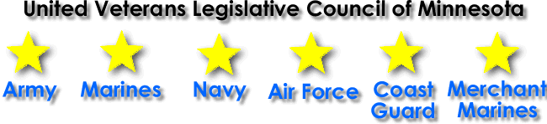
Home Welcome Meetings Minutes Officers Events News Links Resources

Latest news:
Minnesota Military Pension Exemption
YMCA Waives Joiner's Fee for Veterans and Families
Pearl Harbor Ceremony 2016

Chairman's Welcome Message
Welcome to the UVLC website. Our general purpose is to inform and educate member organizations, federal, city and state legislators and agencies of the need for the effect of and the status of legislation, ordinances, rulings and actions that promotes and advances the welfare and interests of all veterans, active military, national guard and reserve personnel of the armed forces of the USA, their dependents and survivors.
In addition to our member organizations, at our monthly meetings we work with the commander’s task force that consists of nine of the many congressionally chartered veteran service organizations in the state of Minnesota. The number of veteran advocate and auxiliary charities has grown in the last ten years. We invite them into our organization to assist us in becoming more veteran friendly. Our monthly meetings are the first Wednesday of each month at 9:30 AM in building 9 auditorium of the Minneapolis Veterans Hospital Campus. Please contact the chairman, United Veterans Legialative Council of Minnesota at (763) 441-2630 should you need additional information.
"The willingness with which our young people are likely to serve in any war, no matter how justified, shall be directly proportional as to how they perceive the Veterans of earlier wars were treated and appreciated by their country." - George Washington, 1789
Copyright © 2016 United Veterans Legislative Council of Minnesota
Contact the Webmaster | Privacy Statement

