March 3, 2017

Dear Legislator:

I am writing a letter of support for the Minnesota State Council on Disability and the technical and complex access information and assistance their staff provides to the public.

The Department of Labor and Industry and MSCOD have had a long and rewarding history of working together. Building code staff from DLI’s Construction Codes and Licensing Division have cooperated with Council staff in coordinating outreach and education efforts on the Minnesota Accessibility Code, Americans with Disabilities Act, and the federal Fair Housing Act. In addition, our staffs have served together on advisory committees adopting codes; jointly participated in numerous educational forums; and implemented legislation such as the vertical stair-chairlift access board and the 2016 mitigation of frivolous accessibility lawsuits.

MSCOD staff are a trusted, knowledgeable, and experienced resource for architects, building owners, building officials, and the general public on the requirements of accessibility laws, the Minnesota Building Code, and the Minnesota Human Rights Act. Council staff always demonstrate a high level of commitment in achieving the greatest degree of access for the citizens of Minnesota.

We look forward to working with MSCOD on these important issues for the Disability Community and the State of Minnesota.

Sincerely,

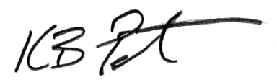

Ken B. Peterson
Commissioner

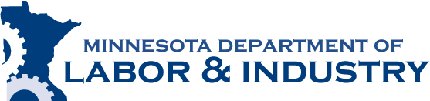

443 Lafayette Road N.

St. Paul, MN 55155

www.dli.mn.gov

(651) 284-5005

1-800-342-5354

This information can be provided to you in alternative formats (Braille, large print or audio).
An Equal Opportunity Employer

This information can be provided to you in alternative formats (Braille, large print or audio tape).
An Equal Opportunity Employer

