

March 28, 2016

Representative Rod Hamilton

443 State Office Building

100 Rev. Dr. Martin Luther King Jr. Blvd.

Saint Paul, Minnesota 55155

Dear Representative Hamilton,

The Long Term Care Imperative would like to offer our support of HF 564 which provides a rate increase for Home and Community Based Services programs. We would also like to thank you for your leadership on ensuring access to care in the community for seniors and those with disabilities.

An increase in funding to these waiver programs will help fund critical services for 108,000 Minnesotans throughout the state with most of the five percent increase directed to 99,000 caregivers and improving quality. **A rate increase will directly help to improve staff wages, reduce turnover and improve the quality of care received.**

60,000 Minnesotans will turn 65 each year from now until at least 2030. As our aging population grows, so does the number of seniors who wish to age in home like-environments. Home and Community Based Services allows low income seniors to access needed care so that they can remain independent and within the community. This bill provides the first step to reforming our waivered services to meet the growing needs of our aging population.

Thank you for your support of our most vulnerable populations.

Sincerely,

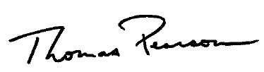 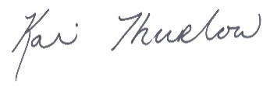

Thomas Pearson Kari Thurlow

Vice President of Advocacy Senior Vice President of Advocacy

Care Providers of Minnesota LeadingAge Minnesota