March 5, 2017

Minnesota House Health and Human Services Reform Committee
State Capital
St. Paul, Minnesota

Dear Chairman Schomacker and members of the House Health and Human Services Reform Committee,

On behalf of the Biotechnology Innovation Organization (BIO), I would like to ask for your support of HF 712. BIO is the international biotechnology trade association representing over 1,200 biopharmaceutical companies, research institutions, universities, and state biotechnology associations, such as Medical Alley.

Our organization supports HF 712, because it contains important provisions that take into account the special and complex characteristics of biologic medicines. Unlike traditional chemically derived medicines, biologics are made from living organisms, making them effective in treating life threatening diseases and conditions such as cancer, rheumatoid arthritis and diabetes. Pharmacy substitution with these special medicines should therefore ensure patient safety by limiting substitution to biologics designated as interchangeable by the U.S. Food and Drug Administration and by establishing open communications between the pharmacy and prescriber as a way to ensure all those involved in a patient’s care know exactly the course of treatment for that patient.

HF 712, by Representative Albright, contains those important provisions, which is why we encourage the House Health and Human Services Reform Committee to support this important legislation.

Please do not hesitate to contact me if you have questions or require any additional information.

Sincerely,
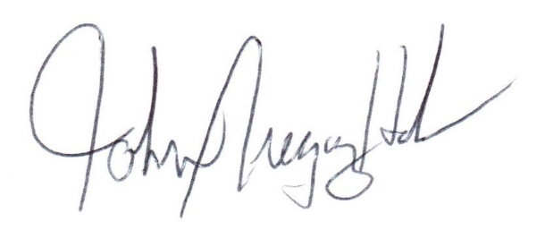
John Gregory Hoke
Director, State Government Affairs
Biotechnology Innovation Organization

