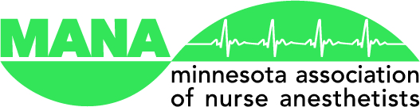
January 13, 2016

Dear Members of the Minnesota House of Representatives:

The Minnesota Association of Nurse Anesthetists (MANA) respectfully asks you to support H.F. 733 (Nurse practices act modified, and licensure requirements for advanced practice registered nurses clarified). MANA supports the Board of Nursing’s efforts to clarify the 2014 Advanced Practice Registered Nurse law. These clarifying changes will ensure the statute is consistent with the original intention of the bill.

On behalf of their members, the Minnesota Association of Nurse Anesthetists urges you to support H.F. 733.

Sincerely,

Jon Wohlhuter, President
Minnesota Association of Nurse Anesthetists

