I am extremely concerned, frustrated, and losing faith in Minnesota legislation for considering an assisted suicide bill! Healthcare means caring for and promoting health of all individuals, and does not mean aiding dying. No person or institution should be encouraged or forced to promote death!

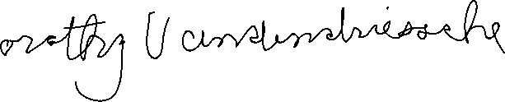

Dorothy Vandendriessche

Marshall, Mn