Report to MN Department of Education
Report period: July 1, 2017 – June 30, 2018
JEWISH FAMILY AND CHILDREN’S SERVICE OF MINNEAPOLIS (JFCS)
5905 Golden Valley Road
Golden Valley, MN 55422
Lee Friedman, COO, Program Contact – 952-542-4812

Report Summary:
PROGRAM DESCRIPTION:
The national research-proven Parent-Child Home Program (PCHP) invests in economically and educationally disadvantaged children, ages 18 months to four years, by successfully strengthening families and empowering parents with the skills and materials they need to prepare their children for school success. The program’s intensive two-year home visiting model builds school readiness, child development, and parenting skills. Over 50 years of research on this program demonstrates successful outcomes for both parents and children. PCHP creates a paradigm shift in which parent program participants become their child’s first and most important teacher.

PCHP is committed to closing the opportunity gap by empowering low-income families with the skills and materials they need to prepare their children for school and life success.

The Parent-Child Home Program works toward three primary outcomes:
- Children are ready for school – age-appropriate in their social, emotional, cognitive, language and physical development.
- Children live in safe, stable, nurturing environments – in families that demonstrate positive parenting techniques, promote language development and access needed community services.
- Children are healthy – up-to-date with immunizations and well child check-ups.

NUMBERS SERVED:
We originally proposed to serve 250 families of which 180 would be supported by this grant. We served 241 families including 247 child participants and 401 parent/caregiver participants. As planned, 180 families were supported by this grant. Foundation and individual donor funding supported the remaining 61 families.

We maintained a total of 211 (88% retention) families out of 241 families who originally enrolled including 28 families in Cass County, 95 families in Minneapolis, 115 families in suburban Hennepin County, 2 families in Anoka County and 1 family in Ramsey County.

81 families (34%) graduated in May and June of 2018. 130 (54%) families will move to year two of the program in fall of 2018. 30 families (12%) dropped out of the program due to relocation and/or job schedules.

POPULATION SERVED:
- Participants represent 28 Cass County families, 95 Minneapolis families, 115 Suburban Hennepin County families, 2 Anoka families and 1 Ramsey family who continued for a year after moving out of the service area.
- All families are at or below 200% of the 2017 Federal Poverty Guidelines (FPG) with 57% at or below 100% of the guidelines and 43% between 100%-200% FPG.
- Of the 18 month – 4 year-old child participants, 56% are males and 44% are female.
- Parents’ ages ranged from under 20 to 50+ with 56% between ages 30-39.
- Child participants’ race/ethnicity represents 52% African; 7% African American; 18% Spanish/Hispanic/Latino; 6% multiracial; 4% Asian and 13% White.

PROPOSAL OUTCOMES OVERVIEW:
Children and parents have met or exceeded almost all measurable goal outcomes described below.

Participating children are learning and demonstrating age appropriate development that will help make them successful when they enter kindergarten. As needed, families are connected to Early Childhood Special Education or other community resources to help support their development. Families are developing an enriched literacy environment in their home. Parents are demonstrating positive, responsive parenting techniques that support children’s social, emotional, cognitive, and physical development. Verbal interaction between the children and their parents show significant improvement.

Families are better integrated into the community and better able to access necessary resources that will support a safe, stable and nurturing environment for their children. Almost all children participants are up-to-date in their immunizations and well-child check-ups.
Goals, Activities, Measurable Outcomes:
Goal #1: Children are ready for school. Children ages 2-4 years will demonstrate age-appropriate social, emotional, cognitive, language and physical development

Activity 1.1:
Families receive up to 60 home visits a year (total 120 visits over 2 years), during which the Early Learning Specialist models and facilitates enriched verbal interaction between the child and parent and models positive parenting techniques such as encouragement, nurturing, redirecting and engaging. One educational toy or book is given to the participating child each week, over 23 weeks minimum, each of 2 years. A total of 10,365 visits were conducted in the 2017-18 program year. A total of 2,622 books and 2,707 toys were distributed.

Outcomes 1.1
- 93% (Goal was 85%) of children demonstrated age appropriate development within six domains as measured by the ASQ and ASQ-SE developmental screening tool: 94% Personal-Social, 91% Communication, 99% Gross Motor, 94% Fine Motor, 94% Problem Solving and 88% Social-Emotional.
- 82% (Goal was 85%) of children participated in kindergarten screening for three-year olds. JFCS will continue to train staff on best practices to encourage and refer families to get kindergarten screenings completed.
- 100% (Goal was 100%) of participating children showed increased familiarity with reading and written materials such as pre-school books, and magazines.
- 63% of first year and 93% of second year participating children (Goal was 60% of first year and 85% of second year children) showed increased attention span and ability to listen to books being read for a sustained period of time.
- 57% of first year and 81% of second year children (Goal was 60% of first year and 85% of second year children) showed increased ability to take turns and tolerate frustration.

Activity 1.2 Children receive early interventions as appropriate
Children who do not demonstrate they are age-appropriate in all domains are flagged and tracked by the PCHP coordinator and program manager who may also consult with an Early Childhood Special Education school district representative to help determine when/if a referral to early intervention services is appropriate. In some cases, the PCHP Manager may determine a referral is appropriate even when the child has passed all six domains measured by the ASQ.
Outcome 1.2
18% (our estimated need was 8%) of participant children were referred for intervention services by the Early Learning Specialist in consultation with the PCHP Coordinator. Referrals are recorded in Early Learning Specialist case notes, the JFCS client data base system and the PCHP National Center data base. Data shows type of referral and status of receipt of service.

Goal #2: Children live in safe, stable, nurturing environments
Activity 2:
- Home Visits are described in Goal 1.
Outcome 2.1 Families demonstrate positive, responsive parenting techniques that support children’s social, emotional, cognitive, and physical development
- 77% (goal was 85%) of families showed progress in demonstrating positive, responsive parenting techniques with their children (For example, recognize and respond to child's needs, exhibit empathy and understanding, talk with the child at eye-level, take deep breaths and speak calmly to diffuse a high-stress situation, and praise the child for positive behavior).
Outcome 2.2 Families promote children’s language development
- 80% (Goal was 85%) of families showed an increase in parent/child communication techniques that promote language/literacy skills of children (For example, have daily conversations with their child, read to their child, play alphabet and word games to increase vocabulary, do storytelling, and play with their child).
During weekly visits, Early Learning Specialists record case notes of observations and parent feedback that are used for anecdotal indicators, such as asking a parent how often they read with their child. Near the end of a family’s participation in PCHP, parents complete a PCHP Parent Survey, which has parents reflect on areas of positive parenting techniques. Parents are asked to first assess how they are often they are utilizing these positive parenting techniques. Then the survey has parents assess if they do these techniques less than, the same as, a little more or much more than before they participated in PCHP. The data reported is a percentage of parent who implement these positive parenting techniques a little more or much more than before participating in PCHP.
Outcome 2.3 Families access community services as needed
- 100% (goal was 100%) of families received at least two referrals to essential community resources (e.g. emergency financial assistance, medical or legal consultation, food pantry, library). This year 1129 referrals (an average of 5 per family) made by Early Learning Specialists helped their families connect to needed resources such as for assistance for housing, transportation and food; referrals for legal, education and employment related services; referrals for mental, physical and dental health; and referrals for reduced fee or free recreational activities for families and children.
100% of families were invited to PCHP library events created to help families gain greater familiarity with their local library, obtain library card, and visit the library at least once during the year. All families had at least one conversation about their local library with their Early Learning Specialist. Early Learning Specialist invited families to attend at least one library story time arranged for PCHP Participants. Based on the number of library referrals for tutoring, story times, computer access, etc., we estimate that nearly all families became more familiar with their library system.

- 96% (goal was 95%) followed up in accessing the services. Receipt of referral was noted by Early Learning Specialist and entered into the agency client database. Early Learning Specialist confirm follow-up receipt of community resource by parents self-reporting during home visits.

Goal #3: Children are healthy
Activity 3.1: Parents are asked at intake and again at the annual evaluation if their children are up to date on immunizations and well-child check-ups. Information and referrals are made when a family needs assistance in this area.
Outcome 3.1 Children are up-to-date with immunizations
- 93% (goal was 85%) of parents reported that their children have up-to-date immunizations.

Outcome 3.2 Children complete annual well-child check-ups.
- 94% (goal was 85%) of parents will report that their children have completed an annual well-child check-up.

EVALUATION OF OUTCOMES
Over 40 measurable indicators are used to assess program goals and outcomes. Examples of specific indicators are included within the goals and outcomes described in the previous section. Outcomes are measured by June of each program year, or after 23 weeks of visits. Some are measured periodically throughout the year.

Research-based assessment tools are used to assess all PCHP children and parents throughout the program. The “Child Behavior Traits” tool, the Evaluation of “Parent and Child Together,” tool, the ASQ and ASQ-SE, and the Positive Parenting Indicator Assessment designed by Wilder Research are used throughout the two-year program. Outcomes of all measures are reviewed by PCHP local and national program representatives who use the information to monitor program quality and fidelity to national standards.
Client and program data is managed through the agency’s client data base system which is EHR compliant (electronic health record). Collection protocols are managed by the PCHP program manager and overseen by the JFCS outcomes project manager. In addition, data is recorded in the PCHP National Center which develops annual reports that track our site outcomes along with over 150 PCHP sites nationally and internationally (e.g. Canada, Ireland).
Minnesota Family Success Stories

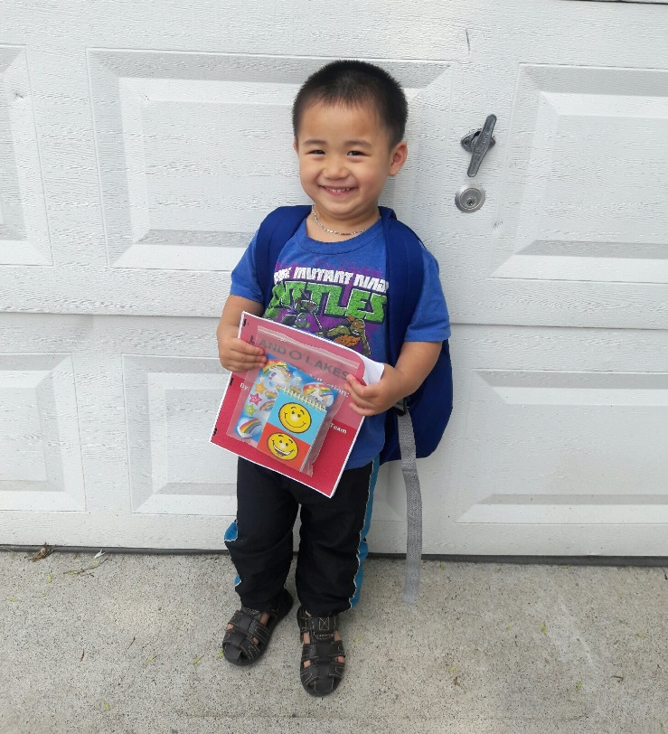
In 2018, Early Learning Specialist, Her Vang, arranged for PCHP families to visit local libraries. Her held two events at local libraries. She introduced three families to the children’s library programs. Lavy’s mother, Xua, had never been to the library before. She had many questions for the librarian: How long can we stay? Do I have to pay for a card? How many books can we check out? After Xua signed up for her library card and discovered she could check out up to 50 books she told Her, “You can go ahead and leave, we are going to stay a while longer and read.” The events were a big success for the families, who felt a great satisfaction in seeing the children surrounded by books and toys in a safe environment and in leaving the parents equipped with a new, free and accessible resource to help their children learn.
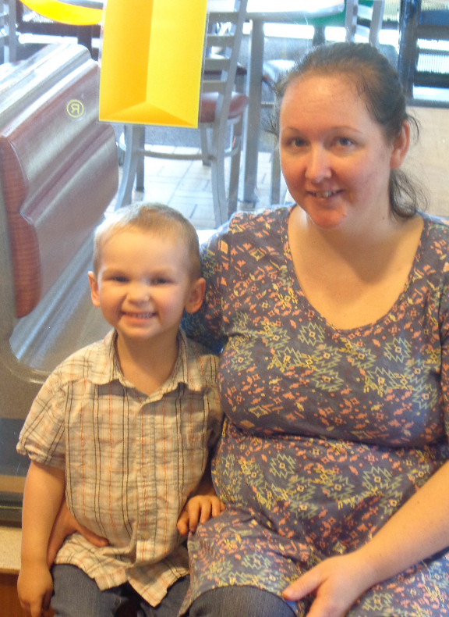
Vicki was a first time mom who had health complications when her child Gunnar was born. Vicky and Gunnar participated in the Healthy Families America Home Visiting Program and the Home Visitor referred the family to PCHP. Gunnar’s speech was not developing and his behaviors reflected his frustration. In PCHP, Gunnar and Vicki began learning and using sign language. Gunnar caught on quickly and his frustrations with communication barriers decreased. Throughout the second year of PCHP Gunnar’s speech slowly emerged. Gunnar and Vicki graduated from PCHP in May of 2018. This fall, Gunnar will be attending the Northland Family Center Preschool.

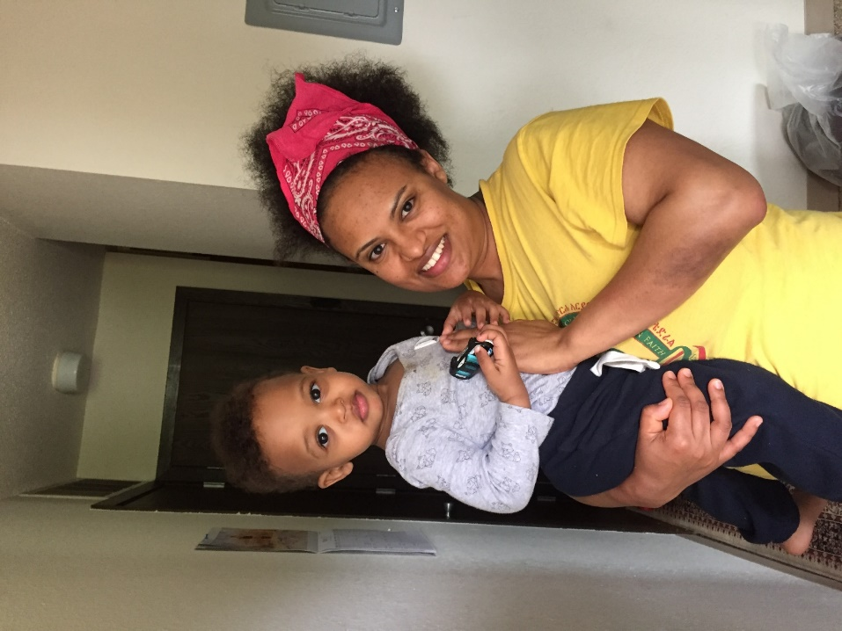
Tsigereda and her son Zebulun were active participants in the PCHP Preview Program this year. Tsigereda recently immigrated to the US and struggled to meet the basic needs of her family. Over time, Tsigereda developed a supportive and trusting relationship the PCHP Early Learning Specialist. She was able to share details her challenging situation and was referred to important community resources including food and job support. The wraparound support Tsigereda received in the PCHP program was paramount to enhancing her family’s situation. She is now working with a job counselor and her goal is to find full-time employment. She looks forward to continuing in the program and being her son’s first and most important teacher.

