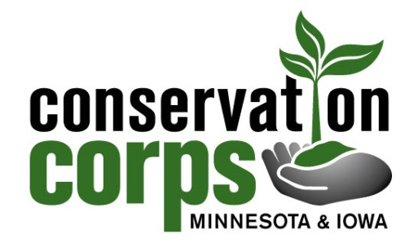
January 21, 2019
Peter Strohmeier
Committee Administrator
Minnesota House of Representatives
Environment and Natural Resources Finance Division
430 State Office Building
St. Paul, MN 55155

Dear Peter,
Thank you for the opportunity to provide information on the impact of the Federal shutdown to the operations and programs of the ConservationCorps MN and IA.
As you are aware, The Conservation Corps provides hands-on environmental stewardship through the facilitation of service-learning opportunities that help youth and young adults from diverse backgrounds gain valuable work readiness skills while accomplishing conservation, natural resource management and emergency response work. The Corps couldn’t not accomplish its works without the ongoing partnership and collaboration of hundreds of local, county, state and federal agencies who serve as project hosts and partners for the corps member crews we deploy across Minnesota.
We have a diverse and relatively stable funding model. We receive operating revenue through federal, state, private, and fee-for-service.
With respect to the current Federal shutdown, we are fortunate that at this point in the shutdown, our impact has been minimal, in the short term, as Winter is our low season for hiring corps members. However, we are monitoring the situation closely, as the impact longer-term could have far more sweeping impacts.
- Federal funding that supports our corps members who do work for MN state agencies is stable due to 2019 federal funding already having been allocated and not impacted.
- Federal funding that supports our corps members and crews for work done in National Parks and agencies, some of which are in Minnesota are impacted and have stalled in the planning and execution. We have several positions currently reassigned for the interim, and they may face redeployment long-term.
- Staff are not able to be in contact with Federal partners to receive project requests and/or plan for the field season to ensure crew schedules can accommodate federal projects including USFWS, USFS and NPS projects throughout MN.
- We may miss out of partnership opportunities for the 2019 season as result of the inability to plan, schedule, and secure agreements.
- In addition to Federally funded work, we have several large projects with MN Valley and Sherburne National Wildlife Refuges that, while funded by non-federal partners like NWTF and MN Valley Trust, may be impacted or cancelled due to the inability to work with Federal employees and/or access to the sites.
- In cases where federal projects were scheduled previously and funding exists we still may not be able to complete the work if scheduled dates are impacted by the shutdown and require staff to re-assign crews to other work. (Due to the inability to re-schedule delayed planned federal projects with seasonal requirements or schedule conflicts.
- Non-federal projects that rely on federal funding sources from grants, matching funds etc. may be reduced or cancelled if funding is unavailable or reduced.
- With respect to our youth programming, we typically hire youth crews to work backcountry trail projects in National Parks. We would typically prepare these agreements in early February and be recruiting now for these positions.
- Prior to the shutdown, the MN Valley Refuge requested corps member specialist, intending to fund the position with federal funds. The agreement process is stalled and position may go unfilled until such time the agreement can be reinstated.
- In the Chippewa National Forest, we have been negotiating an agreement for deploying programs during the summer season. These agreements are typically negotiated at this time year and may not be able to offer these positions this summer, if the shutdown lag continues.
- Youth programming funds exist to plan for implementing a summer program on the Chippewa National Forest for youth with Leech Land Band of Ojibwe. Again, due to our inability to continue program development due to delays caused by the shutdown, we are losing valuable time to foster the necessary recruiting and relationship-building with schools.)
- The Corps has an existing agreement with NPS to place two corps members with the Exotic Plant Management team. Due to start-dates in January, these corps members have been temporarily reassigned due to the shutdown and may have to consider other employment options for 2019, unless the shutdown can be averted soon.

Please let us know if you would like further information.
Regards,

Mark Murphy
Executive Director
Conservation Corps Minnesota & Iowa

