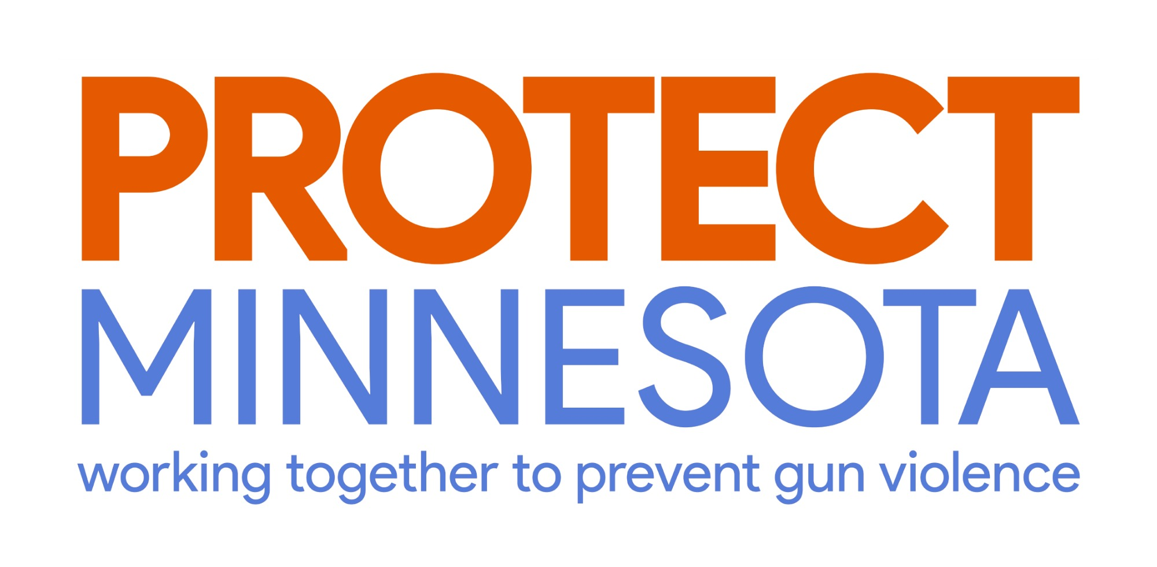

June 12, 2020

Dear Chair Mariani and members of the House Public Safety Committee,

Protect Minnesota, the only independent, state-based organization devoted to gun violence prevention in Minnesota, endorses the package of public safety reforms more commonly known as the POCI caucus bills.
As an organization rooted in public health, we believe that the issue of gun violence cannot be decoupled from the systems in which this violence occurs, including the manner in which justice is administered. In addition, our roots in public health reinforce for us the importance of reliance on data-driven public policy.

The murder of George Floyd has brought the urgent need for policing and criminal justice reform to the forefront of Protect Minnesota’s attention, as it has similarly changed the priorities of our local and state governing bodies. As a gun-violence-prevention organization, we know preventing deaths by police violence is an integral part of our work.

We acknowledge the efforts that each of us must make individually to dismantle systems built on oppression and violence, as well as the role we as an organization must play in doing so. Therefore, we enthusiastically support the list of proposals and reforms brought forward by the POCI caucus, which are both grounded in data and focused on recognizing that structural reform is paramount in addressing Minnesota’s inequities.

Sincerely,

Kate Havelin
C4 Minnesota Advocacy Fund Board Chair
Protect Minnesota
Together, we can work to prevent the public health epidemic of gun violence.

Protect Minnesota – working together to prevent gun violence
2395 University Ave N, Suite 204, St. Paul, MN 55114 651-645-3271 info@protectmn.org

