Minnesota DNR Angler and Hunter
Recruitment, Retention, and Reactivation Grants
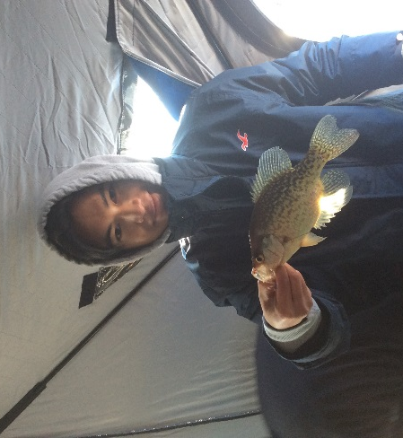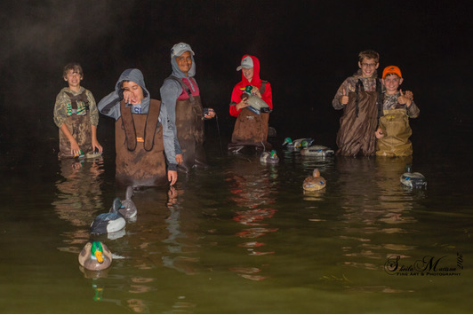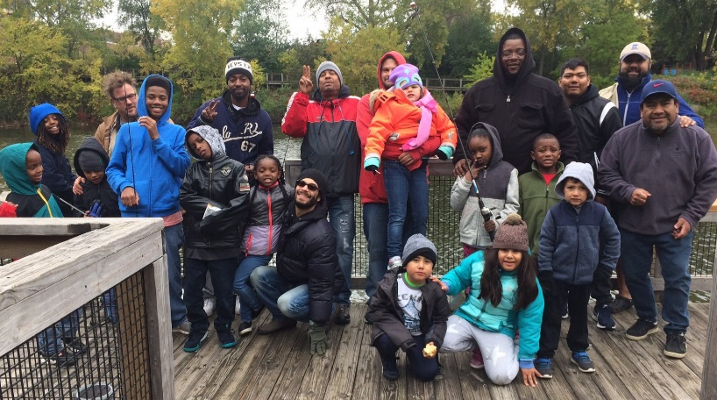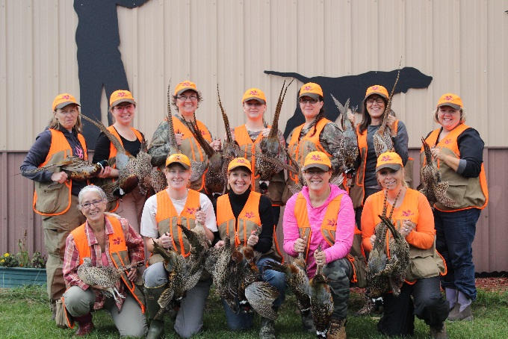

http://www.dnr.state.mn.us/angler_hunter_grants.html

To date (February 2019):
- Angler and Hunter Recruitment, Retention, and Reactivation (R3) Grant program began in 2016.
- 4 rounds - Round 1 projects completed Summer 2017, Rounds 2 and 3 projects completed Fall 2018, Round 4 projects just beginning.
- Round 1 was funded by the Let’s Go Fishing appropriation, Rounds 2-4 were funded by initiatives in the DNR base funding from Game and Fish Fund. No funding is currently dedicated to R3 grants in future budget years.
- 124 applications submitted requesting $1.8 million.
- 45 grants awarded for a total of $630,000.
- First 35 grants (Rounds 1-3) leveraged matching funds totaling $661,595 .

Round 1-3 project highlights:
- Total participants – 10,780
- Demand for funds has far exceeded available dollars
- Focus on engaging new audiences

Contact:
Jeff Ledermann, MN DNR, jeff.ledermann@state.mn.us, 651-259-5247
Round 1 grantee project descriptions and outcomes:

- Tribal Fishing Adventures Inc. - introduced open water and ice fishing to at-risk Native American youth. Of the 100 youth who participated in events, 35 stayed in the program.
- Red Wing Environmental Learning Center - through hands on experiences students reported an increase in knowledge, understanding and respect for the environment.
- St. Paul Urban Ministries - provided opportunities for inner city children, with specific focus on Hmong communities, including a fishing trip to the BWCAW, which was a first for all participants.
- Douglas County Pheasants Forever – provided equipment for Youth Outdoor Activity Day. 90% of kids had no hunting experience and 79% of kids had no fishing experience until this exposure. Over 200 adults from non-shooting families participated in trap or archery.
- Three Rivers Park District – provided equipment to expand fishing and hunting programs to diverse communities.
- Minnesota Waterfowl Association – provided equipment to expand programming and participation at Woodie Camp.
- Ruffed Grouse Society – introduced women to wing shooting. Most reported after the class that they had hunted with family members or had trips planned to hunt in the future.
- Bald Eagle Sportsmen's Association/Minnesota Deer Hunter's Association - Over 90% of participants and mentors in OAKs archery programs hunted during archery season. 65% of participants hunted 6 times or more during the archery season.
- Fishing For Life - provide one-on-one outdoor related experience to youth ages 10-16 years old. An emphasis is placed on youth from military or single parent families. Each mentee participated in the year long program and all mentors have agreed to another year with current mentees.
- Minnesota Trout Unlimited – provided fishing equipment to expand programming for 49 clinics and events. At Metro events, 65% were minorities, 35% had no fishing exposure. 80% have plans for future outings
- Ruffed Grouse Society – developed New Hunter Mentor Program pilot, expanding to all chapters.

