**This patient is 11 months old.** He has seen the medical doctor twice and has not received oral hygiene instructions from his medical doctor. This could have prevented cavities (caries) from occurring.

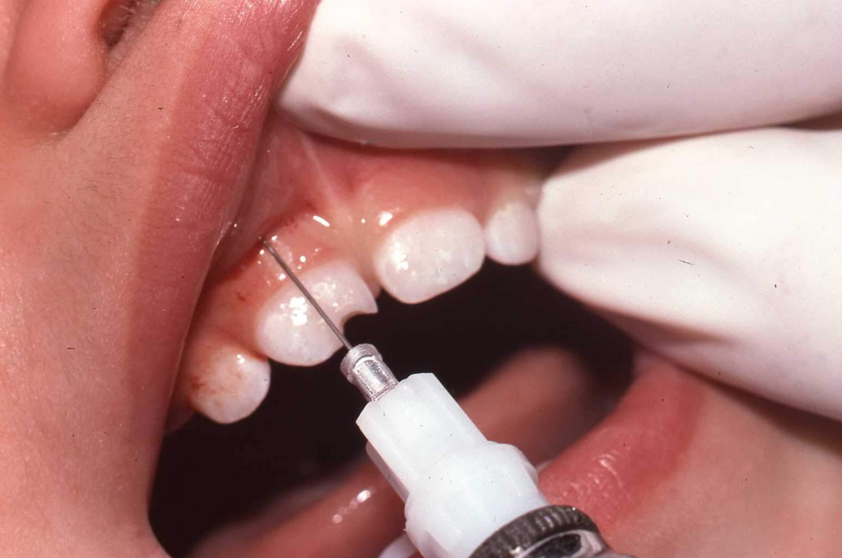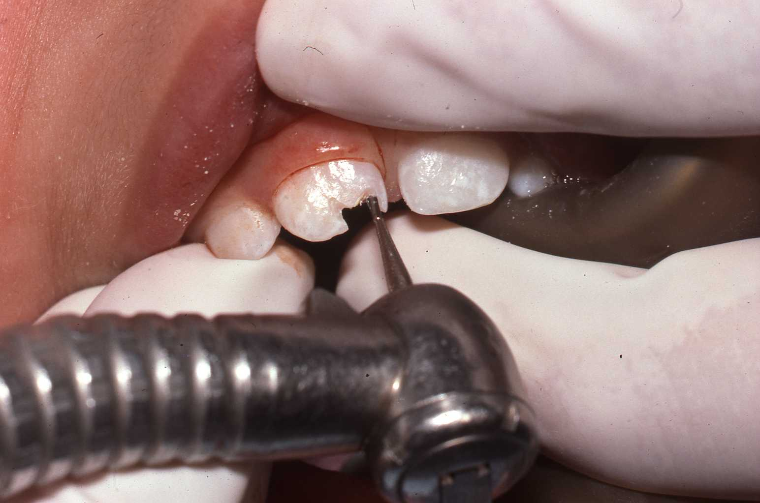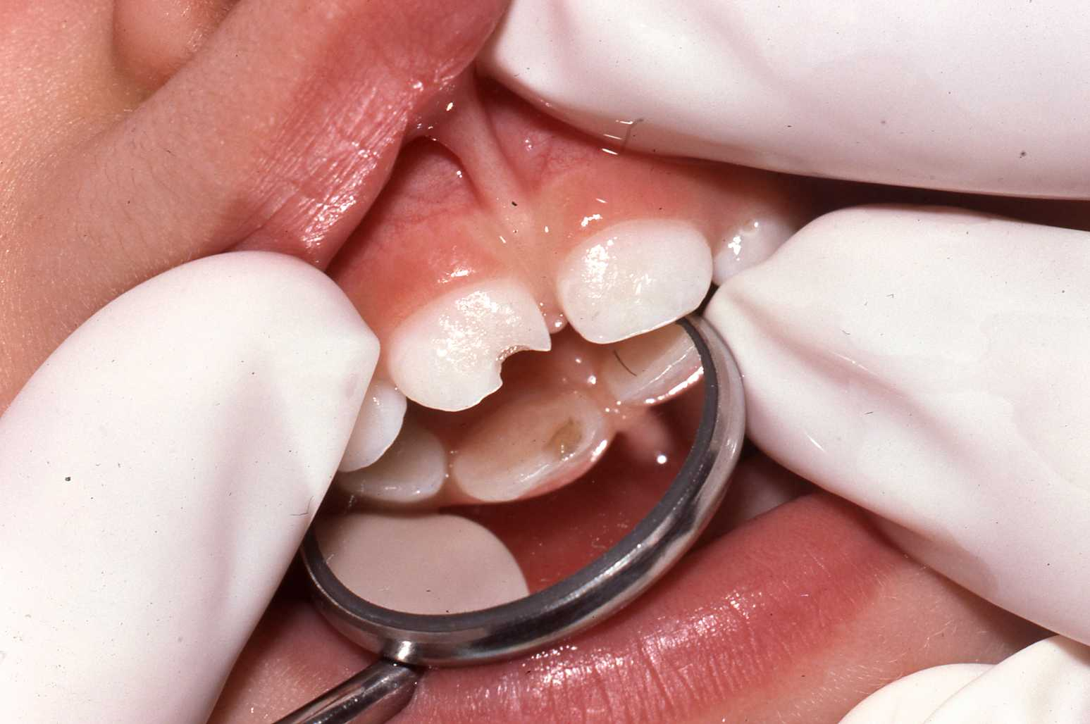

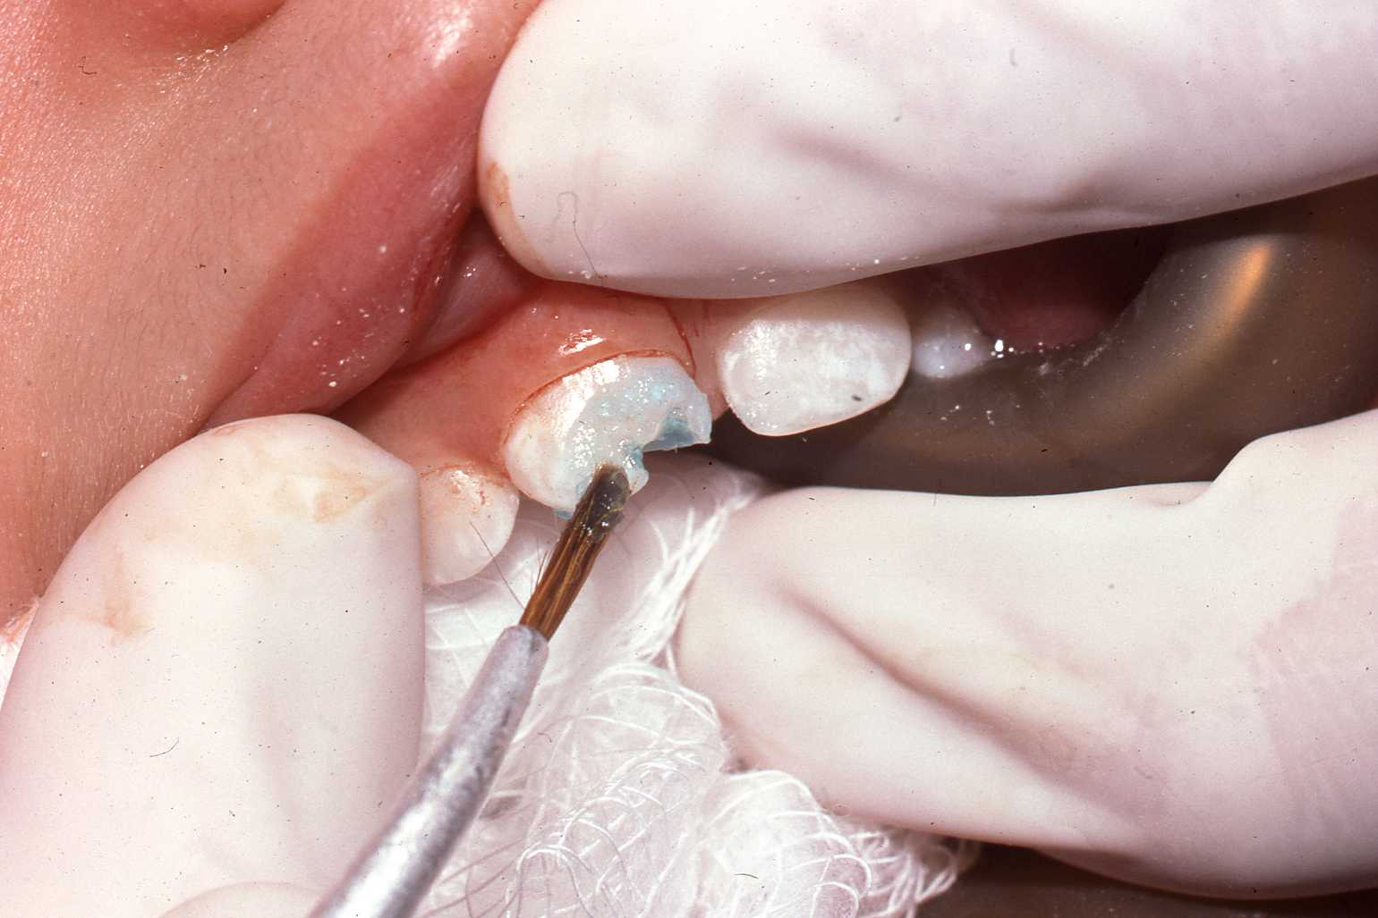

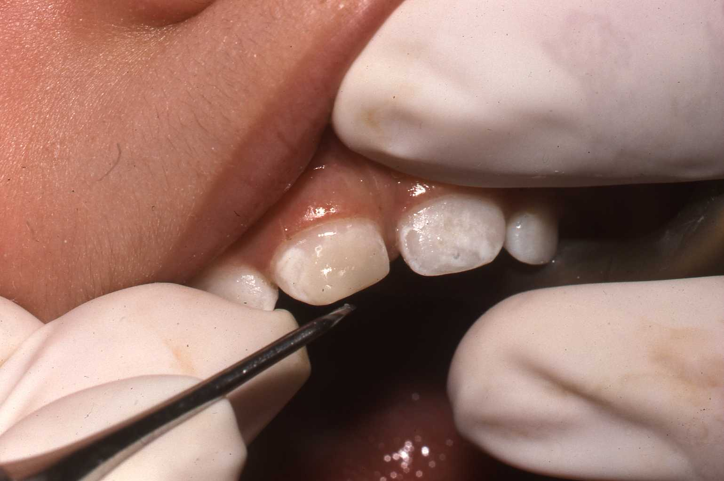

An 11 month old baby has to go through dental procedures. It’s hard on a child and is costly to the State.

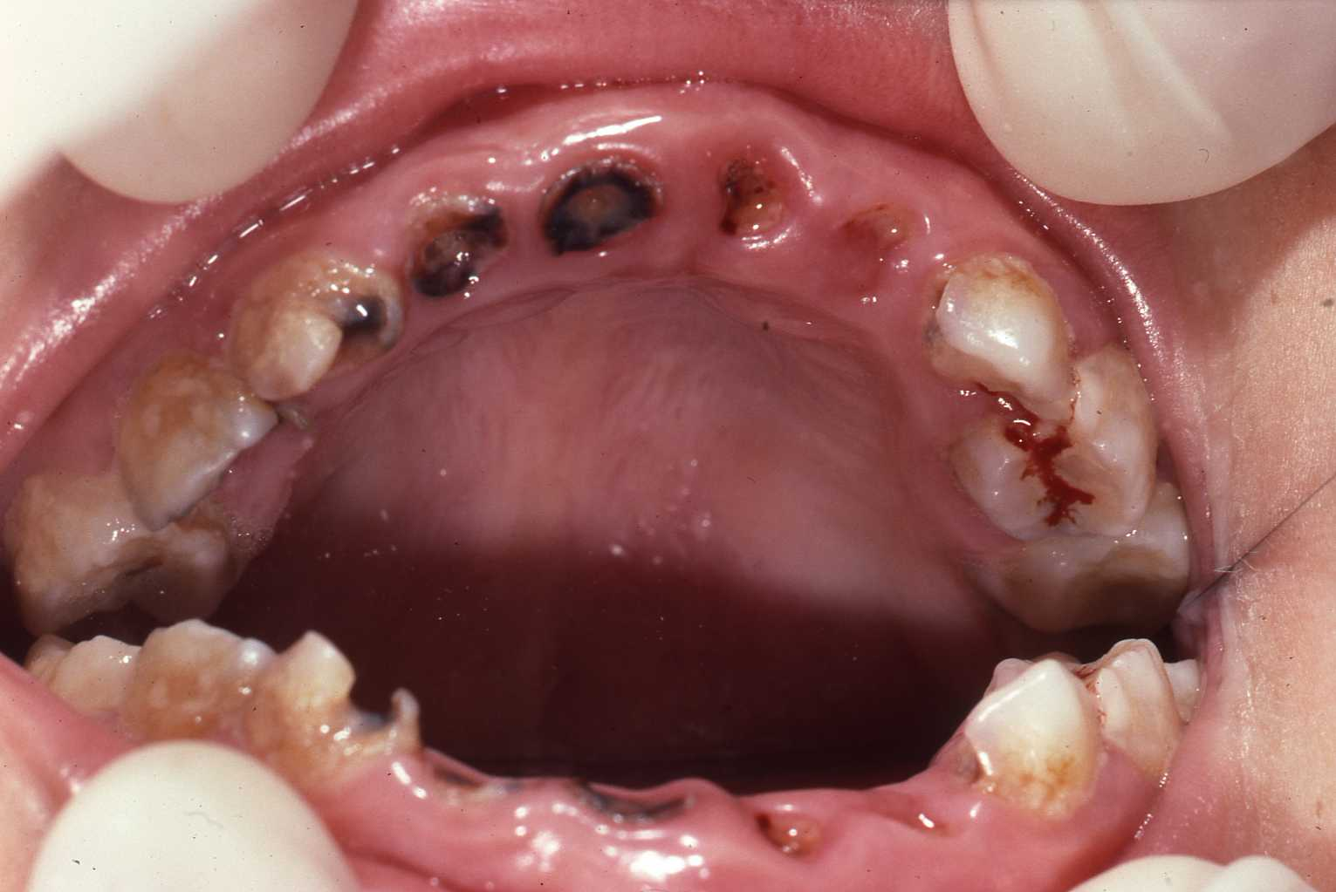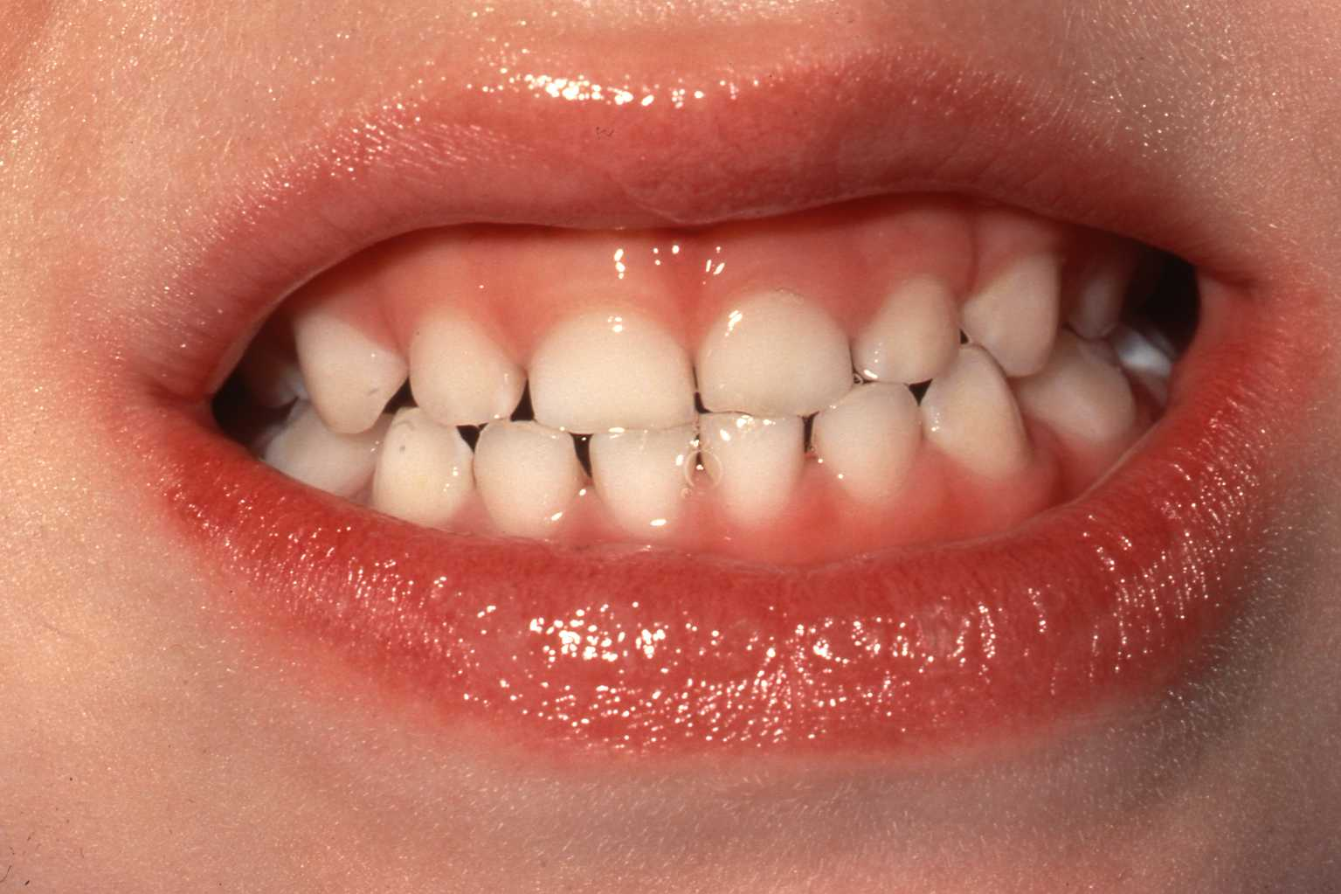

**Caries are aggressive.** Please take care of children’s teeth as soon as they erupt.

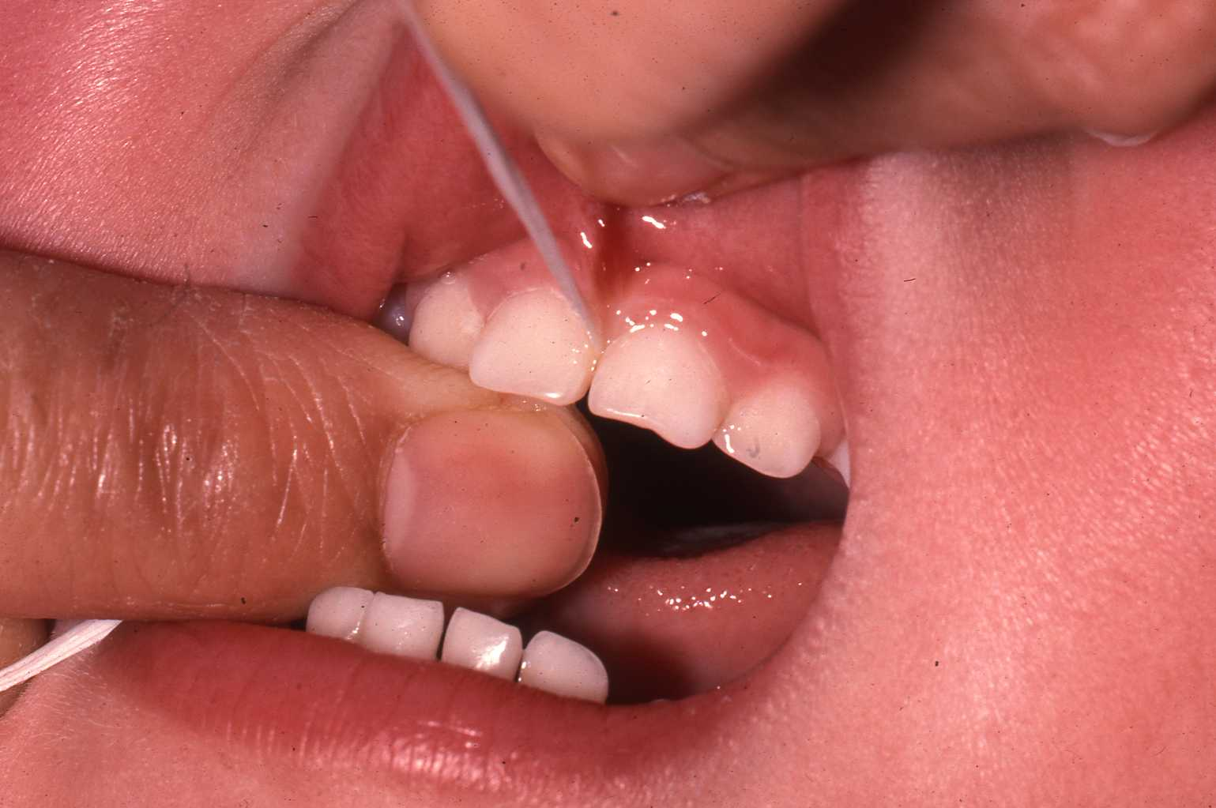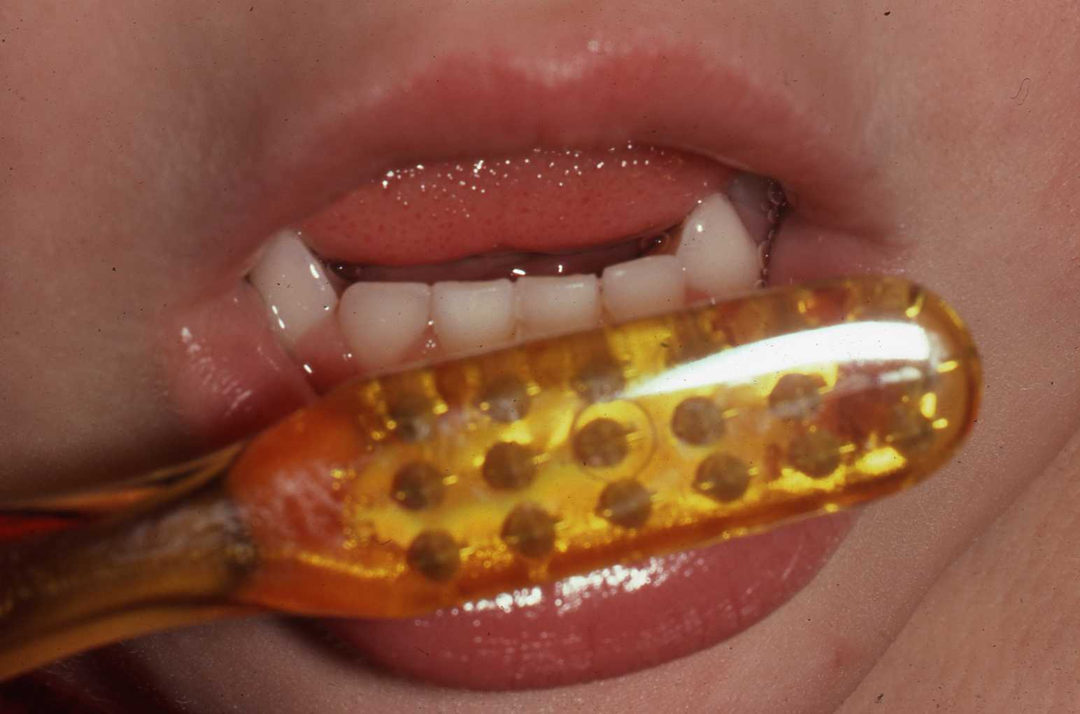

***Healthy teeth for a healthy child!*** We want our children to be happy and healthy! Preventing cavities will prevent the child from dental pain and suffering. **Preventing cavities will** **save the State millions of dollars**.

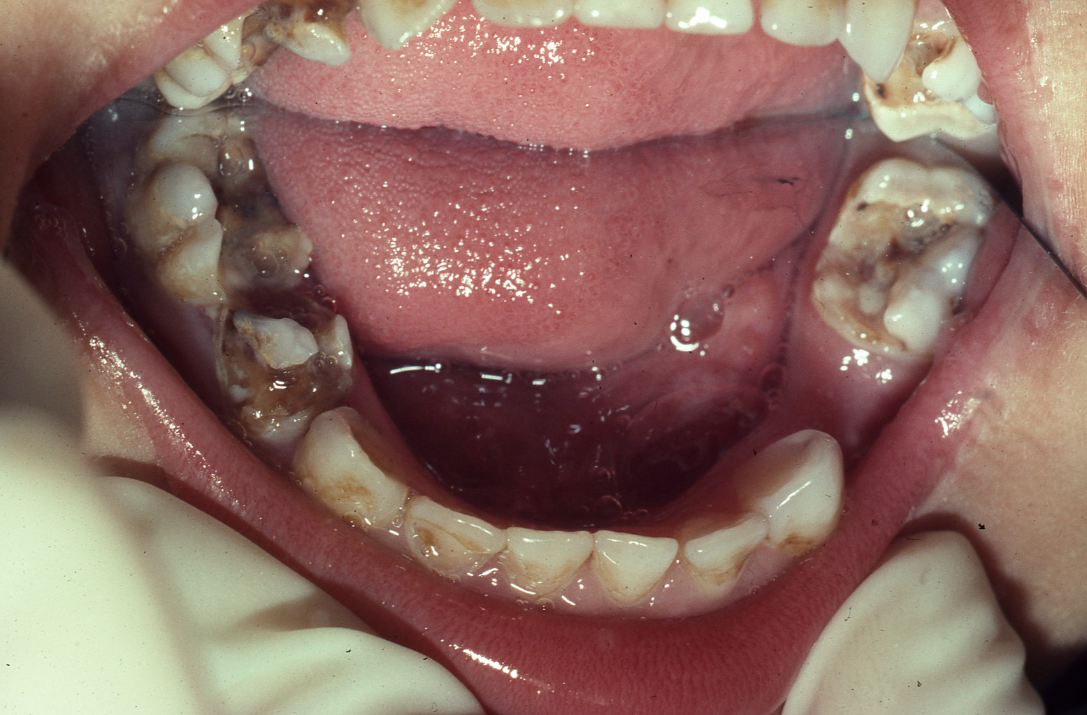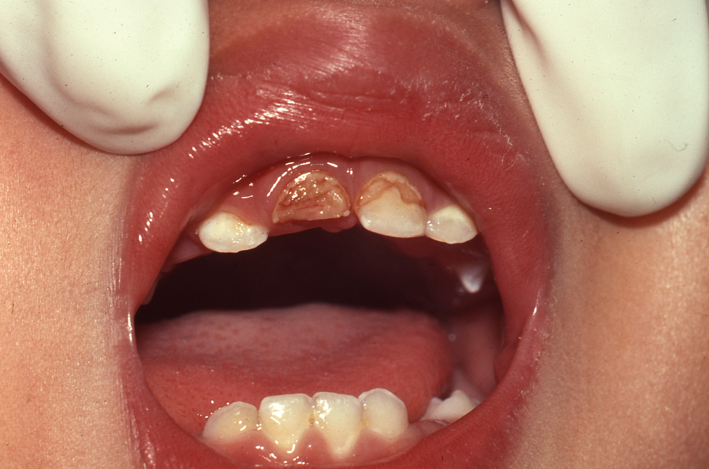

**6 years**

**1 year 6 months**

**4 years**

**11 months**