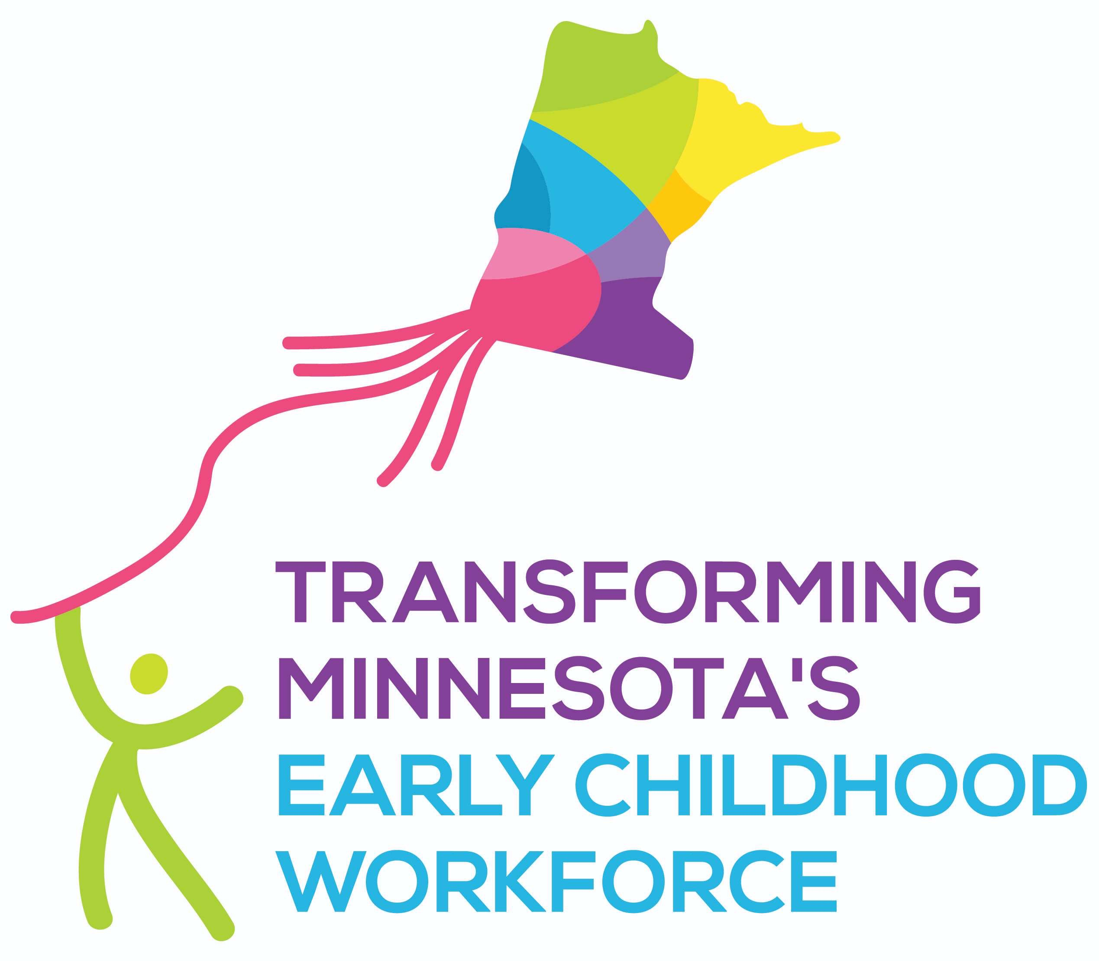
To: Policymakers and others interested in Minnesota’s early childhood workforce
From: B8 Workforce Core Team
Date: April 2019
Re: REETAIN Workforce Retention Program
Minnesota's early childhood workforce - the teachers, assistant teachers, aides, family home providers/business owners, early childhood family educators and the like - are the foundation upon which the rest of the early childhood system depends. Minnesota needs qualified, diverse, supported and fairly compensated early childhood educators so that parents can go to work, businesses can hire employees and children can thrive.
In order to attract and retain the early childhood workforce, reduce turnover as well as foster children's developmental needs, Minnesota needs to provide more support for new and current early childhood educators. The median hourly wage in Minnesota for a child care worker is only $11.44 per hour or $23,795 per year. A bachelor's degree in early childhood is the lowest paid degree you can earn in the United States. Early childhood professionals in Minnesota work long hours, receive few benefits and struggle to meet their own families' needs. Minnesota’s early childhood workers are so poor that 32% of them qualify for public assistance themselves; Minnesota pays $43 million per year in public assistance to the early childhood workforce.
Minnesota received a recent grant from the National Governors Association to examine compensation issues related to early childhood care and education. A report from the workgroup was published in January of 2018. One of the recommendations from that report was to continue and increase funding for REETAIN. The REETAIN (Retaining Early Educators Through Attaining Incentives Now) program is Minnesota’s child care workforce retention program. REETAIN provides bonuses to early childhood professionals and has been found to positively influence their decision to remain in the early childhood field. Recipients of REETAIN bonuses make a commitment to remain in their position for at least one year after receipt of the bonus.
Advantages of REETAIN:
- REETAIN is a proven method of encouraging existing early childhood educators to remain in their jobs
- Reducing turnover is in the best interests of children who can develop more positive and longer lasting relationships with teachers which enhances their development and brain growth
- Keeping existing early childhood professionals in the field helps parents, employers and the economy
Issues with the current REETAIN program:
- Insufficient funds to provide REETAIN bonuses to eligible early childhood providers; over half of all qualified family child care providers who apply are not selected to receive a REETAIN bonus
- Providers can only apply every other year due to limited funds which makes it more likely that they will leave their job in search of higher income
Recommendation:
The B8 Workforce Core Team, like Minnesota’s Workforce Compensation Advisory Group, recommends that Minnesota increase the funding available to support the REETAIN program.
More information about the B8 Workforce Core Team and the work to transform the early childhood workforce can be found at: www.ecworkforcemn.org.

Early Childhood Workforce Index 2016, Center for the Study of Child Care Employment, University of California.
Minnesota’s Workforce Compensation Advisory Group Summary Report and Recommendations, January 2018. This report can be accessed online at: http://mn.gov/gov-stat/pdf/MN_Workforce_Compensation_Advisory_Group_Summary.pdf
Shaw, S., Hilty, R., Lloyd, C. M., Nagle, K., Paschall, K., Warner-Richter, M., Moron, L., & Tout, K. (2018). Evaluation of R.E.E.T.A.I.N., Minnesota’s Child Care Workforce Retention Program – Final Report. Minneapolis, MN: Child Trends for the Minnesota Department of Human Services. DHS-7809A 1-19.

