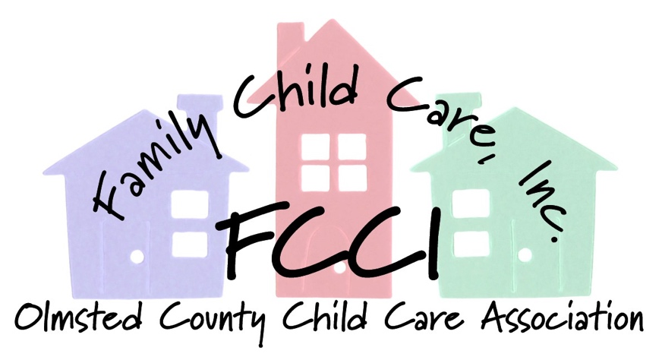
March 12, 2018

Dear Madman Chair and Members of the Committee,

FCCI opposes the following portions of these bills.

HF 3403 Subdivision 16: Increases group family care capacity up to 17 with two adults. Of the total children ender school age, a combine total of no more than six shall be infants and toddlers, no more than four shall be infants.

**FCCI has significant concerns about the proposed increase negatively impacting the critical early years by compromising the time and opportunity for relationship building, sustained interactions, individualized nurturance and care that is essential in healthy brain development and overall quality of program practices.

HF 3405 changes the following language in 245A.1435, Reduction of SUID:
(d) Placing a swaddled an infant swaddled in blanket down to sleep in a licensed setting is not recommended for an infant of any age and is prohibited for any infant who has begun to roll over independently.

A license holder may place the infant who has not yet begun to roll over on its own down to sleep in a one piece sleeper equipped with an attached system that fastens securely only across the upper torso, sleep systems is not under a recall or warning from the United States Consumers Product Commission with not constriction of the hips or legs, to create swaddle.

**FCCI’s search of sleep systems not under recall and on the market raises concerns for the health and safety infant sleep. Sleep systems found included sleep sacks that are weighted on the chest, sleep systems with hoods, a sleep system with strap stound the infant upper torso, and enclosed but not attached to the sleep sleeper. The possible interpretation of sleep systems also present concerns as it opens the door for wedges with or without swaddle straps and other devices such as Babocush which is a system where the infant is placed tummy side strapped on by Velcro to the device. See photos of samples sleep on the next page.

Examples of Sleep Systems that are not under recall and on the market:

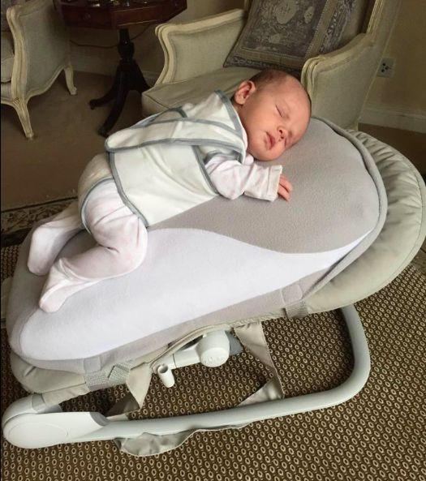

Family Child Care, Inc. is an organization of licensed family child care providers committed to developing and promoting high quality childcare in our community through education, resources and support.

