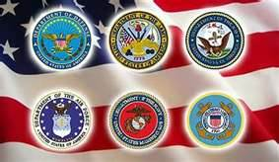

INFO ON THE NORTHERN MINNESOTA VETERANS HOME

- Northern Minnesota’s Veterans are geographically isolated from the state’s existing Veterans Homes and are underserved in this large sixteen county region which includes Beltrami, Cass, Clearwater, Crow Wing, Hubbard, Itasca, Kittson, Koochiching, Lake of the Woods, Mahnomen, Marshall, Norman, Pennington, Polk, Red Lake, and Roseau.

- Approximately 27,658 Veterans live in the Northern Minnesota counties.

- There are 18,155 Veterans living in Beltrami County and its nine surrounding counties according to the American Community Survey of 2015.

- The nearest Veterans Home to Bemidji is Fergus Falls a distance of 128 miles.

- Northern Minnesota is experiencing a rapidly aging Veterans population.

- 77.2% of the veterans living in the 16 counties are over age 55.

- In the 2011 ACS survey, 50% of the veterans in the 16 counties were over age 65; this has now increased to 55.1%.

- Health care needs for these older Veterans is increasing especially for Vietnam War Veterans.

- Northern Minnesota is home to a high concentration of American Indian Veterans.

- Red Lake, Leech Lake, White Earth, and Bois Forte reservations are all located in the 16-county catchment area.

- 1,036 American Indian Veterans live in the 16 counties.

- 35% of Minnesota American Indian Veterans live in Northern Minnesota.

Northern Minnesota Veterans Data

