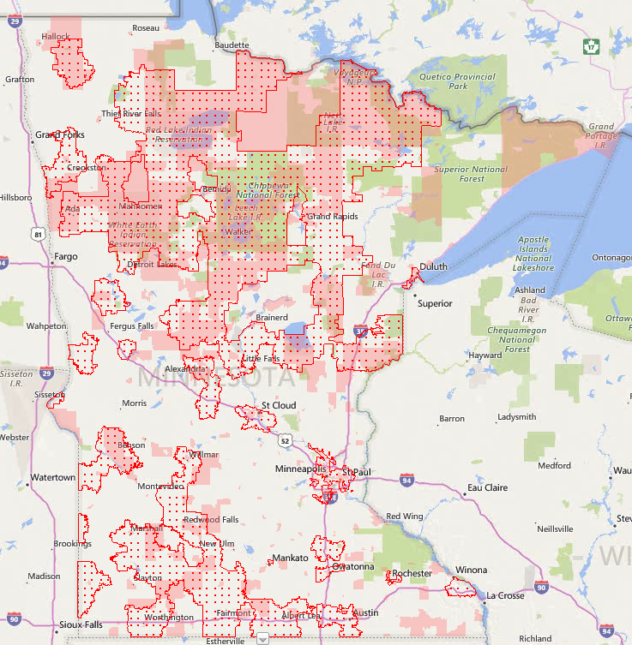
Minnesota Eligible Area Map for Child and Adult Care Food Program (CACFP) and Summer Food Service Program (SFSP)

CACFP: Red Dots Area
SFSP: anywhere that is red dots and/or red solid coloring.

Youthprise Current Service Area—Serving in Hennepin, Ramsey, Dakota, Anoka, Washington County.

